ARKANSAS COMMUNITY AND ECONOMIC
DEVELOPMENT PROGRAM (ACEDP)
Community Development Block Grant Program (CDBG)
State Program for Small Cities

Economic Development Application
Effective for 2021 Program Year (July 1, 2021 through June 30, 2022)

This is an electronically controlled document. The electronic version on the AEDC-Grants website is the most recent version, and is the only official version, of the document. Revisions are made periodically. The version date is shown in the footer of each page of the document. If the user is consulting a version with a version date differing from the version date of the official version on the website, then changes have been made. Refer to the table of revision changes online.
AEDC does not discriminate on the basis of Race, Color, National Origin, Sex, Age, Religion or Disability; and provides upon request, reasonable accommodation including auxiliary aids and services necessary to afford an individual with a disability an equal opportunity to participate in all programs and activities.

Table of Contents

Section A. ECONOMIC DEVELOPMENT APPLICATION GUIDELINES
Overview 3

Part I. General Requirements
- Eligible Applicants 4
- Eligible Businesses 4
- Eligible Activities 4
- Ineligible Activities 5
- CDBG National Objective Requirements 6
- Grant Amounts, Matching Funds, and Leveraging 6
- Application Process 6
- Program Income 8
- Post Award Requirements 9

Part II. Underwriting & Decision Making Criteria 10

Part III. Federal Requirements – “The Strings”
- Environmental Review… 11
- Davis-Bacon Act (and Related Acts) 11
- Reporting & Record-Keeping Requirements 11
- Intrastate Relocation/Anti-Pirating 12
- Compliance with CDBG National Objective Requirements 13
- Public Benefit Standard 17
- DUNS Number 17

Section B. APPLICATION FORMS & INSTRUCTIONS
Application Forms & Instructions 18
Table of Contents Checklist 19
Part I. General Information 22
Part II. Project Budget 25
Part III. Project Description 27
Part IV. Benchmarks 28
Part V. Exhibits and Attachments 29

Section A. Economic Development Application Guidelines

Overview

These application guidelines are for all Economic Development applications. Any eligible applicant must follow the instructions and information within this Application Package in order to apply for Economic Development resources.

To assist with application development, the Grants Division of the Arkansas Economic Development
Commission has prepared ACEDP Application Guidelines (the Guidelines) as an application reference source. The most up-to-date version of these guidelines can be found online. To request a copy of the Guidelines or to obtain assistance regarding application requirements, please contact the Grants Division at (501) 682-1211.

Most funding determinations will be made within 30 to 45 days from the close of the application period. However, if the application is incomplete, additional information may be requested prior to the approval of the application. A completed application will consist of all documents enumerated in the Application Table of Contents. Only one copy of the application is required.

The Economic Development set-aside is designed to provide Arkansas’s non-entitlement cities and counties with resources to assist businesses which expand the State’s economic base and which create quality jobs principally benefiting LMI employees and made available under the LMI CDBG National Objective criteria. Eligible activities will generally include: grants or loans to for-profit businesses (through the applicant community) for a variety of business purposes; or public facilities (infrastructure) projects undertaken by applicant communities for economic development purposes, where a benefiting business agrees to locate or expand premised on the infrastructure improvements and agrees to create jobs for LMI persons.
AEDC shares the cost of project infrastructure needs by committing grants from state and federal infrastructure funds. The amount of assistance committed is dependent upon the strength of the company, number of jobs, average wage, project investment and costs associated with facility/site improvements.

FOR MORE INFORMATION

For further information please contact the following Primary Contact for this program. See also Part 1 for more ACEDP Guidelines and Part 3 for the Exhibits for the application.

Jean Noble
Director, Grants Division
Arkansas Economic Development Commission
1 Commerce Way, Ste. 601
Little Rock, AR 72202
Phone: (501) 682-7389 or (888) 787-2527
Fax: (501) 682-7499
E-mail: JNoble@ArkansasEDC.com
http://www.arkansasedc.com/grants

Part I: General Terms and Conditions
- Eligible Applicants
Eligible applicants include all Arkansas cities and counties under 50,000 in population except for 13 “entitlement cities” which receive their own funds directly from HUD.
Entitlement cities include:

- Little Rock
- North Little Rock
- Conway
- Pine Bluff
- Fayetteville
- Springdale
- Rogers

- Fort Smith
- Hot Springs
- Texarkana
- Jacksonville
- Jonesboro
- West Memphis

- Eligible Businesses
- Manufacturers in NAICS codes 31-33
- Businesses primarily engaged in the design and development of prepackaged software, digital content production and preservation, computer processing, data preparation services or information retrieval services. Eligible computer-related businesses must derive at least 75% of their revenue from out-of-state sales
- Businesses primarily engaged in motion picture production that derive at least 75% of their revenue from out-of-state sales
- Distribution centers that derive 75% of their sales revenue from out-of-state customers
- Intermodal facilities with more than one (1) mode of interconnected movement of freight, commerce, or passengers
- Office sector businesses that support primary business needs and that are non-retail businesses deriving at least seventy-five percent (75%) of their sales revenue from out-of-state
- National or regional corporate headquarters as classified in the NAICS code 551114
- Firms primarily engaged in commercial, physical and biological research as classified in the NAICS code 541710
- Scientific and technical services businesses that derive at least 75% of their revenue from out-of-state sales. The average hourly wage paid by these businesses must exceed 150% of the county or state average hourly wage, whichever is less.
- Eligible Activities
The following activities are eligible within the Economic Development set-aside. If any activity is not noted within the list below, please consult a member of the AEDC Grants Division Representative in order to determine if any other proposed activities are eligible for the program.
Funds may be used by eligible applicants to:
- Provide infrastructure necessary to serve the location of a new or expansion of an existing industry which will create new jobs or retain existing jobs, or provide for the construction of facilities or purchase of equipment, provided that:
  - At least 51% of the beneficiaries of the improvements funded, in whole or in part, with these funds qualify as low-to-moderate-income, as defined by HUD regulations;
  - The scope and capacity of the project improvements bear a reasonable relationship to the needs of the company requiring them;
  - The amount of funds awarded represents a financing gap equal to the project cost, less the amount which the applicant could reasonably invest in the improvements (it is the policy of the State that financial assistance in support of economic development be limited to that which cannot be reasonably financed through local means); and,
  - The company benefiting from such improvements certifies its agreement to fulfill the job creation requirements of the program, or,
- Provide loans to industry for economic development purposes when it can determine that the provision of such financing is necessary to create new jobs and/or retain existing jobs. Eligible activities for loans include, but are not limited to the following: acquisition, construction and equipment, provided that,
  - The applicant can demonstrate feasibility to such an extent that its probable cash flow can support expected debt service;
  - The amount of the loan shall represent the least amount, in conjunction with other resources, required to finance project activities and create/retain jobs;
  - Loan funds are used for eligible economic development activities;
  - The applicant and benefiting company demonstrate that the level of assistance will not unduly enrich the company and is reasonable in relation to the public benefit be achieved; and;
  - No funds are used for refinancing of any kind.
- Provide funds for a Commission-approved training program; or
- Undertake any combination of 1 through 4 above, provided that all other requirements can be met.

For more information see Section I of the Application Guidelines.

- Ineligible Activities
The following activities are ineligible within the CDBG program. If any activity is not noted within the list below, and is not listed as an eligible activity, please consult a member of the AEDC Grants Division in order to determine if any other proposed activities are eligible for the program.
- Buildings used predominantly for the general conduct of government such as:
  - City and halls;
  - County administrative buildings
  - State Capitols,
  - Office buildings or other facilities in which the legislative or general administrative affairs of the government are conducted.
- General government expenses, except those costs that are directly attributable to administration of a local CDBG program;
- Facilities or equipment used for political purposes or to engage in other political activities;
- Purchase of equipment except as set forth in Section 1:D of the Application Guidelines;
- Generally, any expense associated with repairing, operating, or maintaining public facilities, improvements and services. For specific exceptions see Section 1:D of the Application Guidelines;
- For income payments for housing including:
  - Payments for income maintenance;
  - Housing allowances;
  - Down payments;
  - Mortgage subsidies.

For a full description of ineligible CDBG activities, please see Section D of the Application Guidelines.
- CDBG National Objective Requirements
All project activities must meet one of three national objectives of the CDBG program. This is a statutory requirement of the HCDA and a regulatory requirement under HUD CDBG regulations. The three national objectives are:
- benefiting low-to-moderate (LMI) income persons
- aiding in the prevention or elimination of slums or blight
- meeting other community development needs having a particular urgency because existing conditions pose a serious and immediate threat to health or welfare of the community and other financial resources are not available to meet such needs
The majority of projects funded within the ED Program meet the LMI National Objective. The LMI benefit is demonstrated in nearly all projects through job creation, job retention, or both job creation and job retention, by a benefited business. Such job creation or job retention must involve the employment of persons, the majority (51% or more) of whom are LMI persons. A project activity that does not meet the applicable tests for determining whether a national objective has been met is in noncompliance with federal statutory and regulatory requirements. Repayment consequences arise in such circumstances.
- Grant Amounts, Matching Funds, and Leveraging
There is no minimum or maximum amount grant award, no match required, and no minimum leveraging requirements. All Economic Development projects are referred to the Grants Division after undergoing underwriting through a Business Development commitment process.
- Application Process
The only basis for a commitment of funding assistance is upon the receipt and review of a complete application. The only exception to this requirement is that the Arkansas Economic Development Commission may issue a conditional commitment of funding when necessary to attract an industry to locate in an eligible applicant's jurisdiction, but only with the consent and concurrence of the applicant. Such a conditional commitment does not waive the requirement to submit a formal application or to comply with all program requirements.
- Loans. Applications complete a four-step process:
  - Review for eligibility and compliance with applicable requirements;
  - Evaluation of the business plan for appropriateness, feasibility, and credit worthiness;
  - Review and recommendation by AEDC; and
  - Decision made by the Commission’s Executive Director.
- Infrastructure/Grants. Applications complete a three-step process:
  - Review for eligibility and compliance with applicable requirements;
  - Determination of appropriateness, feasibility, need, and recommended funding level; and;
  - Decision by the Commission’s Executive Director.
All applicants for ACEDP Economic Development funds must submit a completed application to the Arkansas Economic Development Commission including an industry commitment to primarily create, retain, and/or make jobs available to persons who qualify as low and moderate income at the time of hire.
Applications must be submitted to and accepted for review by the Grants Management Division of Arkansas Economic Development Commission to be considered for funding. All applications are reviewed for basic eligibility and evaluated to determine the extent to which proposed activities meet program requirements.
Communities and businesses may request guidance and advice prior to the submission of an application, and in fact are encouraged to do so. The preparation of an application represents a significant amount of work; there is little sense in undertaking such work if the project cannot be approved for legal or programmatic reasons. However, such advice and guidance should never be construed as an endorsement of the application or a commitment of funds prior to its submission and review.
Applicants requesting funds to assist businesses should be particularly aware of the existence of federal compliance requirements that do not ordinarily apply to business finance programs. Some of these requirements apply directly to the benefiting company and may cause delays in project execution.
One of the most critical of these requirements, in the earliest stages of a project, is the Environmental Review Process which will take from one week to two months, from the beginning until the project is cleared by the Arkansas Economic Development Commission, depending on the nature of the project. The average time required to complete Environmental Review Process is 40 days.
It is critical that both the applicant and the benefiting company completely understand all project requirements prior to executing irreversible commitments. In some cases, these requirements may mean that ACEDP funds are not feasible for the project, because their enforcement adversely affects the company's operations or timing. As a rule, companies whose financing requirements demand a quick response will find ACEDP requirements counter-productive and frustrating. The minimum time frame for the funding process is at least two months; from the time an applicant begins the application process until the first funds can be released by the Arkansas Economic Development Commission. The time frame will be longer if required steps in the process have to be redone or submitted documents are inadequate.
The contents of the formal grant application must include all required exhibits in sequential order, as described in each activity specific package, before the application will be reviewed. Applicants should be aware that application materials are subject to public inspection. Information, which the benefiting company considers proprietary, may be held in confidence by the Arkansas Economic Development Commission, provided that it is clearly marked and separated from non-confidential materials. Such materials will be returned to the company if the application is rejected for funding.
- Program Income
Notwithstanding any other provision of law, program income realized from any grant/loan distributed by the Commission if such income is realized after individual disbursement of funds received by the unit of local government, while such unit of local government is participating in a Community Development Block Grant (CDBG) program, will be required to return such income to the State to the maximum extent possible for funding economic and community development activities.
Program income for the state's program under the CDBG ED category is regulated by the provisions of 24 C.F.R. §570.489(e). The text of this regulation should be consulted for definitions and for other guidance concerning program income. Grantees that receive a CDBG ED award will be governed by the policies written in the Annual Action Plan and the 5-year Consolidated Plan section “Program Income”. Related policy guidance can be found in the ACEDP Administrative Procedures Manual.
The State CDBG objective for program income is to provide adequate financing for local development to ensure Arkansas’s economic prosperity and to use all resources in a timely manner. The State is seeking to provide a policy for use of program income that coordinates local and State resources to the fullest extent possible. The State is responsible for ensuring that program income at the State and local levels is used in accordance with applicable federal laws and regulations.
Program Income – Definition:
Program income is defined as gross income received by a State, a unit of general local government, or a subgrantee of the unit of general local government that was generated from the use of CDBG funds, regardless of when the CDBG funds were appropriated and whether the activity has been closed out, except in limited circumstances [See also 24 CFR 570.489(e)(2)]. When program income is generated by an activity that is only partially assisted with CDBG funds, the income must be prorated to reflect the percentage of CDBG funds used.

All program income is and remains subject to all requirements of the HCDA and CDBG regulations. Program income includes, but is not limited to, the following:
(1) Proceeds from the disposition by sale or long-term lease of real property purchased or improved with CDBG funds except in instances where the proceeds are received more than 5 years after expiration of the grant agreement between the state and the unit of general local government.” [See also 24 CFR 570.489(e)(2)(v)];
(2) Proceeds from the disposition of equipment purchased with CDBG funds;
(3) Gross income from the use or rental of real or personal property acquired by the unit of general local government or subgrantee of the unit of general local government with CDBG funds, less the costs incidental to the generation of the income;
(4) Gross income from the use or rental of real property, owned by the unit of general local government or other entity carrying out a CDBG activity that was constructed or improved with CDBG funds, less the costs incidental to the generation of the income;
(5) Payments of principal and interest on loans made using CDBG funds;
(6) Proceeds from the sale of loans made with CDBG funds, less reasonable legal and other costs incurred in the course of such sale that are not otherwise eligible costs;
(7) Proceeds from the sale of obligations secured by loans made with CDBG funds, less reasonable legal and other costs incurred in the course of such sale that are not otherwise eligible costs;
(8) Interest earned on funds held in a revolving loan fund's cash balance interest-bearing account;
(9) Funds collected through special assessments made against nonresidential properties and properties owned and occupied by households not of low and moderate income, if the special assessments are used to recover all or part of the CDBG portion of a public improvement; and
(10) Gross income paid to a unit of general local government or subgrantee of the unit of general local government from the ownership interest in a for-profit entity acquired in return for the provision of CDBG assistance.
I. Post Award Requirements
Each eligible application must also comply with any necessary post award requirements. These requirements include: Environmental Review; Davis-Bacon compliance; Procurement, etc.

For more information, and for a complete list of Post Award Requirements, see Section O of the Application Guidelines.
Part II: Underwriting & Decision Making Criteria

The Housing and Community Development Act (HCDA) and HUD's CDBG regulations outline basic project "underwriting" guidelines/standards so that state programs administering federal CDBG funds will achieve the federal objectives of the CDBG program. The underwriting standards—the decision-making criteria—used in the Arkansas CDBG ED category are designed to address these federal guidelines.

The federal CDBG guidelines, as applied by AEDC may be summarized as follows:

- Project costs must be reasonable, not excessive, and must be supported by cost analyses. Transactions must be carried out through arms-length transactions, not insider arrangements.
- All proposed sources of financing necessary to carry out the project must be committed. This ensures that time and effort is not wasted on assessing proposals, or awarding funds to projects, that are not in a position to proceed to project completion within a reasonable time. To fulfill this requirement, AEDC requires a written verification affirming the various funding parties' intentions to make funds available, and, depending on the nature of the funding party, a showing of their capacity to actually provide such funds.
- To the extent practicable, CDBG funds are not to be substituted for other funds. This standard requires a financial underwriting analysis of the project. The level of analysis will vary with the nature and complexity of the project. Since projects in this category provide financing for for-profit businesses, appropriate levels of private source financing (e.g., bank loans) are expected to be present, and equity participation in the project must be sufficient given the financial capacity of those owning the enterprise.
- Financial feasibility of the project. The public benefit expected from the investment of CDBG funds is the creation and maintenance of LMI jobs. That benefit will not materialize if the project is not financially feasible.
- Avoidance of providing an unreasonable return on investment to the owner of the project. The availability of non-interest bearing loans and forgivable loans to for-profit businesses presents a potential for this to occur which must be addressed in analyzing, and in judging the merits of, each project.
- To the extent practicable, CDBG funds should be disbursed on a pro rata basis with other project funding sources. CDBG money should not be the first money into a project, but rather should flow into a project in proportion to other project funding sources.

Applicants must recognize that CDBG ED funds are limited and not all applications are equally meritorious when viewed from Arkansas’s state-wide perspective.

Part III: Federal Requirements—"The Strings":

In addition to the requirements listed in the ACEDP Application Guidelines, applicants and benefited businesses must be aware at the outset of the existence of a host of federal statutes and regulations that have scheduling, cost, and substantial paperwork implications when CDBG funding is used for ED projects. Businesses must be prepared to accept delays and other "strings" requirements and should not harbor unrealistic expectations about the speed with which a project may develop. The following listing is by no means comprehensive. The list simply highlights three areas of the many commonly applicable "strings".

- Environmental Review:
Federal statutes (the National Environmental Policy Act and HCDA) and HUD implementing regulations (24 C.F.R. Part 58) require that CDBG-assisted projects must have an appropriate environmental review process completed prior to costs for the project being incurred. This process must be documented with an appropriate environmental review record. The environmental review process and its documentation are the responsibility of the applicant unit of general local government. The entire project, often referred to in these contexts as the entire "footprint" of the project—not just the portion of the project involving CDBG-funded activities—must be aggregated when reviewing the project's environmental impact. In order for a project application to be considered complete for submission to AEDC, there must be a completed environmental review process and record in place and sufficient evidence of its completion must be included with the application. Specific discussion of the environmental review requirements, including flowcharts (with timing requirements) and forms may be found in the “Environmental” Chapter of the ACEDP Administration Procedures Manual.

The time required to complete the entire environmental review varies considerably depending on the facts and circumstances of each project. The process can take a few days to as much as several months. The time requirement for this process is often underestimated by businesses and applicant communities. In many projects, clearing the environmental review "hurdle" is a time-consuming task and delays in project implementation arising from this process should be anticipated by applicants.

- The Davis-Bacon Act (and related acts)
These federal statutes and their implementing regulations require that federally-assisted construction work in excess of $2,000 must have prevailing wage rates (determined by the U.S. Department of Labor) paid to all employees working on such construction work. If CDBG funds assist even just a portion of the construction work, then Davis-Bacon becomes applicable to the entire construction work. Note however, that CDBG funds can finance activities other than construction work, without triggering Davis-Bacon requirements, even though CDBG funds are "in the mix" of an overall project which may involve construction work. Note also that use of matching funds (from non-CDBG sources) for construction work does not trigger Davis-Bacon requirements.

- Reporting and Record Keeping Requirements

The benefited business and the applicant governmental unit have various, periodic, employment and financial reporting and record keeping requirements pursuant to CDBG regulations. The benefited business must keep a record of the Employee Certification Form (a self-certification of household income that is used for determining low to moderate income status for new hires or for a retention survey). Grantees are required to submit semi-annual Project Status and Job Creation Reports and final reports necessary for close-out of the grant. Requirements for retaining records are addressed in the CDBG Grant Agreement.
- Intrastate Relocation/Anti-Pirating:

CDBG ED funds cannot be used in a project which relocates a business from one Arkansas community to another Arkansas community, unless the business obtains the written approval of the appropriate community officials of the community which is losing the business. This has been a longstanding policy of AEDC, designed to avoid putting the AEDC in the position of financially enabling a "raid" of one Arkansas community by another. It is the responsibility of the business to resolve matters with the community from which it is departing, in order to obtain the approval by that community required by AEDC. In addition to such community approval, AEDC must conclude there are compelling business reasons for—and compelling public benefits associated with—the relocation, in order to assist such an intrastate relocation.

Additionally impacting intrastate relocation is the job-pirating prohibition in the HUD CDBG regulations (explained below). These prohibitions may be applicable to, and possibly pose a barrier to, using CDBG ED funds for relocating a business from one Arkansas community to another Arkansas community.

Prohibition on Use of CDBG Assistance for Job-Pirating Activities.
The federal statute [HCDA, codified at 42 U.S.C. §5305(h)] and implementing regulations issued by HUD [24 C.F.R. §570.482(h) for state programs, effective June 23, 2006] establishing this anti-pirating policy, prohibit the state (and state grantee communities) from using CDBG funds for "job-pirating" activities that are likely to result in significant job loss in the Labor Market Area (LMA) from which the business is relocating. The regulation basically targets businesses that move (or expand) existing operations from one LMA to another LMA. Relocations within a LMA are not subject to the regulations.

The regulations prohibit providing CDBG funds to for-profit businesses (including expansions of existing businesses) if the funding will assist in the relocation of a plant, facility, or operation (terms defined in the regulations)—and—if the relocation is likely to result in a significant loss of jobs in the LMA from which the relocation occurs. A "significant job loss" is not defined in the statute, but is defined in HUD regulations. The regulation uses measurements of:
- 500 jobs lost in a LMA as being definitionally a significant loss; and thus CDBG funds cannot be used in such cases.
- 25 or fewer jobs lost in a LMA as being definitionally not a significant loss; and thus not a job-pirating problem, so CDBG funds can be used in such cases.
- 26-499 jobs lost may be a significant job loss if the lost jobs are equal to or greater than one-tenth of one percent (0.1%) of the total number of persons in the labor force of the LMA from which the proposed business relocation would occur. As an example, 26 jobs lost would be a significant job loss in a LMA with a labor force size of 26,000 people.

Grants to communities for infrastructure improvement that aid the relocation of a specific business, and which are justified for CDBG funding as meeting the national objective of benefiting LMI persons through job creation/retention agreement by a specific business, are covered by this anti-pirating rule, being considered the same as directly assisting the relocating business.

Under the regulations a job will be considered to have been relocated if positions are eliminated at an existing operation within three (3) years of the time when CDBG funding assistance was provided to the expansion site operation of the business.

Certifications (by the business, as to non-relocation of jobs) are required by the regulations to be part of the agreement which governs CDBG assistance to the business. These certifications are made by the business, not by the grantee community. The business must also contractually agree that if significant job losses do occur (within a 3-year window) at an existing location from which an expansion was CDBG assisted, then the business will reimburse the CDBG recipient (the community) for CDBG assistance provided to the business (directly) or expended on behalf of the business (e.g., infrastructure improvement project). These certifications and agreements to reimburse, by the business, must be a part of the MOU for the project.

The community being provided CDBG funding by AEDC has the burden of collecting the necessary labor force data and determining whether a significant job loss will occur as a result of the proposed relocation. This assessment will be part of the normal "packaging" and application process for the project.

States are permitted (but not required) to determine/define applicable Labor Market Areas (LMAs) in non-metropolitan areas of the state. If this is done for Arkansas, AEDC will make its determinations known, through these guidelines or other publication methods. If no differing definitions are made by AEDC, the LMAs defined by the U. S. Department of Labor will be used. At the time of the writing of this portion of these guidelines: the "default" designations of the LMAs are found at the Bureau of Labor Standards website at https://www.bls.gov/lau/laufaq.htm and labor force data by county (annual averages) are found at the Bureau of Labor Standards website at www.bls.gov/lau/home.htm.

The HUD regulations in this area are fairly lengthy and filled with definitions, exceptions, time limits, reporting requirements, and explanations. The guidelines explanations above are not intended to be a full explanation of this rather complicated set of newly imposed (in 2006) CDBG restrictions. The full text of the regulations must be read and understood in order to achieve compliance. The publications of the regulations by HUD appear in the Federal Register for December 23, 2005, Volume 70, Number 246, pages 76362-76371—and—in the Federal Register for May 24, 2006, Volume 71, Number 100, pages 30026-30027.

E. Compliance with CDBG National Objective Requirements
Your attention is directed to the general discussion of this subject in the Overview of General Requirements, found earlier in these guidelines. In that discussion, the CDBG national objective requirement of benefiting low-to-moderate income persons, through job creation and/or job retention by a benefited business is cited. Such job creation (or job retention) must involve the employment of persons, the majority (51% or more) of whom are LMI persons.

- It is required for every project that a CDBG national objective be met. Failure to achieve a national objective has repayment consequences for the benefited business. In the case of public facilities projects, failure to achieve a national objective has repayment consequences for both the business and the applicant community.

- The CDBG national objective of benefiting LMI persons is the one normally applicable to CDBG ED projects.

- Benefiting LMI persons is normally achieved by creating jobs where more than half of such jobs (actually 51% or more) are held by LMI persons. The 51% LMI requirement applies to all jobs created as a result of project activities—it does not just apply to the number of jobs to be created which is agreed by AEDC as the minimum number of jobs required to be created. This is an important point often overlooked or misunderstood by parties to CDBG project agreements.

- Occasionally, in limited circumstances, rather than the job being held by an LMI person, a lesser standard of compliance, called making the job available to LMI persons, may be substituted. However, this "available to" standard is a less satisfactory choice, and compliance with the "available to" standard requires compliance with fairly rigorous regulatory standards. Specifics about how an employment position is considered to be "held by" or "made available to" an LMI person, and other related definitional matters, may be found in the HUD CDBG regulations in 24 C.F.R. Part 570. More detailed discussion can be found in the HUD’s Guide to National Objectives and Eligible Activities for State CDBG Program, which provides some guidance on using the “available to” standard:

  - Jobs that are not held (filled) by LMI persons may be claimed to be “available to” LMI persons only when both of the following are met:
    - The jobs do not require special skills that can only be acquired with substantial (i.e., one year or more) training or work experience, and education beyond high school is a not a prerequisite to fill such jobs, unless the business agrees to hire unqualified persons and train them, and
    - The state grant recipient and/or the assisted business takes actions to ensure that LMI persons receive “first consideration” for filling such jobs. “First consideration” involves the following principles:
      - The business must use a hiring practice that under usual circumstances would result in over 51 percent of the LMI persons interviewed for applicable jobs being hired,
      - The business must seriously consider a sufficient number of LMI job applicants to give reasonable opportunity to fill the position with such a person, and
      - The distance from residence and availability of transportation to the job site must be reasonable before a particular LMI person may be considered a serious applicant for the job.
  - When demonstrating that at least 51% of the jobs created will be available to LMI persons, documentation for each assisted business must include:
    - A written commitment by the business that it will make at least 51% of the jobs on a FTE basis available to LMI persons and will provide training for any of those jobs requiring special skills or education;
    - A listing by job title of employees at the time of application for assistance is submitted;
    - A listing, by job title, of the total permanent jobs to be created, indicating which jobs will be available to LMI persons, which jobs require special skills or education, and which jobs are part-time;
    - Evidence supporting the total number of jobs;
    - A description of actions to be taken by the recipient and the business to ensure that LMI persons will receive first consideration for these jobs;
    - A listing, by job title, race, ethnicity, gender and handicapped status of the permanent jobs created; which jobs were made available to LMI persons; and, a description of how first consideration was given to such persons for those jobs. The description should include the hiring process used; the number of LMI persons considered for each job; and the number of LMI persons actually hired;
    - A description of how the LMI persons status (of those given first consideration) was determined; and, a description of the total number of jobs was determined.

- Job Retention vs. Job Creation.
  - In order to consider jobs as being retained as a result of CDBG assistance, there must be clear and objective evidence that permanent jobs will be lost without CDBG assistance. The mere assertion of such a circumstance (by the business or representatives of the applicant community) is not sufficient to meet HUD CDBG requirements. Clear and objective evidence would include:
    - Evidence that the business has issued a notice to affected employees that their jobs are at risk
    - Evidence that the business has issued a public announcement to that effect
    - An analysis of relevant financial records of the business clearly and convincingly shows that the business is likely to have to cut back employment in the near future without the planned CDBG intervention

  - When job retention (rather than job creation) is invoked to meet the national objective, 51% of more of the retained jobs must be demonstrated as being held by LMI persons at the time of CDBG assistance (by conducting a “retention survey” using the Employee Certification Form with existing employees).

Low-to-Moderate Income Person (LMI): LMI persons are defined as members of a family (single-person family or multi-person family) where the family has an income equal to or less than the most recent HUD-established income limits for the family residence location. In Arkansas (with some exceptions for metropolitan statistical areas) the income limits are determined for each county. These income limits may be found via the HUD website.

A job is considered to be held by an LMI person if the person is, at the time their employment commences, a member of a family whose income falls within the HUD determined income limits. The family's entire income must be counted. The salary or wage associated with the job the LMI person fills is irrelevant.

Full-Time Equivalent Position (FTE): An FTE position represents a culmination of 2,080 work hours per annum per position by a person in a permanent position of employment with a benefiting business at the business' project location site in Arkansas.

Permanent FTE Jobs are Required: Only permanent jobs count. Temporary jobs do not count. Permanent jobs are full or part-time positions at the benefited business at the specified project site, which can reasonably be expected to be occupied for at least six continuous months. Seasonal jobs may be considered to be permanent only if the season is long enough for the job to be considered as the employees' principal occupation. All permanent jobs must be converted to FTEs.

Expectations for the Normally Allowed "Ramp- up" Time; Normally Required Job Maintenance Period: AEDC’s expectation for the normally allowed "ramp-up" time for the business to create the required jobs is 18 months from the Notice of Approval for the project. Longer durations of this ramp-up time are allowed in some project circumstances. Shorter durations may be imposed in some project circumstances, e.g., CDBG-funded job training projects involving only a few employees may well be allowed a ramp-up time of only 12 months. The normally required time for the business to maintain the created jobs is negotiable (usually 6 to 24 months), measured from the date of hire for each respective job. More nuanced and complicated definitions of the beginning and ending dates of the job maintenance period may be invoked in project negotiations (and their resulting MOUs) in some circumstances. These ramp-up times and job maintenance periods are established by agreement of the parties in the MOU.

Aggregating Jobs: As a general rule, jobs from each business receiving CDBG assistance must be considered separately for purposes of demonstrating compliance with the requirements that at least 51% of the resultant created or retained jobs benefit LMI persons. Certain fact settings, e.g., an industrial park, may allow job aggregation for all businesses located on the property. Particulars about such circumstances are found in the CDBG regulations and other HUD materials.

Repayment by the business due to failure to fulfill the national objective’s job creation/maintenance requirements: When the CDBG assistance provided to a business is in the form of a repayable loan, then full repayment of that loan is required per the terms of the promissory note. If the business with the repayable loan obligation fails to achieve a national objective, the consequence is that immediate acceleration of the note obligation will be declared, requiring immediate, full repayment of the note. When the CDBG assistance provided to a business is wholly, or partly, in the form of a forgivable loan or a job training grant, and the business fails to achieve a national objective or related job creation or job maintenance requirements, the consequences vary depending on the nature of the failure:

- CDBG federal statutes and regulations require CDBG funded projects to meet the national objective of principally benefiting low-to-moderate income (LMI) persons. These statutes and regulations require that at least 51% of the created jobs benefit LMI persons; with such benefit achieved by having at least 51% of the created jobs either held by, or made available to, LMI persons. If the benefited business fails to meet the national objective by not having at least 51% of the created jobs benefit LMI persons, then the loan is not forgiven or the job training grant is not made unconditional, and full repayment of the CDBG funds is required.

- If the national objective (51% LMI benefit) is met, but the minimum job creation requirement (the number of such jobs varying with each individual project) is not achieved, then full repayment of the CDBG funding is required of the business absent other agreement by AEDC.

- If the national objective (51% LMI benefit) is met, but the jobs are not maintained for the required job maintenance period (such period varying with each individual project), then full repayment of the CDBG funding is required of the business absent other agreement by AEDC.

- If the national objective (51% LMI benefit) is met, but there is a failure as to both the job creation requirement and the job maintenance period, then full repayment of the CDBG funding is required of the business absent other agreement by the AEDC.

F. Public Benefit Standard

An activity is considered by HUD to provide insufficient public benefit and cannot be assisted with CDBG funds if the amount of CDBG assistance exceeds $50,000 per full-time equivalent (FTE), permanent job (created or retained) or $1,000 per LMI person to which goods and services are provided by the activity.

In addition, an activity would be considered to have an insufficient benefit if it consists of or includes:
- General promotion of the community (as a whole);
- Assistance to professional sports teams;
- Assistance to privately-owned recreational facilities that serve a predominantly higher income clientele where the benefit to users clearly outweighs the benefit of jobs created or retained;
- Acquisition of land for which a specific use has not been identified (i.e., land banking);or,
- Assistance to a for-profit business owner that is the subject of unresolved findings of noncompliance related to previous CDBG assistance.

G. DUNS Number

A DUNS Number, assigned by the company Dun & Bradstreet, is required when submitting any application for Federal funds. If your organization does not already have a DUNS Number, please visit the Dun & Bradstreet website at www.dnb.com or call 1-866-653-1344. The process of obtaining a DUNS Number is free of charge and should take less than 15 minutes. Most organizations will have a 9-digit DUNS Number. Larger organizations that have multiple departments might already use 4-digit extensions on the DUNS Numbers to distinguish between the various offices with the organization. For example, of a State DUNS Number is 123456789, the Housing, Health, and Transportation Departments should all have different 4-digit extensions, especially since these departments might have different addresses and contact personnel. The 13-digit numbers would look like 123456789-1234. In e-snaps, however, the hyphen is NOT entered. See the Exhibits under “Instructions for SAM Registration” for more details.

Section B. Application Forms & Instructions
This section contains all forms and exhibits to be submitted so that your application can be scored and ranked effectively. Application narratives should be thorough and concise. The Grants Division reserves the right to verify all information, and to consult with other agencies on the proposed project.

There are more applicants requesting funds than there are funds available. Applicants must carefully read and review the Application Guidelines and the selection criteria described to develop a competitive application.

In submitting your application, these instructions must be followed:

- Submit ORIGINAL, ONE (1) complete copy

- Do not fold, staple, or bind in any way other than with a binder clip

- Table of Contents must be included

- All pages must be numbered in sequence at the bottom of the page.

- All Exhibits must be labeled at the bottom of the page, right-hand corner.

- All Attachments must be labeled at the bottom of the page, right-hand corner.

Failure to follow these instructions will result in your application being returned for you to correct and resubmit. All applicants will be given one week to correct and resubmit their application.

PAGES MAY BE ATTACHED TOGETHER WITH A BINDER CLIP. DO NOT BIND, FOLD OR STAPLE.

Below is an outline of what an Economic Development Application should look like:
Part I. General Information (found at www.arkansasedc.com/grants) – This should be used as cover sheet
Table of Contents (use Table of Contents Checklist)
Part II. Project Budget
Part III. Project Description
Part IV. Benchmarks
Part V. Exhibits (see Exhibits package)
Part VI. Attachments (supplemental info provided by applicant)
Table of Contents & Checklist

Each applicant must attach a Table of Contents to their application and must include a Table of Contents Checklist for the Program they are applying for with their application.

The following page provides the format for the Table of Contents Checklist for Economic Development applications.

Table of contents checklist
ECONOMIC DEVELOPMENT

Applicants must complete and submit this checklist with the application. Type in additional appendix items as deemed necessary to your project. List appropriate page numbers under PAGE NUMBER column.

PROJECT INFORMATION PAGE NUMBER

Part I – General Information (this 3 page Application should act as the Cover Page)

Table of Contents

Part II Project Budget

Part III Project Description

Part IV Benchmarks

Part V - EXHIBITS

A. Notice of Public Hearing, Exhibit A

B. Authorizing Resolution, Exhibit B

C. Statement of Assurances and Certifications, Exhibit C

D. Citizen Participation Plan, Exhibit D

E. Residential Anti-displacement & Relocation Assistance Plan, Exhibit E

F. Sample Excessive Force Resolution, Exhibit F

G - J. Not Applicable/Skip

K. Federal Funding Accountability and Transparency Act (FFATA) form, Exhibit K

L. Map of Proposed Project Area, Exhibit L

M. Systems for Award Management (SAM) documentation, Exhibit M

N-1. Four Factor Analysis Assessing Limited English Proficiency, Exhibit N-1

N-2. Language Assistance Plan (Optional at the time of application), Exhibit N-2

Please use the language verbatim in each exhibit. Incorrect language may cause a delay in application review and award, if successful. Also, provide the bracketed information as requested in each exhibit. The omission or incomplete description as requested in bracketed text may cause a delay in application review and awards.

Part VI - ATTACHMENTS (where available)

Attachment 1, Commitment Letter/MOU

Attachment 2, Grant & Loan Application & Certifications

Attachment (number and title)

PART I. General Information
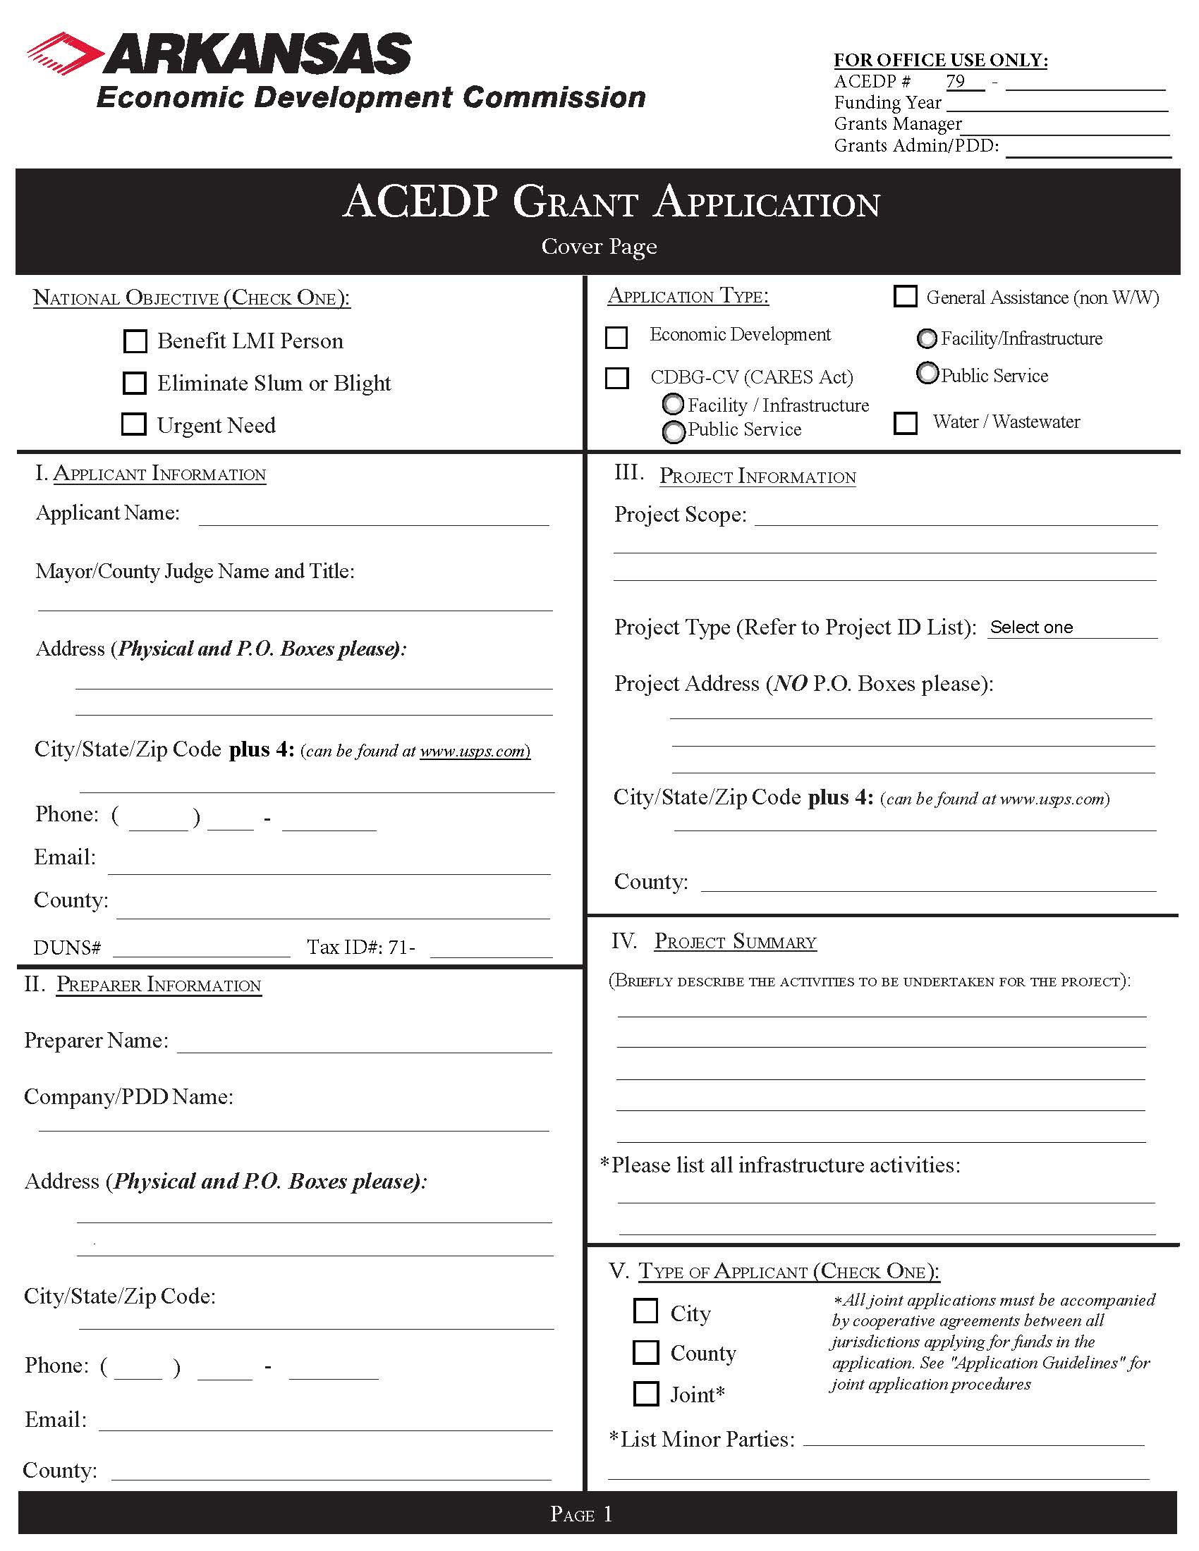

See Part I, General Information
.pdf form online and insert here

See Part I, General Information
.pdf form online and insert here

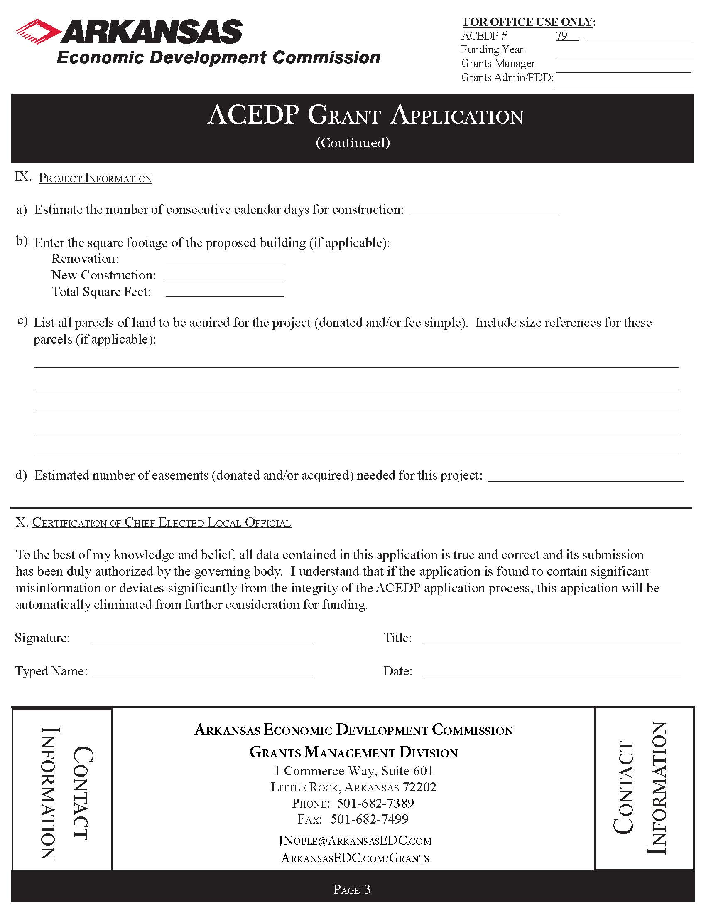

See Part I, General Information
.pdf form online and insert here
Part II. Project Budget
Applicant:
Funding Year: | Grant Year: | ACEDP Grant Control # :

Description |  | IDIS # |  | Other Funding Sources
Cost Classifications |  |  | CDBG | Local Cash |  |  | Total
Acquisition (attach itemized list) |  |  |  |  |  |  | $ 0.00
Land |  |  |  |  |  |  | $ 0.00
Abstractor |  |  |  |  |  |  | $ 0.00
Appraiser |  |  |  |  |  |  | $ 0.00
Legal |  |  |  |  |  |  | $ 0.00
Survey |  |  |  |  |  |  | $ 0.00
Architectural/Engineering: Basic Fee |  |  |  |  |  |  | $ 0.00
Inspection |  |  |  |  |  |  | $ 0.00
Additional Services (attach list) |  |  |  |  |  |  | $ 0.00
Construction |  |  |  |  |  |  | $ 0.00
Contingency (maximum of 5%) |  |  |  |  |  |  | $ 0.00
Equipment |  |  |  |  |  |  | $ 0.00
LMI Hookups |  |  |  |  |  |  | $ 0.00
M & O |  |  |  |  |  |  | $ 0.00
Other |  |  |  |  |  |  | $ 0.00
Fees |  |  |  |  |  |  | $ 0.00
Permits |  |  |  |  |  |  | $ 0.00
Testing |  |  |  |  |  |  | $ 0.00
Other (specify__________________________) |  |  |  |  |  |  | $ 0.00
 |  |  |  |  |  |  | $ 0.00
 |  |  |  |  |  |  | $ 0.00
 |  |  |  |  |  |  | $ 0.00
Subtotal (A) |  |  | 0.00 | 0.00 | 0.00 | 0.00 | $ 0.00
Description |  | IDIS # |  | Other Funding Sources
 |  |  | CDBG |  |  |  | Total
Admin-Contract |  |  |  |  |  |  | $ 0.00
Admin-General |  |  |  |  |  |  | $ 0.00
Admin-Audit |  |  |  |  |  |  | $ 0.00
Subtotal (B) |  |  | $0.00 | $0.00 | $0.00 | $0.00 | $ 0.00

Grand Total (A + B) | $0.00 | $0.00 | $0.00 | $0.00 | $ 0.00

Part II INSTRUCTIONS
FOR COMPLETING THE PROPOSED BUDGET

FOR ACEDP PROJECTS

Although some costs may not be definite at the time of budget preparation, it is important that the Proposed ACEDP Application Budget contains comprehensive, up-to-date cost estimates. These estimates can then be used to negotiate final budget amounts.

Project Information

Enter the name of the City or County as Applicant and the Control Number assigned to the project by the Commission.

Cost Classifications Guidance

If ACEDP funds are requested for professional design services, the following fee scales must be utilized:
• Engineering costs must be in accordance with the RD engineering service fee schedule.
• Architectural costs must be in accordance with the State Building Services fee schedule.
If needed, these scales can be requested from the Commission at 682-1211.

Detailed explanation and justification, including calculation of cost, must be provided for any additional engineering services requested. Usually, no additional services will be approved.

Local cash contributions to the project must be the first construction dollars spent and will be incorporated as a requirement in any grant agreement executed by the applicant and the Commission.

Any funds requested for "Other" must include a discussion of the requested service, including justification and cost calculations.

All acquisition costs must be accompanied by a brief discussion of each service to be provided and justification of the necessity of the services, including cost estimates. Each acquisition cost must indicate the unit rate and estimated number of units.

No ACEDP funds shall be used for Legal Services except for condemnation.

Do not include administrative costs on this budget estimate. These costs will be calculated by the Commission and added to the grant budget.

PART III. Project Description
Please provide a project summary which describes the nature of the assisted business, and explains the project and what the CDBG Economic Development funds will be used for. Please address project viability, the financing commitments which have been achieved and the basic readiness to implement the project.

PART IV. Benchmarks

Benchmarks. Provide a proposed date for each measurable benchmark in order to outline a schedule for the project. If benchmarks are not met, AEDC may invoke the right to terminate the CDBG contract. The following list is not exhaustive; please add benchmarks applicable to the project on a separate sheet of paper if needed.
Benchmark | Completion Date
Application Submitted
Grant Signed
Environmental Review Complete
Receive Release of Funds approval
Acquisition Complete
Plans/Specifications Submitted
Obtain permits and approvals
Advertisement for Bids
Bid Opening
Contract Awarded
Construction Complete
Jobs Created

PART V. Exhibits and Attachments

The Exhibits package contains specific information on the Exhibits that are required for the project as well as any necessary Attachments that must also be provided in order for the applicant to submit a complete application.

The list of required exhibits is identified below as well as provided within the Table of Contents Checklist. All Exhibit information and templates will be found in the Exhibits package.

The following Exhibits include the certification and documentation requirements for all ACEDP Applications, although, as seen in the Table of Contents, not all are applicable to an Economic Development Application.

- Exhibit A: Notice of Public Hearing (including Proof of Publication or Certificate of Posting, attendance roster, and summary of citizen's comments)
- Exhibit B: Authorizing Resolution (Original or Certified copy)
- Exhibit C: Statement of Assurances and Certifications
- Exhibit D: Citizen Participation Plan
- Exhibit E: Residential Anti-displacement and Relocation Assistance Plan
- Exhibit F-1: LMI Census Worksheet (only for LMI area benefit)
- Exhibit F-2: LMI Random Sample Worksheet (only for LMI area benefit)
- Exhibit G: LMC Worksheet (Limited Clientele)
- Exhibit H-1: Slum and Blight Area Basis Documentation (for SBA projects)
- Exhibit H-2: Slum and Blight Spot Basis Documentation (for SBA projects)
- Exhibit I: Urgent Need Certification (for Urgent Need projects)
- Exhibit J: FFATA Federal Funding Accountability and Transparency Act
- Exhibit K: Map of Proposed Project Area
- Exhibit L: Systems for Award Management (SAM) record and clearance documentation
- Exhibit M-1: Four Factor Analysis Assessing Limited English Proficiency
- Exhibit M-2: Language Assistance Plan (optional at the time of application)

The following attachments are required (where applicable) for Economic Development Applications. These items may be collected by and provided to the Applicant by AEDC.
- Attachment 1: Commitment Letter/MOU
- Attachment 2: Grant/Loan Application & Certifications
Any additional attachments that are provided within the application should be appropriately labeled and noted as the information provided within the Table of Contents Checklist.

