CR-05 - Goals and Outcomes
Progress the jurisdiction has made in carrying out its strategic plan and its action plan. 91.520(a)
This could be an overview that includes major initiatives and highlights that were proposed and executed throughout the program year.

The Consolidated Annual Performance and Evaluation Report (CAPER) provides data on the amount and use of housing and community development funds received from the U. S. Department of Housing and Urban Development (HUD) by the State of Arkansas during the program year, July 1, 2022, through June 30, 2023. The investment of housing and community development resources administered by the State of Arkansas is guided by the Five-Year Consolidated Plan published on June 4, 2020. The state develops and publishes an Annual Update to the Consolidated Plan for directing its federally funded housing and community development programs during the upcoming year, and each year the state publishes the CAPER for the preceding program year. The State’s Consolidated Plan Committee oversees the long range and annual planning process. The Consolidated Plan Agency Board consists of representatives of the Arkansas Economic Development Commission (AEDC), the Arkansas Development Finance Authority (ADFA), the Arkansas Department of Health (ADH), and Arkansas Department of Human Services (DHS).
For progress made by CDBG, see the narrative sections below Table 1.
Note: Shelter Homeless (homelessness prevention), reflects the total homeless person assisted in day and overnight shelters.

Comparison of the proposed versus actual outcomes for each outcome measure submitted with the consolidated plan and explain, if applicable, why progress was not made toward meeting goals and objectives. 91.520(g)
Categories, priority levels, funding sources and amounts, outcomes/objectives, goal outcome indicators, units of measure, targets, actual outcomes/outputs, and percentage completed for each of the grantee’s program year goals.

Goal | Category | Source / Amount | Indicator | Unit of Measure | Expected – Strategic Plan | Actual – Strategic Plan | Percent Complete | Expected – Program Year | Actual – Program Year | Percent Complete
Admin | Administration | CDBG: $ / HOPWA: $ / HOME: $ / ESG: $ / HTF: $ | Other | Other | 5 | 3 | 60.00% | 1 | 1 | 100.00%
CHDO | Affordable Housing | HOME: $ | Homeowner Housing Added | Household Housing Unit | 100 | 26 | 26.00% | 20 | 4 | 20.00%
Eco Dev | Non-Housing Community Development | CDBG: $ | Jobs created/retained | Jobs | 1250 | 176 | 14.08% | 250 | 0 | 0.00%
Fac/ Infra | Non-Housing Community Development | CDBG: $ | Public Facility or Infrastructure Activities other than Low/Moderate Income Housing Benefit | Persons Assisted | 40000 | 7974 | 19.94% | 7000 | 0 | 0.00%
Fire Prot | Non-Housing Community Development | CDBG: $ | Public Facility or Infrastructure Activities other than Low/Moderate Income Housing Benefit | Persons Assisted | 15000 | 9187 | 61.25% | 3000 | 0 | 0.00%
HOPWA Hsg Asst | Non-Homeless Special Needs | HOPWA: $ | Tenant-based rental assistance / Rapid Rehousing | Households Assisted | 1000 | 681 | 68.10% | 200 | 242 | 121.00%
HOPWA Sup Svs | Non-Homeless Special Needs | HOPWA: $ | Public service activities other than Low/Moderate Income Housing Benefit | Persons Assisted | 750 | 697 | 92.93% | 150 | 203 | 135.33%
Perm Hsg | Homeless | HTF: $ | Rental units constructed | Household Housing Unit | 110 | 41 | 37.27% | 22 | 9 | 40.91%
Perm Hsg | Homeless | HTF: $ | Other | Other | 0 | 0
Prev | Homeless | ESG: $ | Tenant-based rental assistance / Rapid Rehousing | Households Assisted | 2000 | 786 | 39.30%
Prev | Homeless | ESG: $ | Homeless Person Overnight Shelter | Persons Assisted | 0 | 0 |  | 0 | 0
Prev | Homeless | ESG: $ | Homelessness Prevention | Persons Assisted | 4000 | 1389 | 34.73% | 800 | 415 | 51.88%
Purc Asst | Affordable Housing | HOME: $ | Homeowner Housing Added | Household Housing Unit | 0 | 0 |  | 0 | 0
Purc Asst | Affordable Housing | HOME: $ | Direct Financial Assistance to Homebuyers | Households Assisted | 1250 | 852 | 68.16% | 250 | 34 | 13.60%
Rent Hsg | Affordable Housing | HOME: $ | Rental units constructed | Household Housing Unit | 125 | 144 | 115.20%
Rent Hsg | Affordable Housing | HOME: $ | Rental units rehabilitated | Household Housing Unit |  |  |  | 25 | 23 | 92.00%
Rent Rehab | Affordable Housing | HOME: $ | Rental units rehabilitated | Household Housing Unit | 125 | 130 | 104.00% | 25 | 0 | 0.00%
Shel | Homeless | ESG: $ | Homeless Person Overnight Shelter | Persons Assisted | 0 | 0 |  | 0 | 0
Shel | Homeless | ESG: $ | Homelessness Prevention | Persons Assisted | 25000 | 27118 | 108.47% | 5000 | 4000 | 80.00%
TBRA | Affordable Housing | HOME: $ | Tenant-based rental assistance / Rapid Rehousing | Households Assisted | 375 | 367 | 97.87% | 75 | 33 | 44.00%
Table 1 - Accomplishments – Program Year & Strategic Plan to Date

Assess how the jurisdiction’s use of funds, particularly CDBG, addresses the priorities and specific objectives identified in the plan, giving special attention to the highest priority activities identified.
The Strategic Plan for 2020 laid out the direction the state intended to take in the distribution of CDBG, HOME, ESG, HOPWA, and HTF funding for five years. The priorities listed were determined through consultation with service providers and consideration of a community survey that was conducted in the development of the Consolidated Plan. Some of the activities included will be targeted to individual households who qualify for the programs according to their income status (individual benefit). Other programs are directed toward particular areas within Arkansas where the median incomes of the census tracts involved are below 80 percent of the area median income (area benefit).
It should be noted that many of the CDBG projects funded with 2020-2022 program funds are still ongoing, and actual accomplishment may not yet be realized. Typically, the State documents accomplishment for CDBG activities when the projects are completed.
The State's progress towards addressing the priorities and specific objectives identified in the plan, giving special attention to the highest priority activities identified, is detailed throughout this document, and below, specifically as it relates to CDBG:
Economic Development (Eco Dev)
In Program Year 2022 the State of Arkansas will identify and fund projects which lead to employment opportunities for the citizens of Arkansas. The state will provide approximately $8,300,000 in 2022 to cities and counties to fund eligible economic development activities, primarily grants, for the improvement of public infrastructure related to the location or expansion of industry in the state, and to capitalize loans that benefit businesses and industries that are locating or expanding in Arkansas. These grants will provide job opportunities to an estimated 250 persons. At least 51% of all new jobs created or retained by these projects will be held by or made available to persons with household incomes below 80% of the area median income.Actual Accomplishments (Eco Dev)As of June 30, 2023, the state had awarded one economic development projects for a total of $312,700. This project will improve economic opportunities for approximately 50 Arkansans through the improved access to job opportunities. Approximately 51% of the new jobs created by these projects will be made available to persons of low- to moderate-income.
Grantee | Project Type | Project Status | Grant Total | Jobs Created (Plan)
City of Monticello | $312,700 | Grant Signed | $312,700 | 50
Table 1 - CDBG Program Year 2022 Actual Accomplishments (Economic Development)
Public and Community Facilities, and Infrastructure (Fac / Infra)
Within the Public and Community Facilities, and Infrastructure Priority Need, CDBG funds will be utilized for public infrastructure and public facility projects. Within this Program, CDBG funds will be utilized for and will generally be made available under the LMI Area Benefit or LMI Limited Clientele or Presumed Benefit National Objective measures. Funds are awarded for: residential water and wastewater; senior centers; child care centers; public health facilities; youth centers; accredited public libraries; removal of architectural barriers from city halls or county courthouses for accessibility; street, curb, gutter, sidewalk, or storm sewer; flood control and drainage; and, other public facility or infrastructure project determined to be a high priority, and not eligible to be funded under another CDBG program.Actual Accomplishments (Fac / Infra)As of June 30, 2023, the state had awarded three public facility projects, and 12 public facility projects from Program Year 2022 funds, for a total of $7,318,056. These projects will provide enhancement to public facilities and infrastructure by improving availability, accessibility and affordability of public facilities, and public infrastructure, benefitting approximately 19,467 Arkansans. Approximately 75% of the persons benefitting from these improvements will be of low- to moderate-income.
Grantee Name | Project Type | Grant Total | Persons Served (Plan)
Izard County | Disabled Persons Center | $532,960 | 30
City of Ozark | Food Pantry | $531,590 | 3,623
City of Greenwood | Senior Center | $534,750 | 2,138
Desha County | Wastewater | $532,100 | 11,538
Howard County | Water | $533,591 | 964
City of Mineral Springs | Water | $530,792 | 373
City of Luxora | Water | $526,888 | 942
City of Waldo | Water | $530,598 | 1,372
City of Amity | Water | $535,085 | 753
City of Decatur | Water | $1,036,910 | 103
City of Hardy | Water | $287,210 | 743
City of Bradford | Water | $151,544 | 653
Town of Emerson | Water | $530,300 | 320
City of Hackett | Water | $524,420 | 958
City of DeQueen | Water | $531,418 | 6,495
Table 1 - CDBG Program Year 2022 Actual Accomplishments (Fac / Infra)

CR-10 - Racial and Ethnic composition of families assisted
Describe the families assisted (including the racial and ethnic status of families assisted). 91.520(a)

 | CDBG | HOME | HOPWA | ESG | HTF
White | 17,434 | 57 | 230 | 0 | 5
Black or African American | 7,862 | 31 | 142 | 0 | 4
Asian | 219 | 1 | 0 | 0 | 0
American Indian or American Native | 232 | 3 | 3 | 0 | 0
Native Hawaiian or Other Pacific Islander | 3 | 1 | 1 | 0 | 0

Total | 25,750 | 93 | 376 | 0 | 9

Hispanic | 3,964 | 4 | 36 | 0 | 0
Not Hispanic | 21,786 | 90 | 340 | 0 | 9
Table 2 – Table of assistance to racial and ethnic populations by source of funds

Narrative
Planned accomplishment data is included for CDBG. Projects funded with 2022 Program Year funds are still ongoing and have not resulted in actual benefit at the time of this report.
Additional HOME data is included in the Table of Assistance to Racial and Ethnic Status.
See Attachment section.

CR-15 - Resources and Investments 91.520(a)
Identify the resources made available
Source of Funds | Source | Resources Made Available | Amount Expended During Program Year
CDBG | public - federal | 20,438,878 | 94,713
HOME | public - federal | 17,471,086 | 5,982,146
HOPWA | public - federal | 2,482,635 | 1,083,423
ESG | public - federal | 4,229,722
HTF | public - federal | 4,573,938 | 2,007,741
Table 3 - Resources Made Available

Narrative
Community Development Block Grant (CDBG) program funding levels were consistent with anticipated amounts. The Arkansas Economic Development Commission (AEDC) received $18,438,878 as its 2022 CDBG allocation. Program income receipted in SF was $484,256.81, which includes economic development loan repayments and grant reimbursements. CDBG funds expended from Program Year 2022 is $96,712.85.
CDBG-CV resources made available are included below:
CDBG-CV1: $10,814,424
CDBG-CV2: $8,210,252
CDBG-CV3: $7,363,278
Total CDBG-CV Allocation: $26,387,954
Arkansas Development Finance Authority (ADFA) - HOME Investment Partnerships Program (HOME) received $11,478,294 as its 2022 HOME allocation. Program income receipted in Fiscal Year 2023 (7/1/22 through 6/30/23) was $5,992,792 from HOME funded activities, which includes Recaptured Homebuyer Funds. HOME funds expended during fiscal year 2023 were $5,982,146.04. This amount includes program income and funds committed and expended from prior year allocations.
ADFA - National Housing Trust Fund (HTF) was awarded $4,573,938 for its 2022 HTF award, for the construction of rental housing for Arkansas’s extremely low-income households, with a preference to serve veterans. For Fiscal Year 2023 (7/1/22 through 6/30/23) ADFA has drawn down $2,007,740.65 in HTF funds, and $182,761.65 in administrative HTF costs from IDIS. Two projects were funded in FY 2023, which will benefit of 15 Units upon completion. One HTF project was completed in FY 2023, for an additional 9 housing units.
Emergency Solutions Grants (ESG) funding levels were consistent with anticipated amounts. ESG amount expended is an estimate on funds that have been drawn down as of June 2021.
ESG-CV resources made available are included below:
ESG-CV1: $
ESG-CV2: $
Total ESG-CV Allocation: $
Housing Opportunities for Persons with AIDS (HOPWA) funding levels were consistent with anticipated amounts. Note: Under Resources Made Available: This amount includes unexpended funds from prior FY HUD allocations in addition to FY 2022 HUD allocation for HOPWA.
Resources made available as unexpended funds from prior Program years:
ARH20F999- from HOPWA FY 20: $194,203
ARH21F999- from HOPWA FY 21: $1,030,952
ARH22F999-HOPWA FY22: $1,257,480

Identify the geographic distribution and location of investments
Target Area | Planned Percentage of Allocation | Actual Percentage of Allocation | Narrative Description
CDBG Eligible Areas | 17 |  | Low-Income Areas for Area Benefit
Statewide | 83 | 100 | Areas for Individual Benefit and Administration
Table 4 – Identify the geographic distribution and location of investments

Narrative
Projects created in response to the five federal funding programs, CDBG, HOME, HOPWA, ESG and HTF, are spread across non-entitlement communities throughout the state. The vast majority of the combined funding is provided through individual benefit criteria, available to low-income individuals/households regardless of the demographics of the community in which they reside. A smaller portion, primarily funded through the CDBG Program, addresses infrastructure and public facility concerns within CDBG eligible areas where more than 51 percent of residents earn less than 80 percent of the area median income. For CDBG, 50 percent of CDBG funding will be used in CDBG area benefit eligible areas.
Investments are allocated according to responses to programmatic opportunities and client response to funding availability. Rehab programs may be targeted to the CDBG Eligible Areas or as individual benefit to low-income households. Public services, likewise, may be offered in low-income areas or generally to all qualified residents. Public facilities and infrastructure projects are restricted to CDBG Eligible Areas only.
The proposed allocation of funds was based on federal funding requirements for each formula-allocated grant. Areas of low- to moderate-income concentration and certain areas of high minority concentration are targeted. Areas of low homeownership and deteriorating housing conditions were also considered in the targeting process.
The distribution of funds by target area is projected to be primarily Statewide due to use of funds for administrative, non-profit support, and individual benefit-oriented programmatic uses of the funds. The remaining funds are estimated to be spread through smaller CDBG-eligible areas.
Higher ratings were given to counties with racial and low-income concentrations; and housing resource agencies were encouraged to develop more affordable housing resources in counties with proportionately less subsidized rental housing.
Leveraging
Explain how federal funds leveraged additional resources (private, state and local funds), including a description of how matching requirements were satisfied, as well as how any publicly owned land or property located within the jurisdiction that were used to address the needs identified in the plan.
Add CDBG leveraging report
Match liability report attached - As OFF 8/26/2023 - HOME Match Requirement is $418,436.27.
See Attachments for Match Report - Additionally, ADFA has a Carry Forward of Bond Match totalling $59,088,479.10, this bonds Match balance will usually be carry-forwarded, and not applied to Match Requirement unless needed.
A cummulative MATCH correction as been made to ADFA's 2023 MATCH Report.

Fiscal Year Summary – HOME Match
1. Excess match from prior Federal fiscal year | 4,776,683
2. Match contributed during current Federal fiscal year | 286,831
3. Total match available for current Federal fiscal year (Line 1 plus Line 2) | 5,063,514
4. Match liability for current Federal fiscal year | 418,436
5. Excess match carried over to next Federal fiscal year (Line 3 minus Line 4) | 4,645,078
Table 5 – Fiscal Year Summary - HOME Match Report

Match Contribution for the Federal Fiscal Year
Project No. or Other ID | Date of Contribution | Cash  (non-Federal sources) | Foregone Taxes, Fees, Charges | Appraised Land/Real Property | Required Infrastructure | Site Preparation, Construction Materials, Donated labor | Bond Financing | Total Match
10FINAL TOTAL ALL BOND MATCH CARRY FORWARD | 0 | 0 | 0 | 0 | 0 | 0 | 0 | 59,088,479
1V6698603 - A14608 | 12/01/2022 | 0 | 0 | 0 | 0 | 15,070 | 0 | 15,070
2V6743034 - A14647 | 03/23/2023 | 0 | 0 | 0 | 0 | 16,103 | 0 | 16,103
3V6758039 - A13872 | 04/20/2023 | 0 | 56,250 | 0 | 0 | 0 | 0 | 56,250
4V6773495 - A14498 | 05/31/2023 | 0 | 23,158 | 60,000 | 0 | 0 | 0 | 83,158
5V6790623 - A14402 | 07/17/2023 | 0 | 0 | 0 | 0 | 56,250 | 0 | 56,250
6space - ADFA WILL NOT APPLY BOND MATCH | 0 | 0 | 0 | 0 | 0 | 0 | 0 | 0
7space - UNLESS NEEDED - WE WILL CARRY FORWARD | 0 | 0 | 0 | 0 | 0 | 0 | 0 | 0
8BONDS ISSUED 2023 - MATCH | 0 | 0 | 0 | 0 | 0 | 0 | 0 | 7,000,000
9PREVIOUS BOND MATCH CARRY FORWARD | 0 | 0 | 0 | 0 | 0 | 0 | 0 | 52,088,479
Table 6 – Match Contribution for the Federal Fiscal Year

HOME MBE/WBE report
Program Income – Enter the program amounts for the reporting period
Balance on hand at begin-ning of reporting period  $ | Amount received during reporting period  $ | Total amount expended during reporting period  $ | Amount expended for TBRA  $ | Balance on hand at end of reporting period  $
5,643,966 | 5,992,792 | 2,304,261 | 151,920 | 9,332,497
Table 7 – Program Income

Minority Business Enterprises and Women Business Enterprises – Indicate the number and dollar value of contracts for HOME projects completed during the reporting period

 | Total | Minority Business Enterprises |  |  |  | White Non-Hispanic
 | Total | Alaskan Native or American Indian | Asian or Pacific Islander | Black Non-Hispanic | Hispanic | White Non-Hispanic

Contracts
Dollar Amount | 27,651,186 | 0 | 0 | 0 | 0 | 27,651,186
Number | 15 | 0 | 0 | 0 | 0 | 15

Sub-Contracts
Number | 15 | 0 | 0 | 4 | 4 | 7
Dollar Amount | 7,940,967 | 0 | 0 | 566,092 | 3,404,392 | 3,970,483

 | Total | Women Business Enterprises | Male

Contracts
Dollar Amount | 27,651,186 | 0 | 27,651,186
Number | 15 | 0 | 15

Sub-Contracts
Number | 15 | 0 | 15
Dollar Amount | 7,940,967 | 0 | 7,940,967
Table 8 - Minority Business and Women Business Enterprises

Minority Owners of Rental Property – Indicate the number of HOME assisted rental property owners and the total amount of HOME funds in these rental properties assisted

 | Total | Minority Property Owners |  |  |  | White Non-Hispanic
 | Total | Alaskan Native or American Indian | Asian or Pacific Islander | Black Non-Hispanic | Hispanic | White Non-Hispanic
Number | 0 | 0 | 0 | 0 | 0 | 0
Dollar Amount | 0 | 0 | 0 | 0 | 0 | 0
Table 9 – Minority Owners of Rental Property

Relocation and Real Property Acquisition – Indicate the number of persons displaced, the cost of relocation payments, the number of parcels acquired, and the cost of acquisition

Parcels Acquired | 0 | 0
Businesses Displaced | 0 | 0
Nonprofit Organizations Displaced | 0 | 0
Households Temporarily Relocated, not Displaced | 0 | 0

Households Displaced | Total | Minority Property Enterprises |  |  |  | White Non-Hispanic
Households Displaced | Total | Alaskan Native or American Indian | Asian or Pacific Islander | Black Non-Hispanic | Hispanic | White Non-Hispanic
Number | 0 | 0 | 0 | 0 | 0 | 0
Cost | 0 | 0 | 0 | 0 | 0 | 0
Table 10 – Relocation and Real Property Acquisition

CR-20 - Affordable Housing 91.520(b)
Evaluation of the jurisdiction's progress in providing affordable housing, including the number and types of families served, the number of extremely low-income, low-income, moderate-income, and middle-income persons served.

 | One-Year Goal | Actual
Number of Homeless households to be provided affordable housing units | 22 | 9
Number of Non-Homeless households to be provided affordable housing units | 395 | 74
Number of Special-Needs households to be provided affordable housing units | 0 | 20
Total | 417 | 103
Table 11 – Number of Households

 | One-Year Goal | Actual
Number of households supported through Rental Assistance | 75 | 33
Number of households supported through The Production of New Units | 67 | 36
Number of households supported through Rehab of Existing Units | 25 | 0
Number of households supported through Acquisition of Existing Units | 250 | 34
Total | 417 | 103
Table 12 – Number of Households Supported

Discuss the difference between goals and outcomes and problems encountered in meeting these goals.
The outcomes reported above are based on activities that were completed in the HUD Integrated Disbursement and Information System (IDIS) during this reporting period. The one-year goals set for HOME funded programs are based on available resources and funding commitments. A reduction in actual outcome was due to providing technical support to new recipients, changes within their organizations, funded projects with normal and COVID-related delays in construction and/or a reduction in funding priorities during the reporting period. ADFA is working diligently with sub-recipients to make sure these projects move forward.
Discuss how these outcomes will impact future annual action plans.
Future annual action plans will continue to consider funding priorities based on housing needs. The state will continue monitoring the progress of projects that have been funded but not closed, as well as projects that are underway but delayed due to various plausible reasons. The state will continue to monitor the housing needs in underserved areas as well as developer's subsidy and down payment and closing cost assistance. Additionally, the State will monitor lower interest rates to encourage homeownership for low- to moderate-income households.
Include the number of extremely low-income, low-income, and moderate-income persons served by each activity where information on income by family size is required to determine the eligibility of the activity.
Number of Households Served | CDBG Actual | HOME Actual | HTF Actual
Extremely Low-income | 0 | 26 | 9
Low-income | 0 | 28
Moderate-income | 0 | 30
Total | 0 | 84

Table 13 – Number of Households Served

Narrative Information
The above numbers are from the PR23 report in the HUD Integrated Disbursement and Information System (IDIS) during this reporting period.
See Attachments for reports.

CR-25 - Homeless and Other Special Needs 91.220(d, e); 91.320(d, e); 91.520(c)
Evaluate the jurisdiction’s progress in meeting its specific objectives for reducing and ending homelessness through:
Reaching out to homeless persons (especially unsheltered persons) and assessing their individual needs
DHS/DCO provided funding to eligible agencies throughout the state. The funds were used to establish relationships with unsheltered homeless people by providing food and water, basic hygienic items, and rain cloaks. Individual needs were assessed where these interactions occurred. This activity supported the state’s goal of moving unsheltered homeless into safer nighttime sleeping place by increasing levels of trust between unsheltered homeless, who often have mental health issues, and local agencies who are able to assist with housing needs.
Addressing the emergency shelter and transitional housing needs of homeless persons
DHS/DCO provided funding to eligible agencies throughout the state. The funds were used to address the operational needs of facilities that provide emergency shelter to literally homeless individuals, families, women with children, and to those fleeing domestic violence or other unsafe situations. In addition to safe nighttime places to sleep, the sub-grant recipients also provided essential services such as budgeting, basic life skills, and assistance with connecting the program participants to sources of income.
Helping low-income individuals and families avoid becoming homeless, especially extremely low-income individuals and families and those who are: likely to become homeless after being discharged from publicly funded institutions and systems of care (such as health care facilities, mental health facilities, foster care and other youth facilities, and corrections programs and institutions); and, receiving assistance from public or private agencies that address housing, health, social services, employment, education, or youth needs
DHS/DCO provided funding to eligible agencies throughout the state. The funds were used to prevent low-income persons and families from becoming homeless by providing financial assistance with rent payments to those about to be evicted from their FMR- and rent reasonableness-compliant residences. These funds also assisted in transitioning participants from correctional institutions into suitable housing. These activities supported the State’s goal of eliminating homelessness by preventing individuals and families at risk of homelessness from becoming actually homeless.
Helping homeless persons (especially chronically homeless individuals and families, families with children, veterans and their families, and unaccompanied youth) make the transition to permanent housing and independent living, including shortening the period of time that individuals and families experience homelessness, facilitating access for homeless individuals and families to affordable housing units, and preventing individuals and families who were recently homeless from becoming homeless again
DHS/DCO provided funding to eligible agencies throughout the state. The funds were used to assist homeless persons and families, and those fleeing domestic violence or other unsafe living situations, with obtaining safe, affordable FMR- and rent reasonableness-compliant residences. These funds were primarily used to assist participants who were transitioning from emergency shelters and had already received supportive services such as job training, budgeting skills training, and/or assistance with connecting to mainstream assistance programs. These activities supported the State’s goal of eliminating homelessness by moving participants from temporary housing in shelters to permanent housing.

CR-30 - Public Housing 91.220(h); 91.320(j)
Actions taken to address the needs of public housing
ADFA continues to fund Tenant-Based Rental Assistance (TBRA) to public housing authorities to supplement their Section 8 vouchers and to agencies in communities that lack rental assistance to address the housing cost burden.
Actions taken to encourage public housing residents to become more involved in management and participate in homeownership
ADFA does not manage public housing authorities (PHA) units.
Actions taken to provide assistance to troubled PHAs
ADFA does not manage public housing authorities (PHA) units.

CR-35 - Other Actions 91.220(j)-(k); 91.320(i)-(j)
Actions taken to remove or ameliorate the negative effects of public policies that serve as barriers to affordable housing such as land use controls, tax policies affecting land, zoning ordinances, building codes, fees and charges, growth limitations, and policies affecting the return on residential investment. 91.220 (j); 91.320 (i)
There are no known public policy barriers to affordable housing development in Arkansas, though market factors do influence the ability to produce a range of housing to address all income levels. Most of these factors, including the cost of construction, price of developable land, and tenant/homebuyer incomes, are beyond the influence of the State of Arkansas. Where possible, the state provides or funds services that address market factors, such as job training and business development activities.
Actions taken to address obstacles to meeting underserved needs. 91.220(k); 91.320(j)
The state will continue to look for new funding sources for programs to address underserved needs. Funding is the major obstacle in providing the services needed to focus on the vast variety of issues that prevent families from breaking out of poverty and from living in the best, most affordable housing possible.
Actions taken to reduce lead-based paint hazards. 91.220(k); 91.320(j)
ADFA requires dwelling units built prior to 1978 comply with the rehabilitation requirements of the Lead Safe Housing Rule (24 CFR Part 35, Subpart J).
The requirements of the Lead Safe Housing Rule depend on the level of assistance provided to the unit. The summary below provides a brief overview of the regulations.
For units with a level of assistance less than $5,000, paint testing must be conducted on all painted surfaces to be disturbed or replaced during the renovation, or it must be presumed that all these painted surfaces are coated with lead-based paint. Safe work practices must be employed during the rehabilitation work, and upon completion, a clearance examination of the worksite is required. Clearance of the worksite is required prior to the unit being reoccupied.
For units with a level of assistance over $5,000 and up to $25,000, lead hazards must be identified by a risk assessment (or presumed to be present) and then addressed through interim controls or standard treatments. Proper safe work practices, trained staff, and unit clearance are also required.
For units with a level of assistance over $25,000, lead hazards must be identified through a risk assessment (or presumed to be present) and addressed through abatement by a certified abatement contractor. Clearance is required.
All homeowners must receive the lead-based based pamphlet, Protect Your Family From Lead in Your Home as well as other relevant information pertaining to the rehabilitation work. The Recipients must have documented evidence that this notice was provided.
Actions taken to reduce the number of poverty-level families. 91.220(k); 91.320(j)
The state continues its efforts in conjunction with the five (5) Continua of Care in Arkansas to reduce the number of poverty-level families through the development of services needed to assist those families with educational opportunities, job growth, and life skills training through the various social service agencies operating in the communities across the state.
Actions taken to develop institutional structure. 91.220(k); 91.320(j)
- Worked with non-profit organizations to address community needs and provide support to federal and non-federal funding initiatives.
- Worked with private industry to address important issues that hamper housing and community development efforts.
- Identified opportunities to create private/public partnerships for project finance and development to leverage federal funds.
Actions taken to enhance coordination between public and private housing and social service agencies. 91.220(k); 91.320(j)
The state continues to coordinate planning activities with subgrantees and private housing and social service agencies, including participation in the Balance of State Continuum of Care meetings, development of the Continuum of Care, and coordinate the enumeration of point-in-time and homeless surveys by continua throughout the state. State staff will continue its participation in other coalitions and study groups as the opportunity arises.
Identify actions taken to overcome the effects of any impediments identified in the jurisdictions analysis of impediments to fair housing choice. 91.520(a)
Effective January 1, 2012, applicants applying for HOME, HTF, or NSP program funds as well as Tax Credits must successfully complete the Fair Housing Training Course prior to receiving funding. Applicants will be required to have the following members of the development team successfully complete the course: Owners, Developers, Sponsors of the Project, Consultants, Management Company, Architects, Community Housing Development Organization (CHDO), Subrecipients
Act 944 of Arkansas, closes the loophole used by out-of-state predatory lenders. Amendment 89 to the Arkansas Constitution, passed by voters in 2010, set the interest rate cap for consumer loans at 17 percent APR. Arkansas is one of 17 states, plus DC and the US Military, with interest rate caps that prevent high-cost payday lending.
In the 2020-2024 Analysis to Impediments to Fair Housing Choice, Arkansas lists as #10, Increase Outreach to Developers, Real Estate Professionals, Landlords, and Citizens on Fair Housing rights. As one CDBG grant requirement, grantees must undertake at least one activity to affirmatively further fair housing. Fair housing characterizes the ability of persons, regardless of race, color, religion, sex, age, handicap, familial status or national origin, of similar income levels, to have available to them the same housing and employment choices. Activities undertaken by CDBG subrecipients in 2022 included, or may include:
- Sending letters to those in the business of selling or renting housing and in the business of financing housing, encouraging them to adhere fully to the Federal Fair Housing Law
- Publicly endorsing the principles of fair housing and adherence to the Federal Fair Housing Law, in the form of a proclamation, resolution, advertisement or similar publicized statement of support from the Grantee’s chief executive officer
- Improving community facilities and public services in racially integrated neighborhoods to help preserve their mixed character
- Initiating a public education program on fair housing, involving, for example, representatives of fair housing organizations, human relations groups, minority organizations, the real estate industry, government, and local media
- Developing a public awareness campaign for Fair Housing during April (Fair Housing Month)
In the 2020-2024 Analysis to Impediments to Fair Housing Choice, Arkansas lists as #11, Continue Economic Development, Job Creation, Small Business Entrepreneurial Opportunities and Jobs paying “living wages”. As of June 30, 2022, AEDC had awarded one economic development projects for a total of $312.700. This project will improve economic opportunities for approximately 50 Arkansans through the improved access to job opportunities. Approximately 51% of the new jobs created by these projects will be made available to persons of low- to moderate-income. The average hourly wage of the jobs created as a result of these investments will be $17.33.
CDBG Actions
CDBG subrecipient CDBG Certified Administrators receive training in the civil rights rules and regulations during training sessions. Training sessions are reinforced with updates through the AEDC Grants Division monthly newsletters and other outreach which is published on an as needed basis. Each subrecipient program eligibility criteria are reviewed to determine whether the criteria or methods of administration may have the effect of subjecting individuals to discrimination on the basis of race, color, age, sex, national origin or disability. Comparisons are made between recent census data regarding those protected classes and the percentages of those protected classes participating and receiving benefits from CDBG funds. All grantees are required to maintain, on an ongoing basis, and on file permanently, numerical and percentage documentation and information regarding the following: 1. Total beneficiaries in project 2. Total numbers of males/females. 3. Actual number of Whites, Blacks, Hispanics, Asians, Native Americans, and others. 4. Percentages of males, females, minorities, female heads of household, disabled population, and low to moderate income persons receiving benefits from the project funds. Program representatives are required to consider this information, compared with census data, and determine if there is any indication any person and/or group of persons were denied benefits or employment on the grounds of race, age, sex, or disability. The State's review of all information gathered through monitoring visits indicates that subrecipient CDBG programs are being administered in a manner, which does not deny any benefit or employment on the grounds of race, age, sex, national origin, and/or disability. All applicants applying for federal resources submit a Four Factor Analysis, assessing Limited English Proficiency of the anticipated beneficiaries of the project activity(ies), in addition to a Language Assistance Plan if determined as necessary by the four-factor analysis conducted as part of the application review process. AEDC Grants Division staff reviews these analyses and plans and provides recommendations to the grant applicants regarding any clarifications or missing information needed for compliance under Title VI of the Civil Rights Act of 1964. Applicants are encouraged to ask questions of AEDC staff and also resubmit their analyses and plans for final review.

CR-40 - Monitoring 91.220 and 91.230
Describe the standards and procedures used to monitor activities carried out in furtherance of the plan and used to ensure long-term compliance with requirements of the programs involved, including minority business outreach and the comprehensive planning requirements
To ensure that all statutory and regulatory requirements are being met for activities funded with HUD funds, the State agencies use various monitoring standards and procedures.
AEDC and ADFA is responsible for ensuring that grantees under the CDBG, HOME, and HTF. Programs carry out projects in accordance with both federal and State of Arkansas statutory and regulatory requirements. In most cases, these requirements are set forth in the grant agreement executed between the State and the Grantee. The State provides maximum feasible delegation of responsibility and authority to grantees and developers under these Programs. Whenever possible, deficiencies are rectified through constructive discussion, negotiation, and assistance.
AEDC and ADFA conduct two basic types of monitoring: off-site monitoring (also known as "desktop monitoring"), and on-site monitoring. AEDC Grants Division and ADFA Compliance staff regularly review each project to verify that it is proceeding in the manner set forth in the grant agreement and in accordance with applicable laws and regulations. It is AEDC policy that each project is monitored twice, on an Interim basis, and one Final monitoring. Each project will be monitored at least once, ADFA monitors through the period of affordability on all projects.
Desktop monitoring is an ongoing process in which the AEDC Grants Manager and ADFA Compliance Manager, are responsible for overseeing the grantee and developer projects, using all available information to review the grantee and developer performance in carrying out the approved project. This review process enables AEDC and ADFA to identify problems requiring immediate attention and to schedule projects for on-site monitoring, while ADFA performs on-site monitoring throughout the affordability period. Materials used for this review include but are not limited to: Grant Agreement Amendments; Project Status Reports, Requests for Payment of funds (RFPs); AEDC grant database review; and ADFA project database; and other supporting documents.
On-site monitoring is a structured review conducted by the Grants Manager and ADFA Compliance staff at the locations where project activities are being carried out, or where project records are being maintained. AEDC performs one on-site monitoring visit, normally conducted during the course of a project, unless determined otherwise; while ADFA performs onsite visits every three years. Additionally, an ADFA Construction Inspector reviews projects throughout the construction phase and for project completion of housing projects.
The monitoring review considers all available evidence of whether a project conformed to an approved Program; whether substantial progress toward program goals had been met; compliance with applicable laws and regulations; and continued capacity of the Grantee or Developer and Grant Administrator (AEDC and ADFA) to carry out the approved Program project.
Checklists are utilized to ensure that all issues are addressed. AEDC has CDBG and ADFA have specific checklists based on the types of activities within a given project. The number of times a project is monitored will depend upon the issues that may arise during the desktop or on-site monitoring.

Citizen Participation Plan 91.105(d); 91.115(d)
Describe the efforts to provide citizens with reasonable notice and an opportunity to comment on performance reports.
The Citizen Participation Plan (CPP) is the CPP established for the State of Arkansas’s Five-year Consolidated Plan, which covers the 2020 through 2024 Program Years.
Notification and Comment Period
In accordance with the state’s CPP, the state provided the public with advance notice of the availability of the draft version of the Consolidated Annual Performance and Evaluation Report (CAPER), how the document could be obtained, and the time frame during which it would be available
Notification
A legal advertisement was published on September 10, 2023, in teh Arkansas Democrat Gazette, the statewide newspaper of general circulation in Arknasas. The notice indicated when the document would be available and provided: a web address to download a copy of the report, a physical address where a hard copy of the report could be reviewed and a phone number and email address for requesting copies to be mailed or emailed. Per the state's CPP, additional avenues for public notification were also used to capitalize on new technology and expand the reach of the notification effort. The draft document was made available via download from the www.arkansasedc.com/grants website and via email from the Arkansas Economic Development Commission, lead agency for the development of the CAPER.
Timeframe for Review and Comment Period
The 15-day comment period for public review and comment ran September 11, 2023. The deadline for submitting written comments was close of business at the end of the 15-day period, or 4:30 p.m. on September 25, 2023.
Summary of Comments Received
There were no comments received.

CR-45 - CDBG 91.520(c)
Specify the nature of, and reasons for, any changes in the jurisdiction’s program objectives and indications of how the jurisdiction would change its programs as a result of its experiences.
In 2022, AEDC set aside $1,000,000 for Emergency/Unmet Need projects within the Public and Community Facilities, and Infrastructure Priority Need. These CDBG funds will be used to assist local units of government with situations that pose a serious and immediate threat to public health, safety, or welfare. Priority is given to those projects that are meeting the Urgent Need national objective criteria but could qualify under LMI Benefit Area or Limited Clientele.
Local units of government must submit a pre-application to the WWAC (if a water or wastewater project) or should otherwise consult with the AEDC Grants Division before submitting a full application. This set-aside was developed to give applications an opportunity to apply for emergency or urgent need projects any time during the year without having to wait until the deadline through another program.
This flexibility in application also allows applicants to better time their CDBG project with funding from other resources.
The objectives of the CDBG have generally remained the same as in previous years, during the 2020-2024 Consolidated Plan.
Does this Jurisdiction have any open Brownfields Economic Development Initiative (BEDI) grants?
No
[BEDI grantees] Describe accomplishments and program outcomes during the last year.

CR-50 - HOME 24 CFR 91.520(d)
Include the results of on-site inspections of affordable rental housing assisted under the program to determine compliance with housing codes and other applicable regulations
Please list those projects that should have been inspected on-site this program year based upon the schedule in 24 CFR §92.504(d). Indicate which of these were inspected and a summary of issues that were detected during the inspection. For those that were not inspected, please indicate the reason and how you will remedy the situation.
691 Inspections were performed for Fiscal Year 2023, for all HOME Rental Projects, including TBRA Unit Inspections.
See Attachments: CR-50 HOME Unit Inspections.
Provide an assessment of the jurisdiction's affirmative marketing actions for HOME units. 24 CFR 91.520(e) and 24 CFR 92.351(a)
To further the commitment to nondiscrimination and equal opportunity in housing, and in accordance with the regulations of the HOME Investment Partnerships Program (HOME), ADFA requires HOME subgrantees, Community Housing Development Organizations (CHDOs), and developers of HOME Program funds to comply with the affirmative marketing requirements. Applicants applying for HOME funds must submit an affirmative marketing plan upon application and adopt policies and procedures that inform the public, potential tenants, homebuyers, homeowners, and rental property owners of their program through an Affirmative Marketing Plan (AMP or Plan).
Refer to IDIS reports to describe the amount and use of program income for projects, including the number of projects and owner and tenant characteristics
Total program income receipted in FY 2023 was $5,992,792.16 which includes loan repayments of $5,822,832.64, recaptured homebuyer funds of $169,959.52 and no repayments to the HOME local account. (Ten percent of ordinary program income $582,283.26) was retained for administration which excludes recaptured homebuyer funds and repayments to the HOME local account. Program income was used for various projects as requests for drawdowns were submitted and processed.
Describe other actions taken to foster and maintain affordable housing. 24 CFR 91.220(k) (STATES ONLY: Including the coordination of LIHTC with the development of affordable housing). 24 CFR 91.320(j)
Low-income Housing Tax Credit Program (LIHTC)
The Arkansas Development Finance Authority (ADFA) administers the federal Low-income Housing Tax Credit Program (LIHTC) for the State. The program incentivizes private equity investments from owners and developers to build or rehabilitate multi-family housing that is rented to families whose income is not greater than 60% of the area median. Developers receiving tax credits sell them to corporations that use them to offset federal income tax liability. For calendar year 2023, ADFA will administer $7,583,213 in housing tax credits for the construction or rehabilitation of nine (9) properties across the state that will offer rents affordable to households earning up to 60 percent of the area median family income. The credits are expected to help finance the building of nine (9) high quality, new properties with a total of 499 units to income-eligible households.
Additionally, ADFA anticipates issuance of $1,019,593 of Volume Cap/4% Tax Credits, to fund one (1) project rehabbing 50 units, of which 11 will be HOME units.
Single-Family Homeownership Program
ADFA utilizes Mortgage-Backed Securities (MBS) sold on the open market to generate funds for the single-family homeownership program. Loans are originated by participating lenders throughout the state to homebuyers. During FY 2023, ADFA made 1,142 MBS loans totaling $192,540,609, with an average loan amount of $168,600.
Mortgage Credit Certificate (MCC) Program
The Mortgage Credit Certificate (MCC) Program provides for a federal tax credit of up to $2,000 per year as long as the home is used as the borrowers primary residence. The MCC is an incentive for first-time homebuyers to purchase a home. During fiscal year 2023, ADFA issued sixteen (16)* Mortgage Credit Certificates totaling $2,629,834, with an average loan amount of $164,000 with 95% issued to Targeted Areas and 5% issued to Non-Targeted areas.
*These MCCs are carry overs from the previous year.

CR-55 - HOPWA 91.520(e)
Identify the number of individuals assisted and the types of assistance provided
Table for report on the one-year goals for the number of households provided housing through the use of HOPWA activities for: short-term rent, mortgage, and utility assistance payments to prevent homelessness of the individual or family; tenant-based rental assistance; and units provided in housing facilities developed, leased, or operated with HOPWA funds.
Number of Households Served Through: | One-year Goal | Actual
Short-term rent, mortgage, and utility assistance to prevent homelessness of the individual or family | 75 | 69
Tenant-based rental assistance | 60 | 103
Units provided in permanent housing facilities developed, leased, or operated with HOPWA funds | 0 | 0
Units provided in transitional short-term housing facilities developed, leased, or operated with HOPWA funds | 15 | 8
Total | 150 | 180
Table 14 – HOPWA Number of Households Served

Narrative
HOPWA NOTE, your text was too large to include in narrative box so I had to split them up into text boxes, let me know if you want this labled a different way; labels are in bold
Goal 1, Objective 1:
Goal 1: Provide direct housing subsidy assistance to enable low-income, HIV-positive individuals to remain in their homes and to reduce their risks of homelessness.
Objective 1: Provide tenant-based rental assistance (TBRA).
Outcome: Housing stability.Outcome Statement: Establish and/or better maintain a stable living environment in housing that is safe, decent, affordable, and sanitary.
Performance Indicator: Provide funding to maintain or increase assistance to 60 households utilizing tenant-based rental assistance(TBRA) for a period of up to 36 months.
Actual accomplishments: HOPWA expended $449,374 to maintain or increase assistance to 103 households utilizing tenant-based rental assistance (TBRA) for a period of 12 months out of a 36-month eligibility period. This was 43 more than projected in the FY 2022 annual action plan, and 6 more than served in FY 2021.
Objective 2:
Objective 2: Provide short-term rent, mortgage, and utility assistance (STRMU).
Outcome: Housing stability.
Outcome Statement: Establish and/or better maintain a stable living environment in housing that is safe, decent, affordable, and sanitary.
Performance Indicator: Provide funding to maintain or increase assistance to 75 households accessing short-term rent, mortgage, and utility assistance (STRMU) for some portion of the permitted 21-week period.
Actual Accomplishments: HOPWA expended $130,722 to maintain or increase assistance to 69 households on STRMU. This was 6 clients less than estimated in the FY 2022 AAP.Reason for not meeting performance indicator: Project sponsor was successful in referring some clients to community partners for assistance especially with utility costs, reserving HOPWA STRMU as payer of last resort
Objective 3:
Objective 3: Provide Permanent Housing Placement (PHP) Assistance.
Outcome: Housing affordability and stability.
Outcome Statement: Establish permanent residency by placing clients who are homeless or living in undesirable situations in safe, decent, stable, and affordable rental units.
Performance Indicator: Provide funding assistance to pay for up to two months of rent, and (or) a one-time security and (or) utility deposits.Actual Accomplishments: 62 clients benefitted from permanent housing placement services at a cost of $47,496.00
Objective 4:
Objective 4: Provide Transitional Facility-Based Housing (hotel/motel) Assistance.
Outcome: Housing affordability and stability.
Outcome Statement: Establish temporamy, stop-gap residency by providing clients who are homeless or living in undesirable situations with safe, decent, and affordable hotel/motel voucher assistance for up to sixty (60) days within any six (6) month period; rental housing is identified but not immediately available to approved clients for move-in.
Performance Indicator: 15 clients are transitioned and established in longterm housing.
Actual Accomplishments: 8 clients benefitted from short-term hotel/motel stay at a cost of $15,032.70. Reason for not meeting performance indicator: Project sponsor did not receive as many requests for servicing this need.
Goal 2, Objective 1:
Goal 2: Service Coordination and Case Management: Improve access to health care and other supportive services for HIV-positive individuals and their families.
Objective: Provide support in conjunction with HOPWA-funded housing assistance.
Outcome: Access to health care and support.
Outcome Statement: Improve access to health care and other supportive services.
Performance Indicator: Spend approximately $229,543.00 to provide case management to assist 150 clients with obtaining housing; coordinate long-term plan of employment assistance and training to enable clients transition to self-sustaining, stable, permanent housing, and to coordinate complimentary supportive services.
Actual Accomplishments: HOPWA expended $117,791.00 to provide service coordination to assist 203 clients with obtaining housing, coordinating long-term plans for allowing clients to remain in housing and coordinating complementary supportive services. This was 53 more clients than projected in the FY2022 annual action plan (AAP).

CR-56 - HTF 91.520(h)
Describe the extent to which the grantee complied with its approved HTF allocation plan and the requirements of 24 CFR part 93.
The state is implementing the approved HTF Allocation Plan, which requires that all HTF-funded activities be reserved for extremely low-income (ELI) households, which are those at or below 30% of area median income (AMI). Per 24 CFR 93.250(a), in any fiscal year in which the total amount available for allocation of HTF funds is less than $1 billion, ADFA will use 100% of its HTF grant for the benefit of ELI families or families with incomes at or below the poverty line (whichever is greater).
ADFA will administer the HTF program to provide funds to develop new construction or rehabilitate existing structures to create decent, safe, and sanitary rental housing, primarily targeting a specific underserved group: the ELI population in Arkansas. Preference will be given to ELI Veterans and surviving spouses of deceased Veterans.
Recipients of HTF funding are required to determine that each family occupying a HTF-funded unit is income-eligible as required by 24 CFR 93.151, and income targeting requirements described in 24 CFR 93.250 will be met regardless of the annual allocation for HTF funds as all occupants of the HTF-funded units are required to be at or below 30% AMI or the federal poverty level, whichever is greater.
The only eligible activities for the state’s HTF program are rental new construction or rehabilitation of rental housing. This is in compliance with the HTF eligible activities provided for in 24 CFR 93.200 and further ADFA’s HTF program does not allow for prohibited activities identified in 24 CFR 93.204. In selecting projects for funding, ADFA ensure that sites for the proposed project meet requirements in 24 CFR 983.57(e)(2). Per requirements established in 24 CFR 93, ADFA will follow established policies and procedures. These include: eligibility as affordable rental housing, maximum per unit development subsidy amount, underwriting, subsidy layering, property standards, tenant protections and selection, other applicable Federal requirements, and performance reviews and sanctions. Some of these are described in the Method of Distribution and HTF program specific sections of the Annual Action Plan along with program documents on ADFA’s website.

Tenure Type | 0 – 30% AMI | 0% of 30+ to poverty line (when poverty line is higher than 30% AMI) | % of the higher of 30+ AMI or poverty line to 50% AMI | Total Occupied Units | Units Completed, Not Occupied | Total Completed Units
Rental | 9 | 0 | 0 | 9 | 0 | 9
Homebuyer | 0 | 0 | 0 | 0 | 0 | 0

Table 15 - CR-56 HTF Units in HTF activities completed during the period

CR-58 – Section 3
Identify the number of individuals assisted and the types of assistance provided

Total Labor Hours | CDBG | HOME | ESG | HOPWA | HTF
Total Number of Activities | 0 | 14 | 0 | 0 | 1
Total Labor Hours | 0 | 7,000 |  |  | 0
Total Section 3 Worker Hours | 0 | 1,966 |  |  | 0
Total Targeted Section 3 Worker Hours | 0 | 0 |  |  | 0
Table 15 – Total Labor Hours

Qualitative Efforts - Number of Activities by Program | CDBG | HOME | ESG | HOPWA | HTF
Outreach efforts to generate job applicants who are Public Housing Targeted Workers |  | 14 |  |  | 1
Outreach efforts to generate job applicants who are Other Funding Targeted Workers. |  | 1 |  |  | 0
Direct, on-the job training (including apprenticeships). |  | 1 |  |  | 0
Indirect training such as arranging for, contracting for, or paying tuition for, off-site training. |  | 0 |  |  | 0
Technical assistance to help Section 3 workers compete for jobs (e.g., resume assistance, coaching). |  | 0 |  |  | 0
Outreach efforts to identify and secure bids from Section 3 business concerns. |  | 5 |  |  | 1
Technical assistance to help Section 3 business concerns understand and bid on contracts. |  | 0 |  |  | 0
Division of contracts into smaller jobs to facilitate participation by Section 3 business concerns. |  | 5 |  |  | 1
Provided or connected residents with assistance in seeking employment including: drafting resumes,preparing for interviews, finding job opportunities, connecting residents to job placement services. |  | 0 |  |  | 0
Held one or more job fairs. |  | 0 |  |  | 0
Provided or connected residents with supportive services that can provide direct services or referrals. |  | 0 |  |  | 0
Provided or connected residents with supportive services that provide one or more of the following: work readiness health screenings, interview clothing, uniforms, test fees, transportation. |  | 0 |  |  | 0
Assisted residents with finding child care. |  | 0 |  |  | 0
Assisted residents to apply for, or attend community college or a four year educational institution. |  | 0 |  |  | 0
Assisted residents to apply for, or attend vocational/technical training. |  | 0 |  |  | 0
Assisted residents to obtain financial literacy training and/or coaching. |  | 0 |  |  | 0
Bonding assistance, guaranties, or other efforts to support viable bids from Section 3 business concerns. |  | 0 |  |  | 0
Provided or connected residents with training on computer use or online technologies. |  | 0 |  |  | 0
Promoting the use of a business registry designed to create opportunities for disadvantaged and small businesses. |  | 1 |  |  | 0
Outreach, engagement, or referrals with the state one-stop system, as designed in Section 121(e)(2) of the Workforce Innovation and Opportunity Act. |  | 0 |  |  | 0
Other. |  | 1 |  |  | 0
Table 16 – Qualitative Efforts - Number of Activities by Program

Narrative
There are no CDBG projects funded from Program Year 2022 that have been completed or progressed enough to have received Section 3 reporting.
Section 3 does not apply to ESG and HOPWA programs.

CR-60 - ESG 91.520(g) (ESG Recipients only)
ESG Supplement to the CAPER in e-snaps
For Paperwork Reduction Act
1. Recipient Information—All Recipients Complete
Basic Grant Information
Recipient Name | Arkansas

Organizational DUNS Number | 024720901

UEI

EIN/TIN Number | 710847443

Indentify the Field Office | LITTLE ROCK

Identify CoC(s) in which the recipient or subrecipient(s) will provide ESG assistance

ESG Contact Name
Prefix | Ms

First Name | Lorie

Middle Name

Last Name | Williams

Suffix

Title | Assistant Director

ESG Contact Address
Street Address 1 | PO Box 1437, S 330

Street Address 2

City | Little Rock

State | AR

ZIP Code | -

Phone Number | 5016828714

Extension

Fax Number | 5016826736

Email Address | lorie.williams@dhs.arkansas.gov

ESG Secondary Contact
Prefix | Mrs

First Name | Mary

Last Name | Franklin

Suffix

Title | Director, Division of County Operations

Phone Number | 5016828377

Extension

Email Address | Mary.Franklin@dhs.arkansas.gov

2. Reporting Period—All Recipients Complete
Program Year Start Date | 07/01/2022

Program Year End Date | 06/30/2023

3a. Subrecipient Form – Complete one form for each subrecipient
Subrecipient or Contractor Name
City
State
Zip Code
DUNS Number
UEI
Is subrecipient a vistim services provider
Subrecipient Organization Type
ESG Subgrant or Contract Award Amount

CR-65 - Persons Assisted
4. Persons Served
4a. Complete for Homelessness Prevention Activities
Number of Persons in Households | Total
Adults | 0
Children | 0
Don't Know/Refused/Other | 0
Missing Information | 0
Total | 0
Table 16 – Household Information for Homeless Prevention Activities

4b. Complete for Rapid Re-Housing Activities
Number of Persons in Households | Total
Adults | 0
Children | 0
Don't Know/Refused/Other | 0
Missing Information | 0
Total | 0
Table 17 – Household Information for Rapid Re-Housing Activities

4c. Complete for Shelter
Number of Persons in Households | Total
Adults | 0
Children | 0
Don't Know/Refused/Other | 0
Missing Information | 0
Total | 0
Table 18 – Shelter Information

4d. Street Outreach
Number of Persons in Households | Total
Adults | 0
Children | 0
Don't Know/Refused/Other | 0
Missing Information | 0
Total | 0
Table 19 – Household Information for Street Outreach

4e. Totals for all Persons Served with ESG
Number of Persons in Households | Total
Adults | 0
Children | 0
Don't Know/Refused/Other | 0
Missing Information | 0
Total | 0
Table 20 – Household Information for Persons Served with ESG

5. Gender—Complete for All Activities
 | Total
Male | 0
Female | 0
Transgender | 0
Don't Know/Refused/Other | 0
Missing Information | 0
Total | 0
Table 21 – Gender Information

6. Age—Complete for All Activities
 | Total
Under 18 | 0
18-24 | 0
25 and over | 0
Don't Know/Refused/Other | 0
Missing Information | 0
Total | 0
Table 22 – Age Information

7. Special Populations Served—Complete for All Activities
Number of Persons in Households
Subpopulation | Total | Total Persons Served – Prevention | Total Persons Served – RRH | Total Persons Served in Emergency Shelters
Veterans | 0 | 0 | 0 | 0
Victims of Domestic Violence | 0 | 0 | 0 | 0
Elderly | 0 | 0 | 0 | 0
HIV/AIDS | 0 | 0 | 0 | 0
Chronically Homeless | 0 | 0 | 0 | 0

Persons with Disabilities:
Severely Mentally Ill | 0 | 0 | 0 | 0
Chronic Substance Abuse | 0 | 0 | 0 | 0
Other Disability | 0 | 0 | 0 | 0
Total (Unduplicated if possible) | 0 | 0 | 0 | 0
Table 23 – Special Population Served

CR-70 – ESG 91.520(g) - Assistance Provided and Outcomes
10. Shelter Utilization
Number of New Units - Rehabbed | 0
Number of New Units - Conversion | 0
Total Number of bed-nights available | 0
Total Number of bed-nights provided | 0
Capacity Utilization | 0.00%
Table 24 – Shelter Capacity

11. Project Outcomes Data measured under the performance standards developed in consultation with the CoC(s)
N/A

CR-75 – Expenditures
11. Expenditures
11a. ESG Expenditures for Homelessness Prevention
 | Dollar Amount of Expenditures in Program Year
 | 2020 | 2021 | 2022
Expenditures for Rental Assistance | 0 | 0 | 0
Expenditures for Housing Relocation and Stabilization Services - Financial Assistance | 0 | 0 | 0
Expenditures for Housing Relocation & Stabilization Services - Services | 0 | 0 | 0
Expenditures for Homeless Prevention under Emergency Shelter Grants Program | 520,794 | 133,710 | 0
Subtotal Homelessness Prevention | 520,794 | 133,710 | 0
Table 25 – ESG Expenditures for Homelessness Prevention

11b. ESG Expenditures for Rapid Re-Housing
 | Dollar Amount of Expenditures in Program Year
 | 2020 | 2021 | 2022
Expenditures for Rental Assistance | 0 | 0 | 0
Expenditures for Housing Relocation and Stabilization Services - Financial Assistance | 0 | 0 | 0
Expenditures for Housing Relocation & Stabilization Services - Services | 0 | 0 | 0
Expenditures for Homeless Assistance under Emergency Shelter Grants Program | 543,438 | 139,642 | 0
Subtotal Rapid Re-Housing | 543,438 | 139,642 | 0
Table 26 – ESG Expenditures for Rapid Re-Housing

11c. ESG Expenditures for Emergency Shelter
 | Dollar Amount of Expenditures in Program Year
 | 2020 | 2021 | 2022
Essential Services | 0 | 0 | 0
Operations | 1,018,945 | 557,729 | 0
Renovation | 0 | 0 | 0
Major Rehab | 0 | 0 | 0
Conversion | 0 | 0 | 0
Subtotal | 1,018,945 | 557,729 | 0
Table 27 – ESG Expenditures for Emergency Shelter

11d. Other Grant Expenditures
 | Dollar Amount of Expenditures in Program Year
 | 2020 | 2021 | 2022
Street Outreach | 11,322 | 8,355 | 0
HMIS | 153,217 | 26,000 | 0
Administration | 16,608 | 60,188 | 0
Table 28 - Other Grant Expenditures

11e. Total ESG Grant Funds
Total ESG Funds Expended | 2020 | 2021 | 2022
3,189,948 | 2,264,324 | 925,624 | 0
Table 29 - Total ESG Funds Expended

11f. Match Source
 | 2020 | 2021 | 2022
Other Non-ESG HUD Funds | 0 | 0 | 0
Other Federal Funds | 0 | 0 | 0
State Government | 0 | 0 | 0
Local Government | 0 | 0 | 0
Private Funds | 0 | 0 | 0
Other | 2,264,323 | 2,261,347 | 0
Fees | 0 | 0 | 0
Program Income | 0 | 0 | 0
Total Match Amount | 2,264,323 | 2,261,347 | 0
Table 30 - Other Funds Expended on Eligible ESG Activities

11g. Total
Total Amount of Funds Expended on ESG Activities | 2020 | 2021 | 2022
7,715,618 | 4,528,647 | 3,186,971 | 0
Table 31 - Total Amount of Funds Expended on ESG Activities

Attachment
CDBG 2022 PER Financial Summary
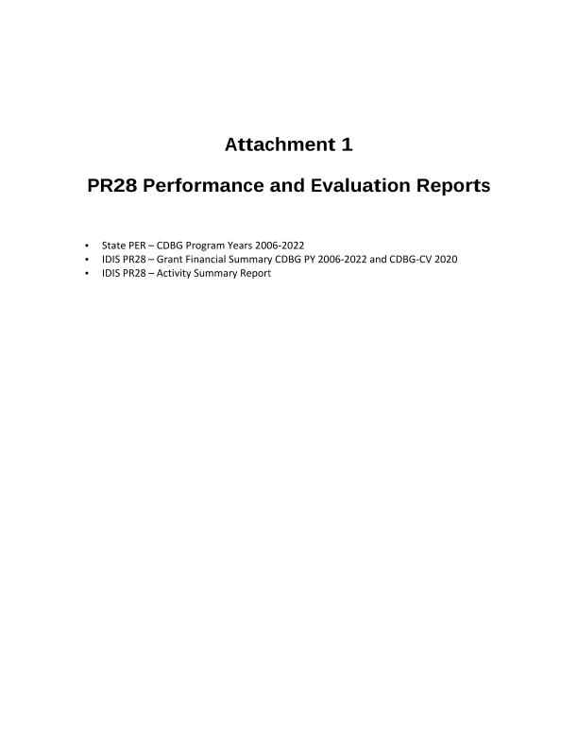
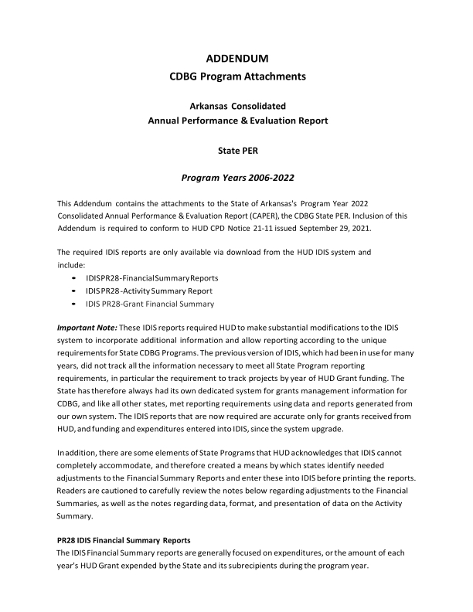
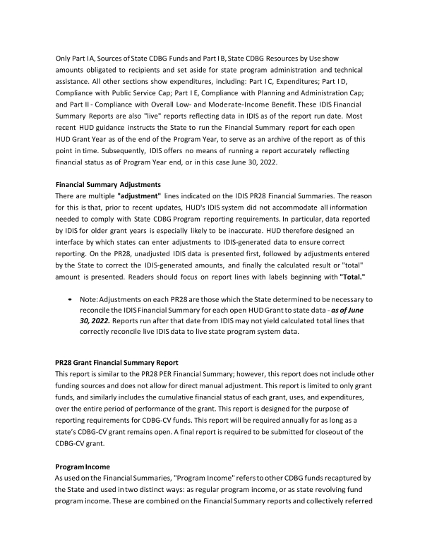
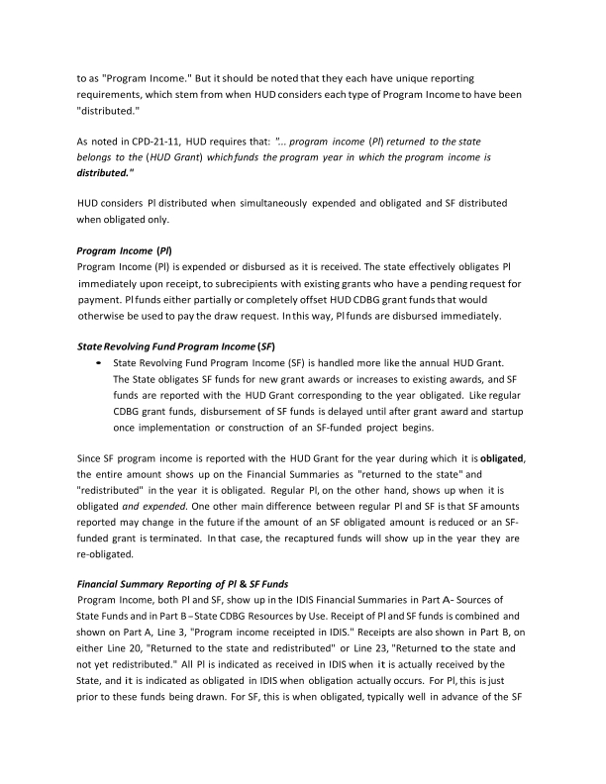
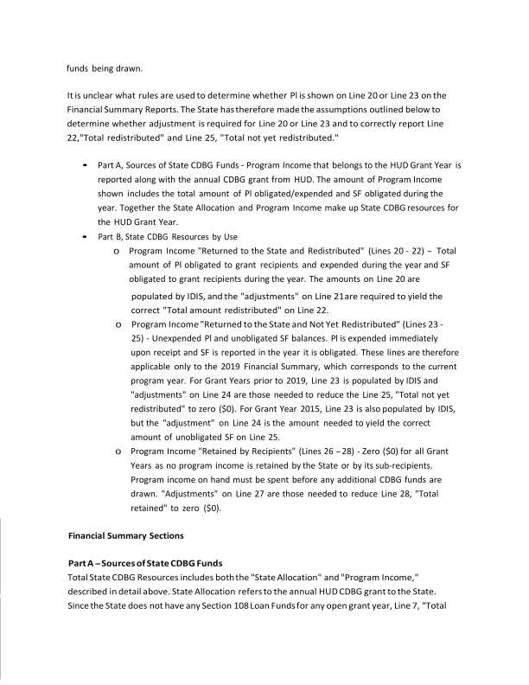
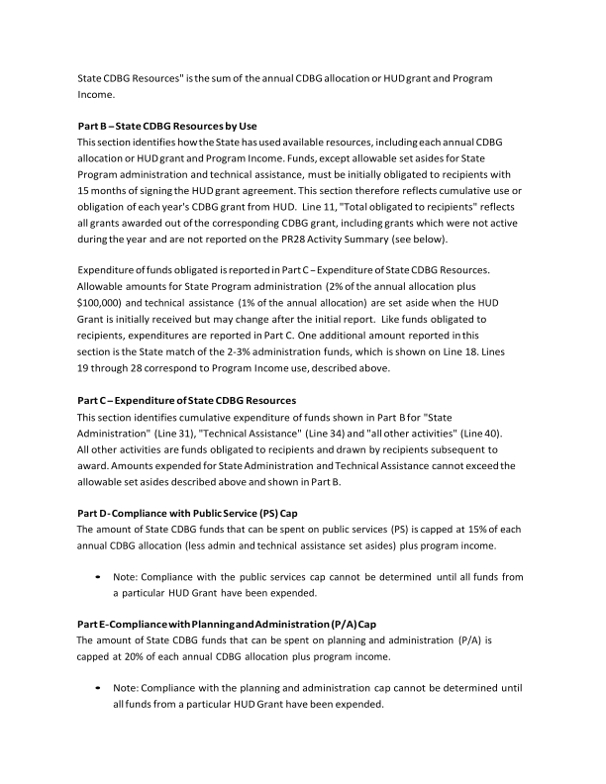
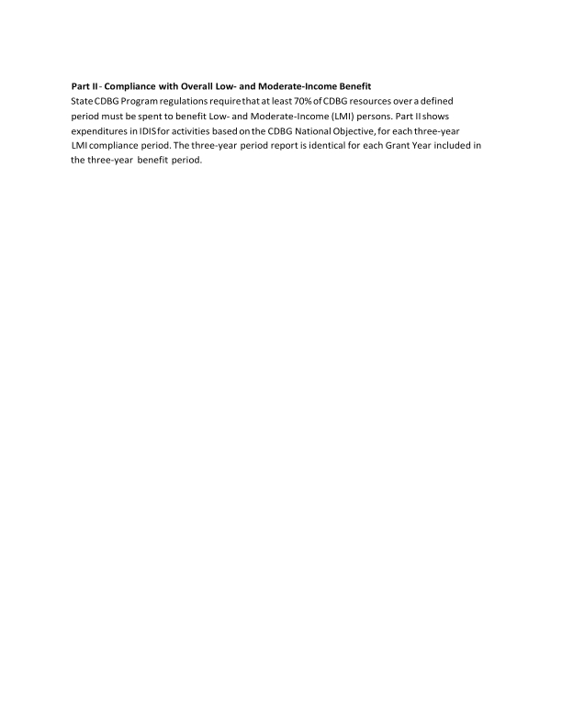
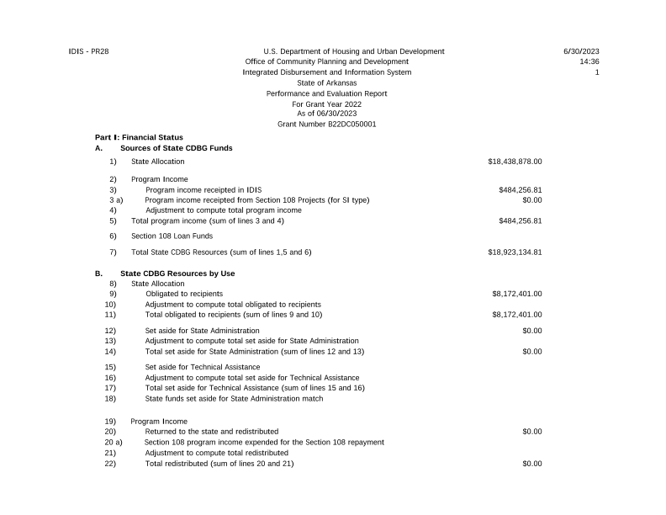
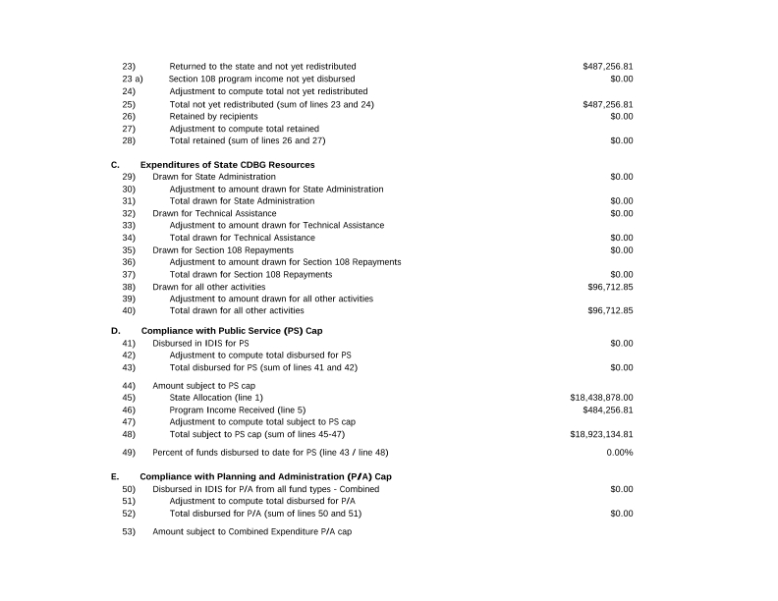
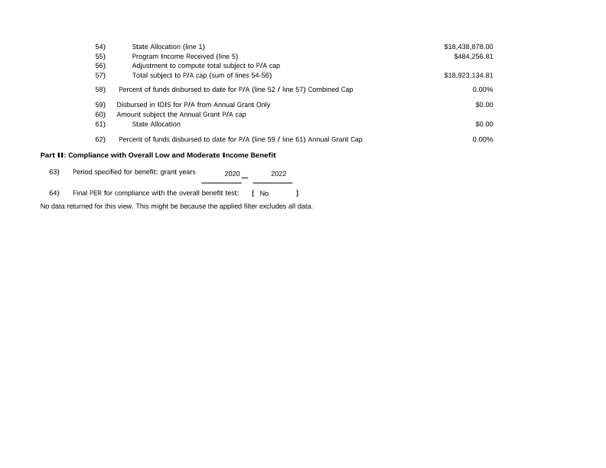
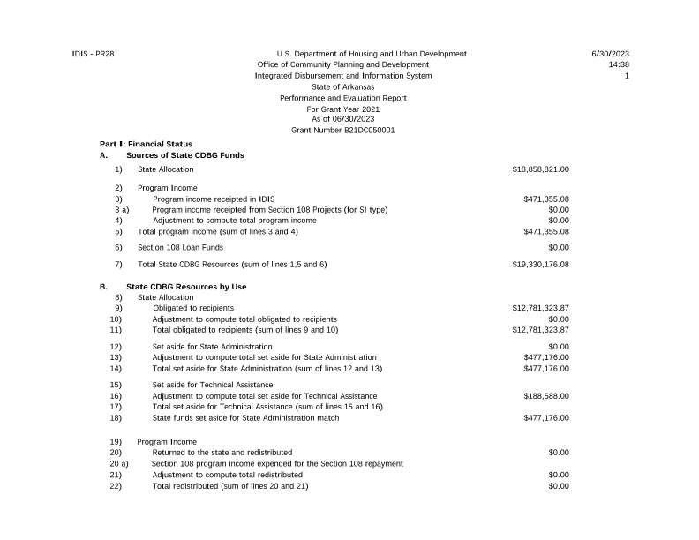
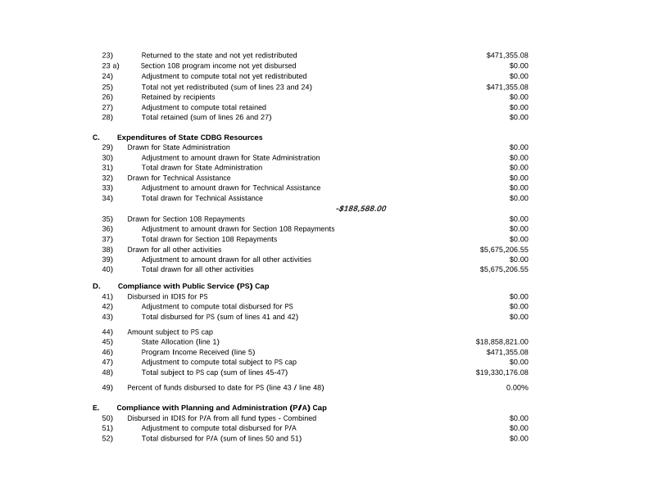
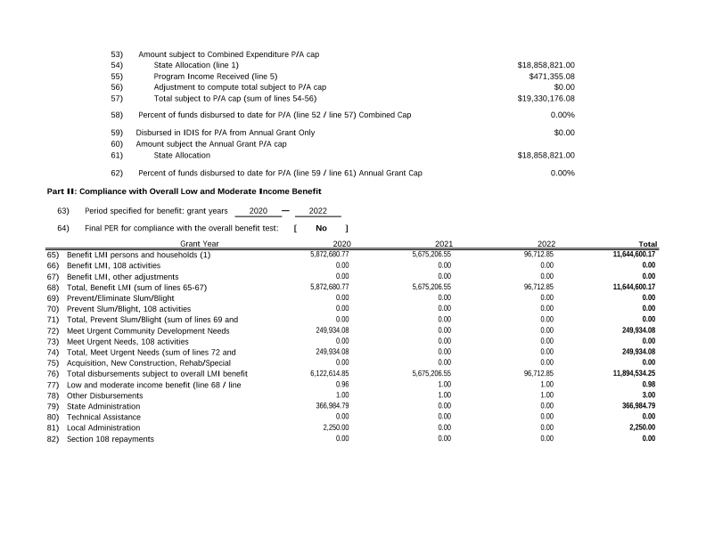
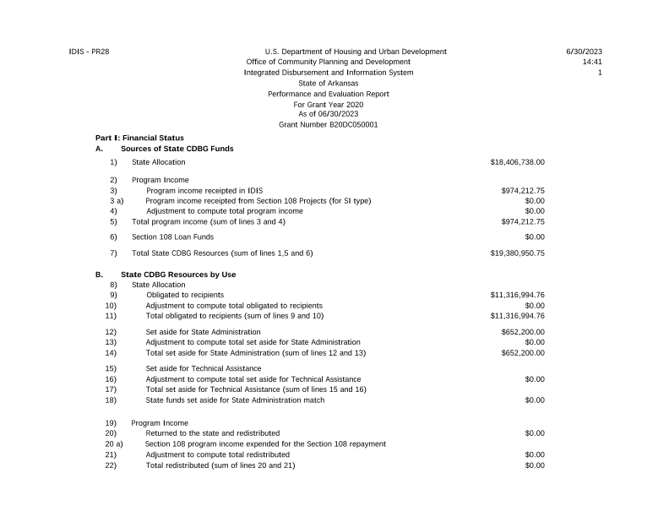
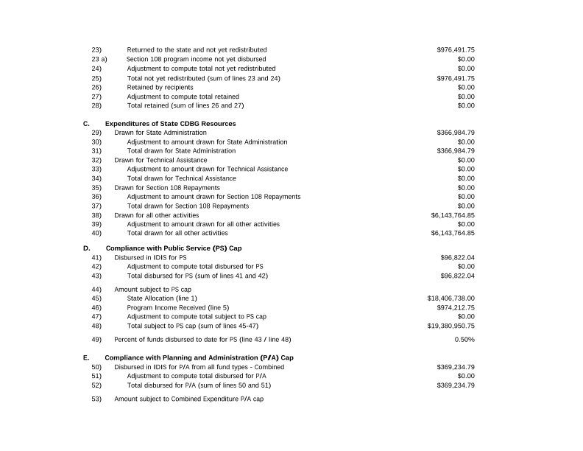
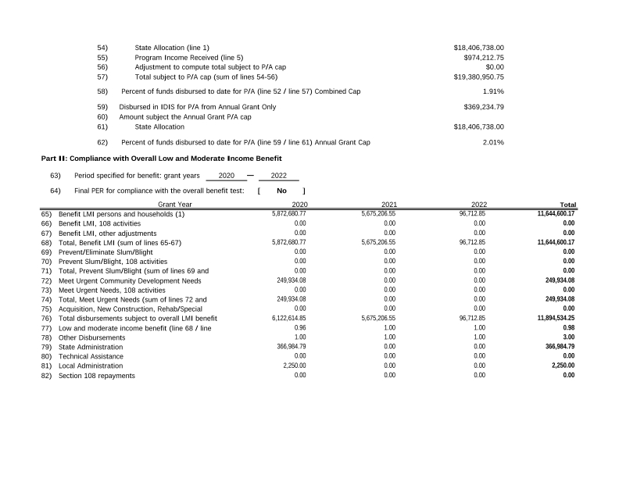
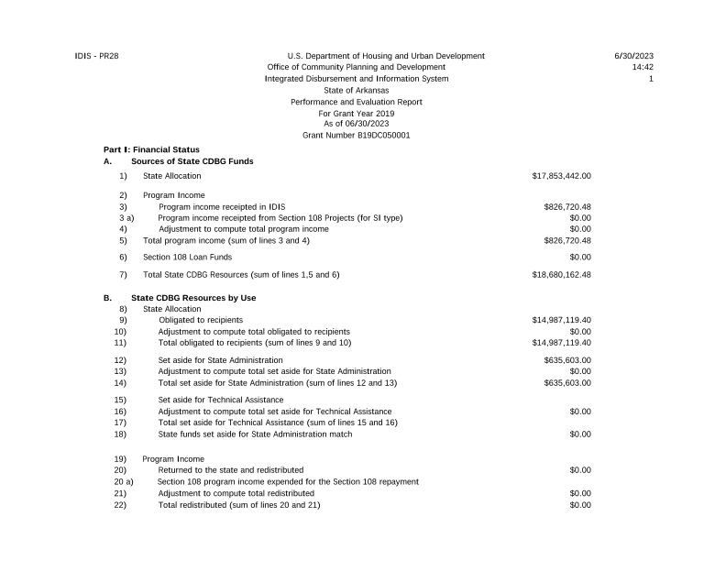
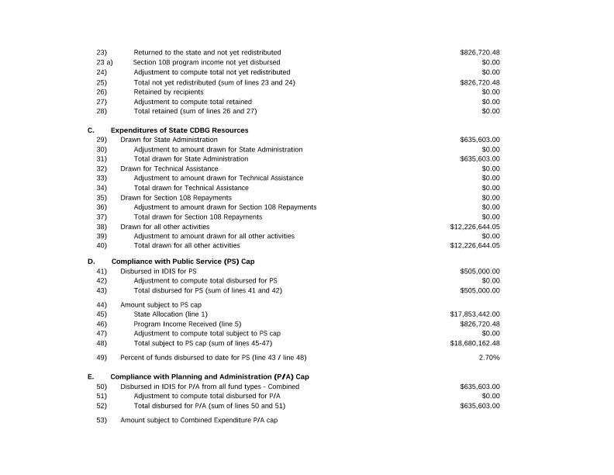
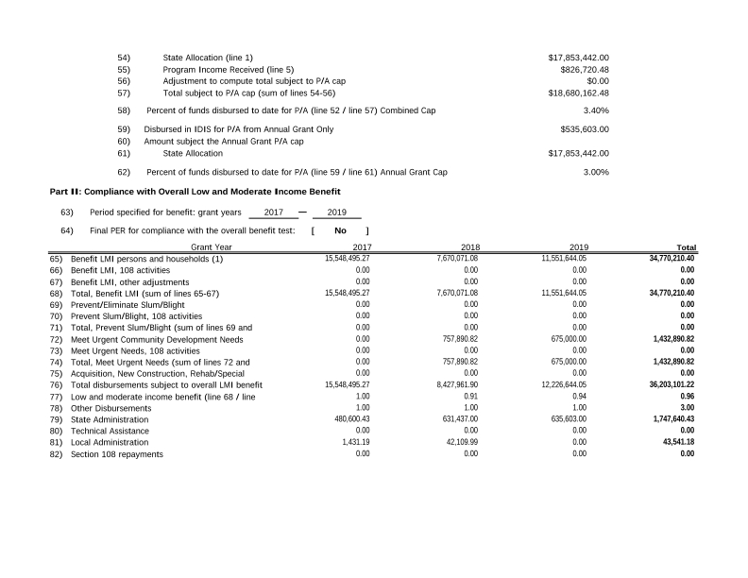
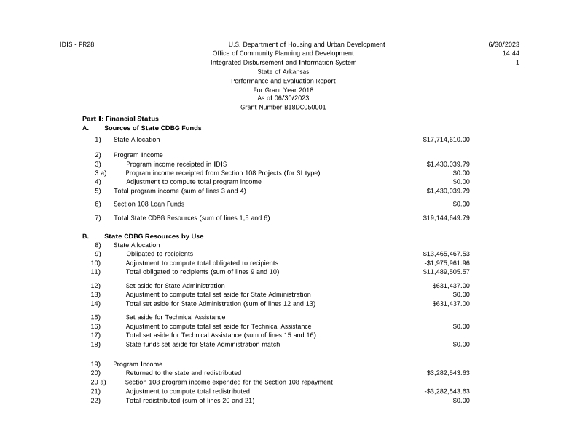
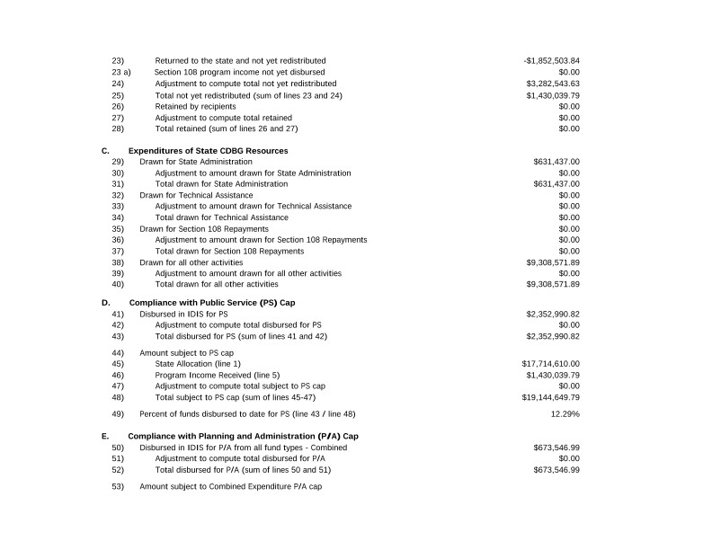
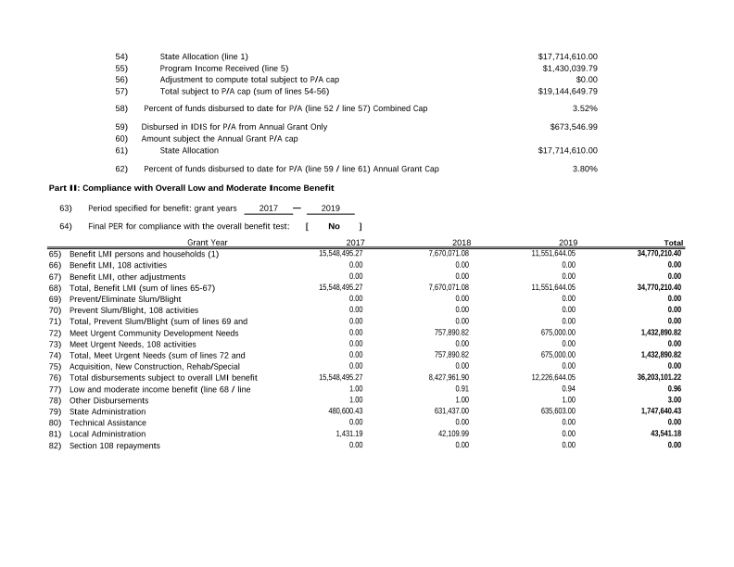
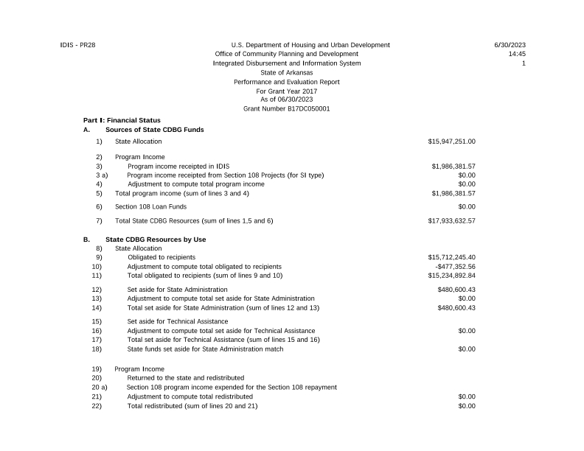
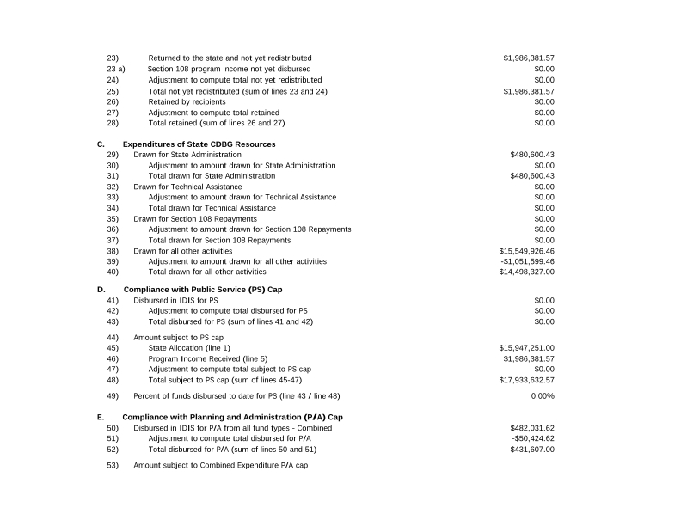
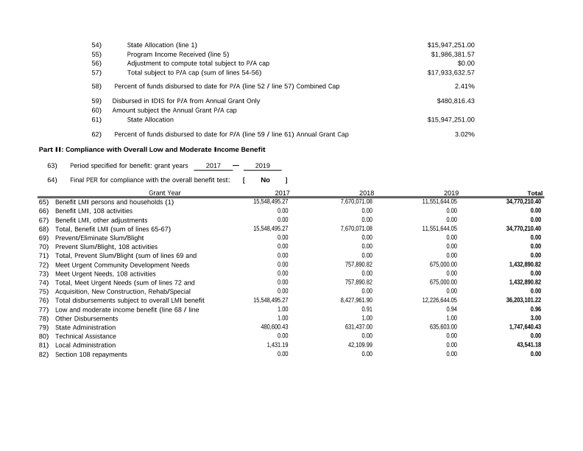
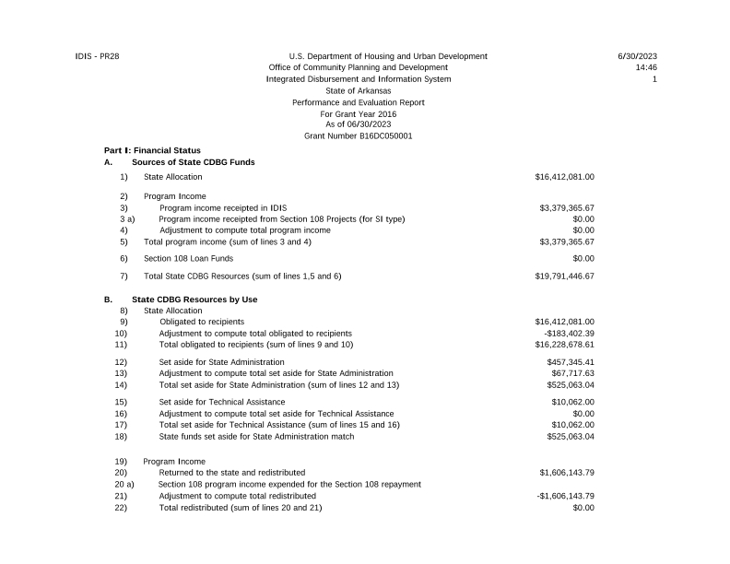
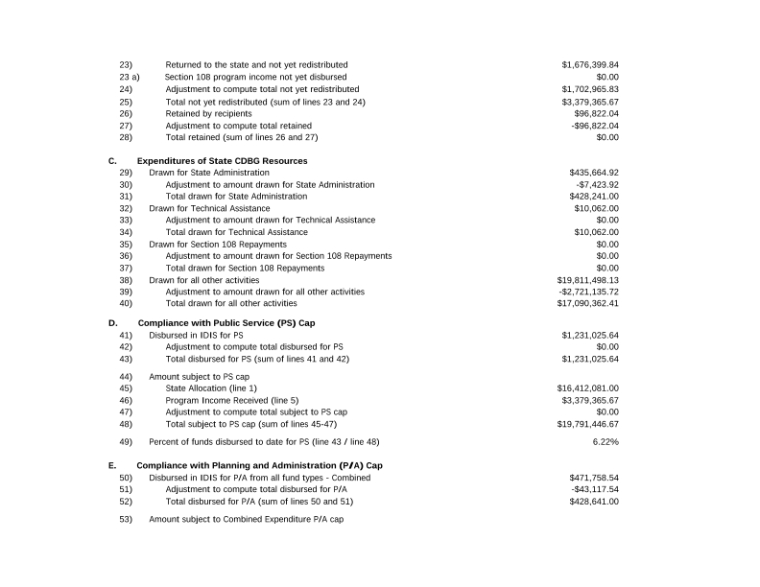
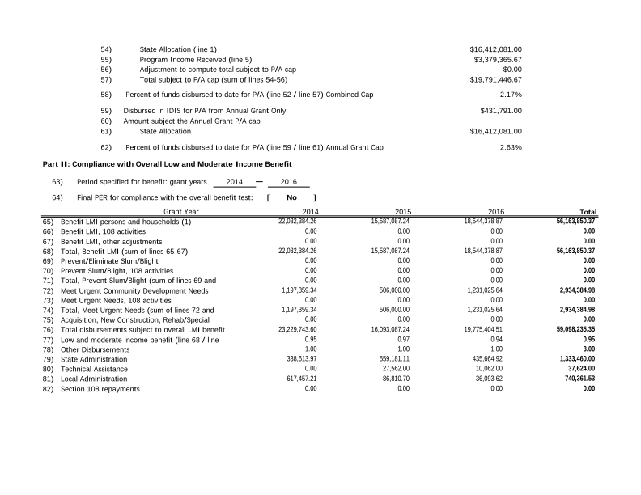
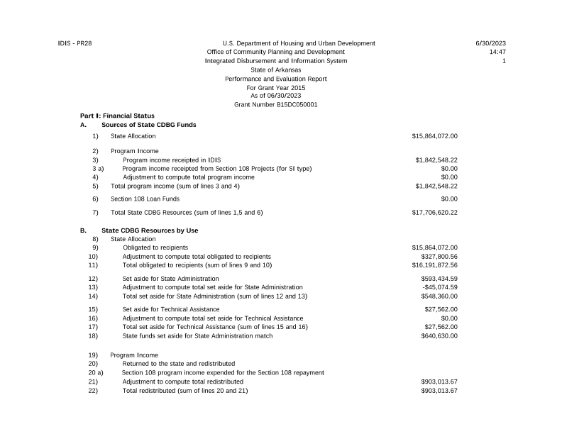
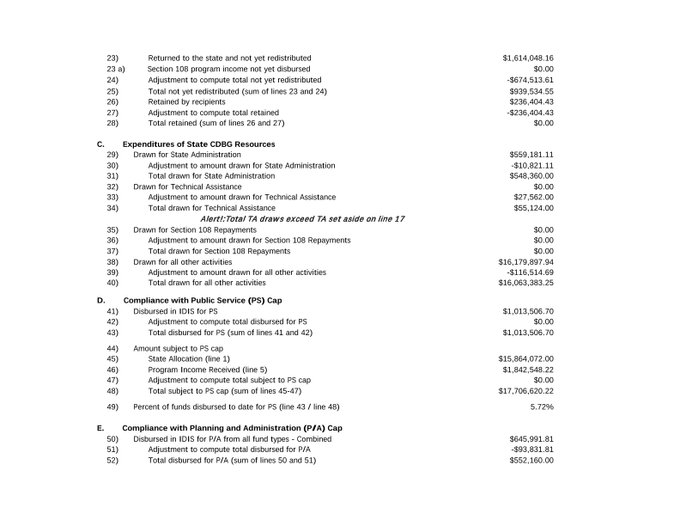
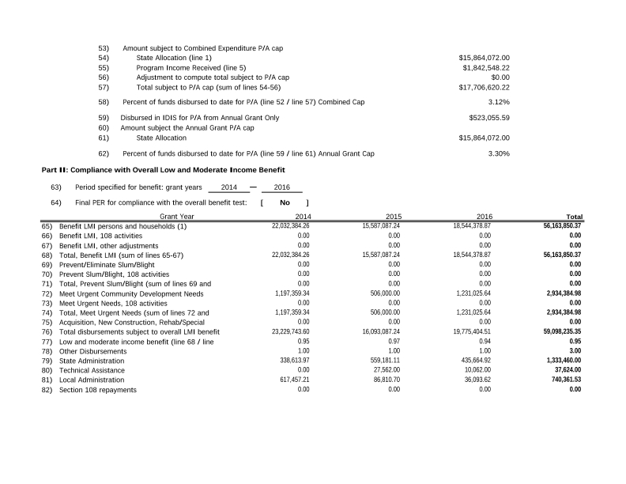
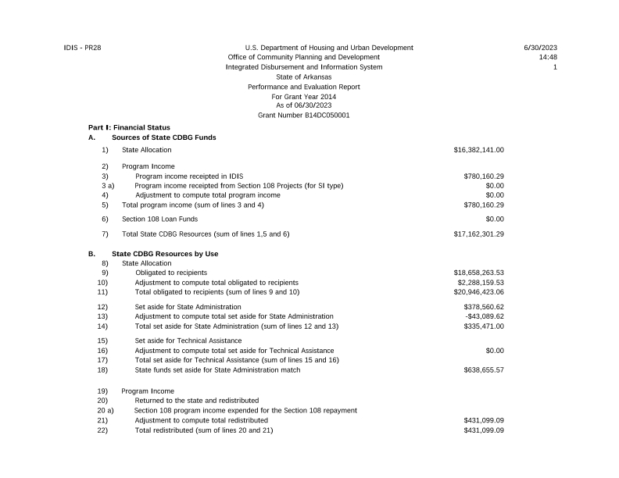
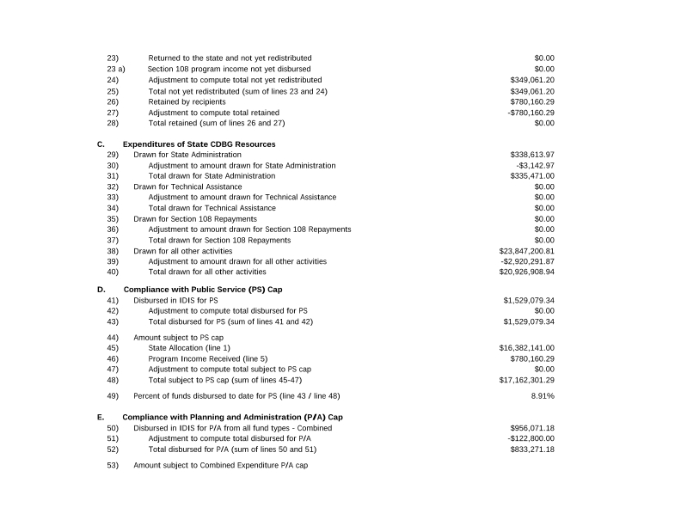
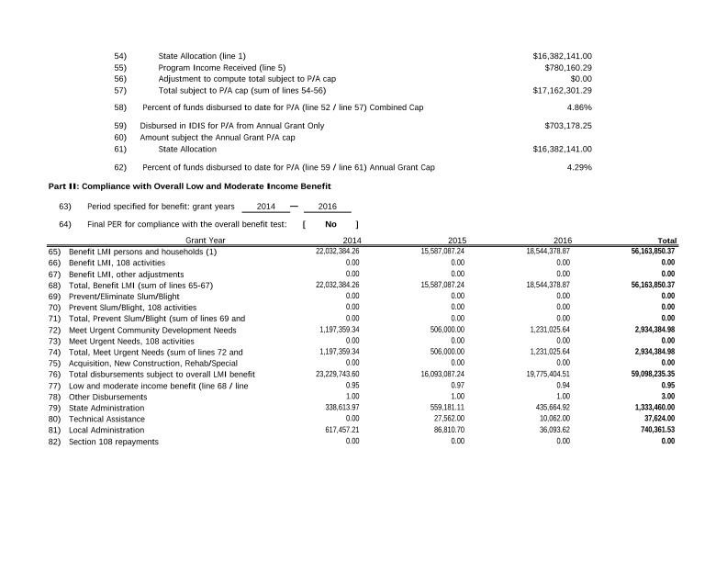
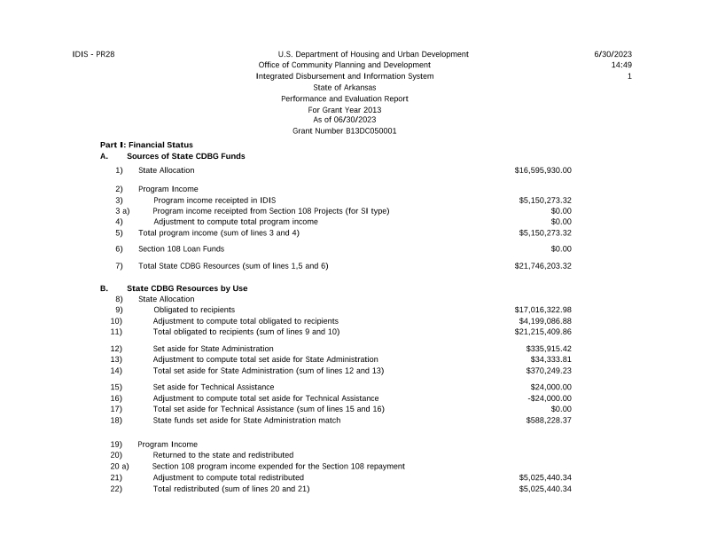
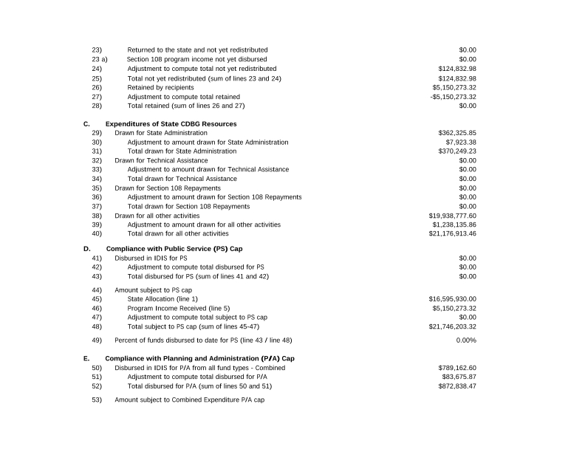
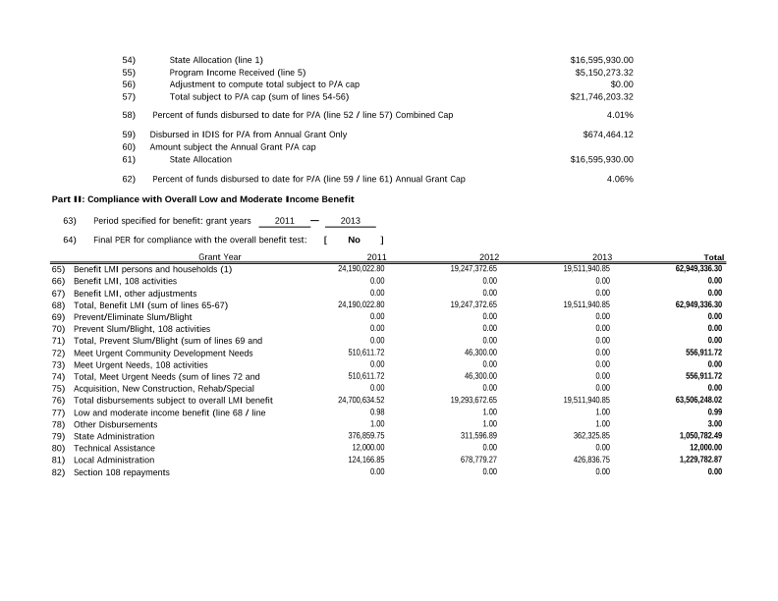
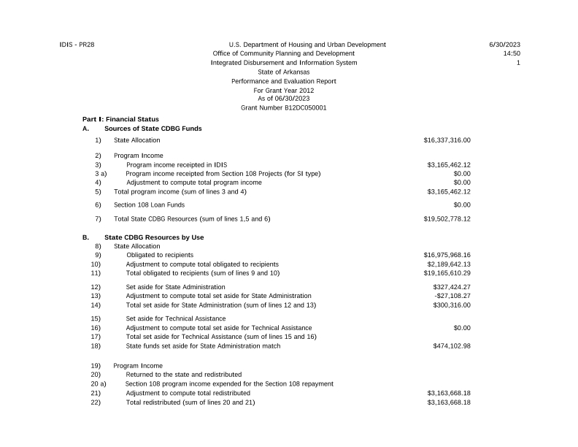
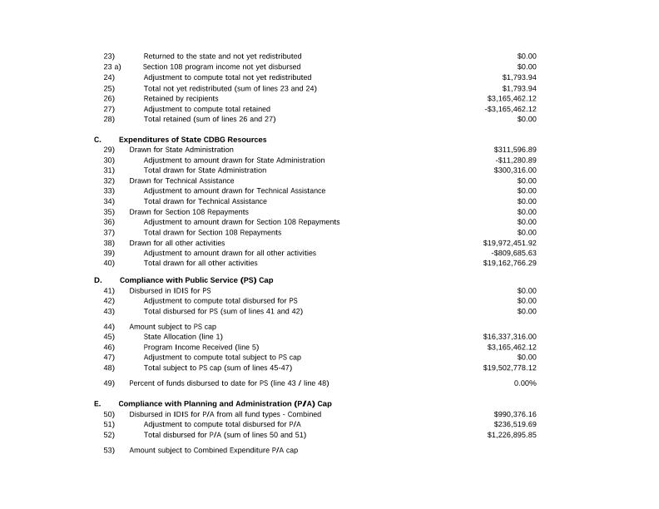
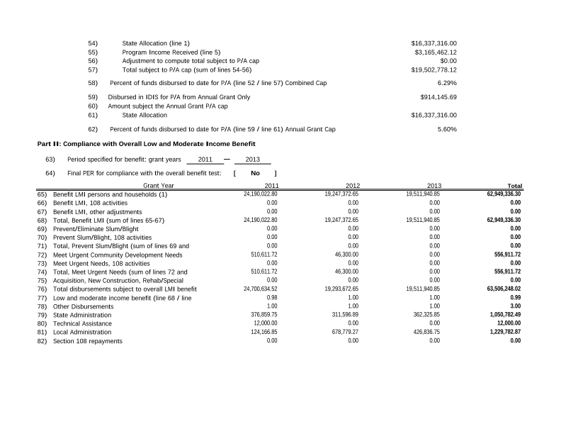
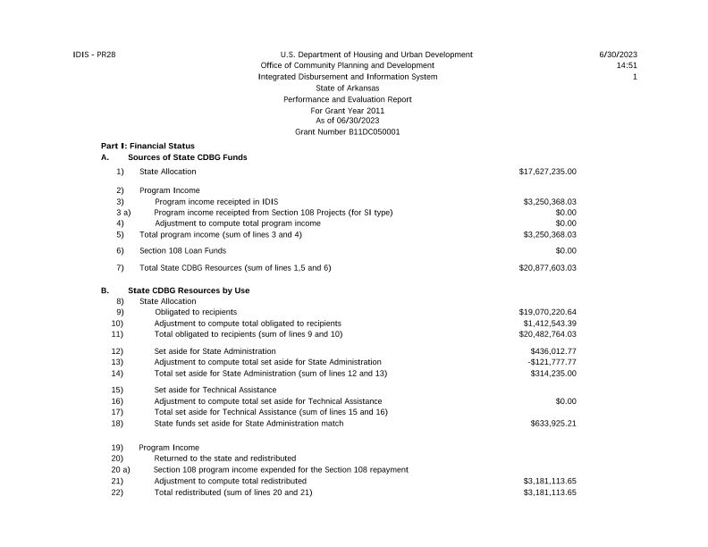
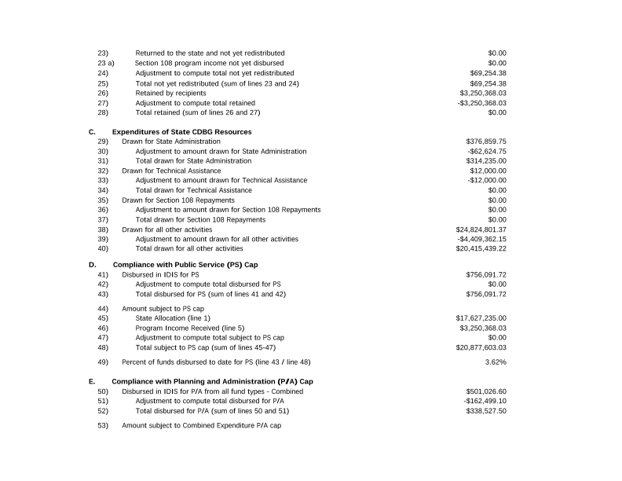
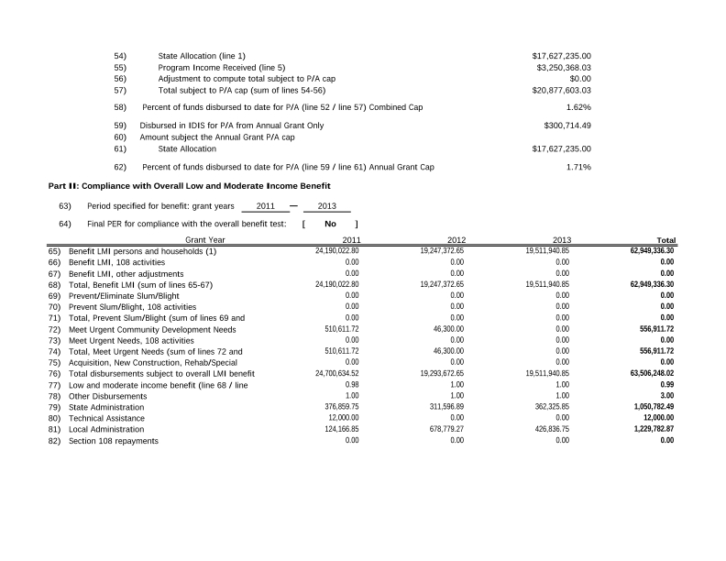
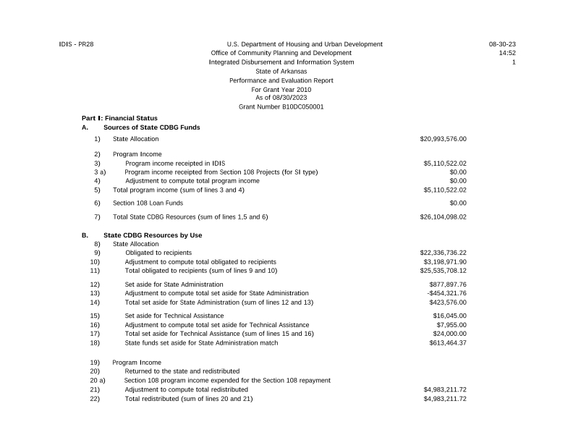
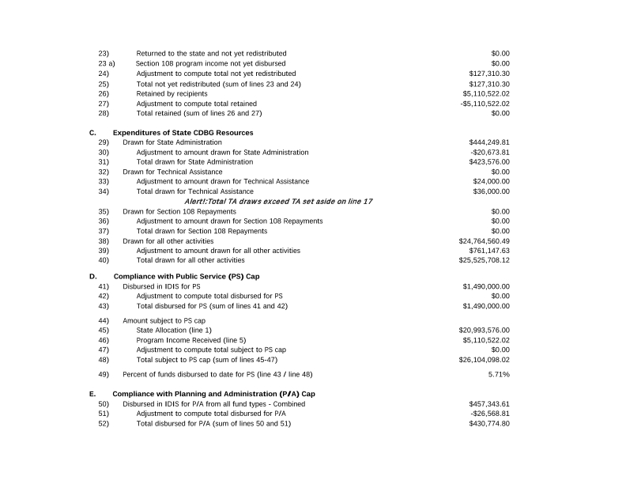
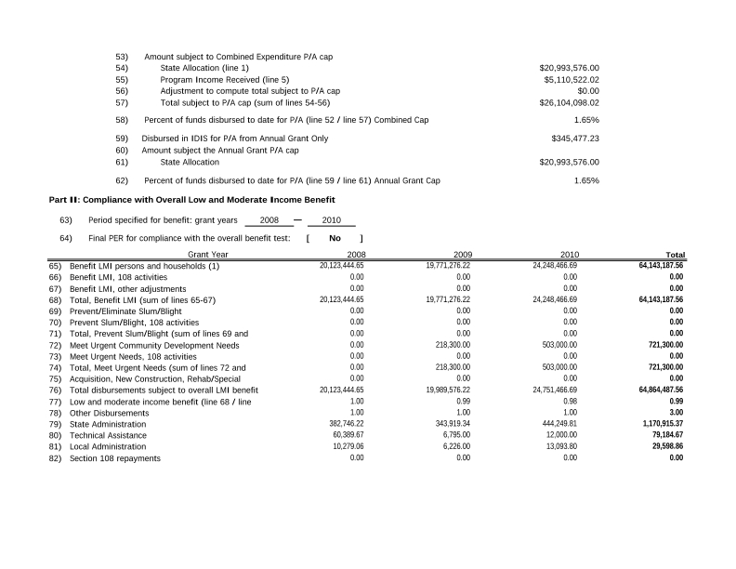
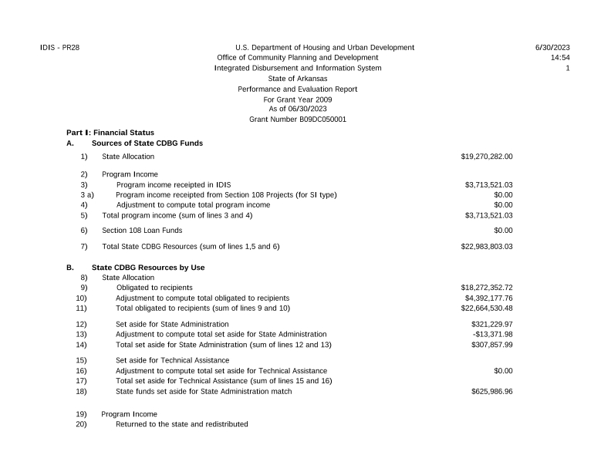
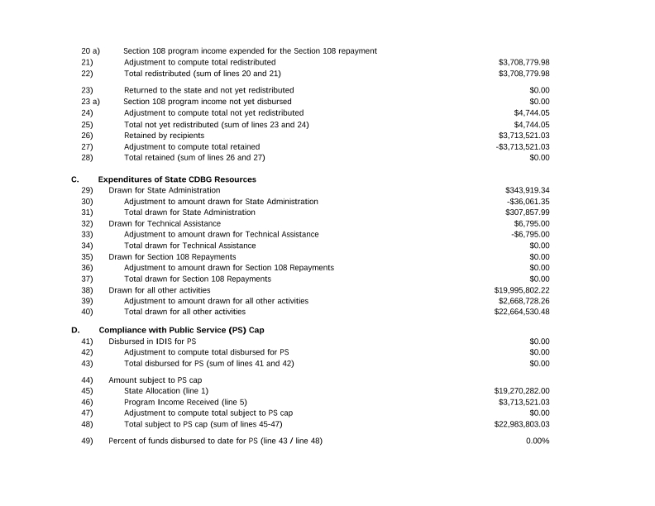
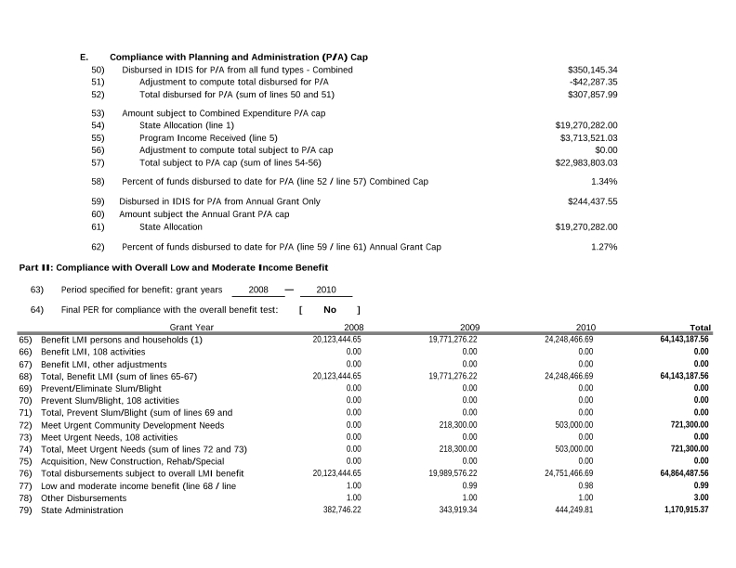
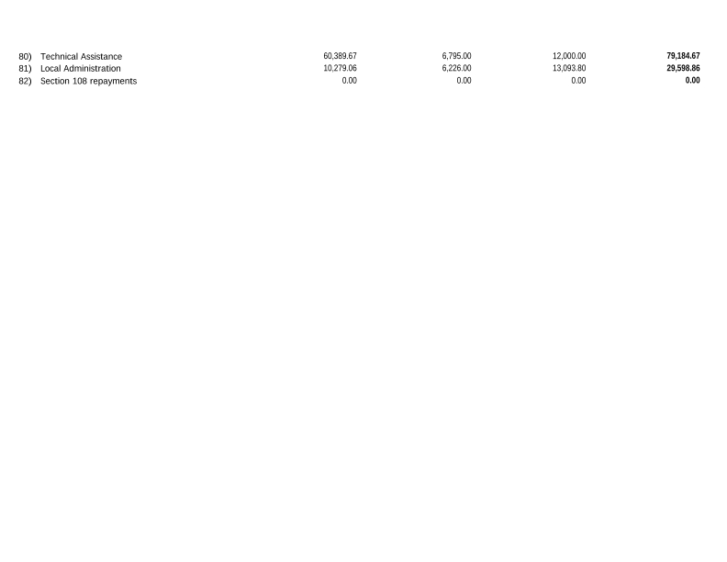
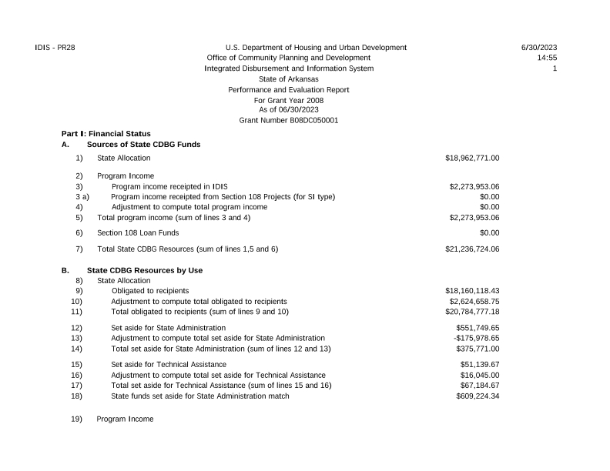
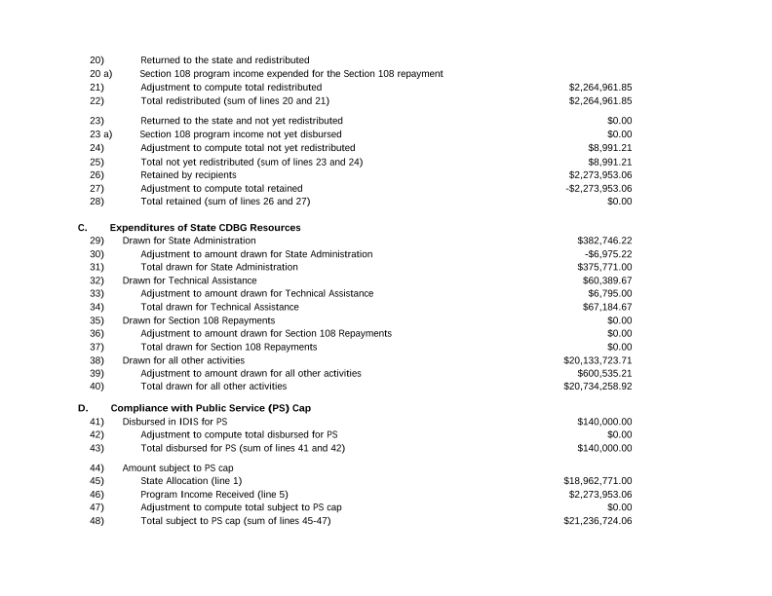
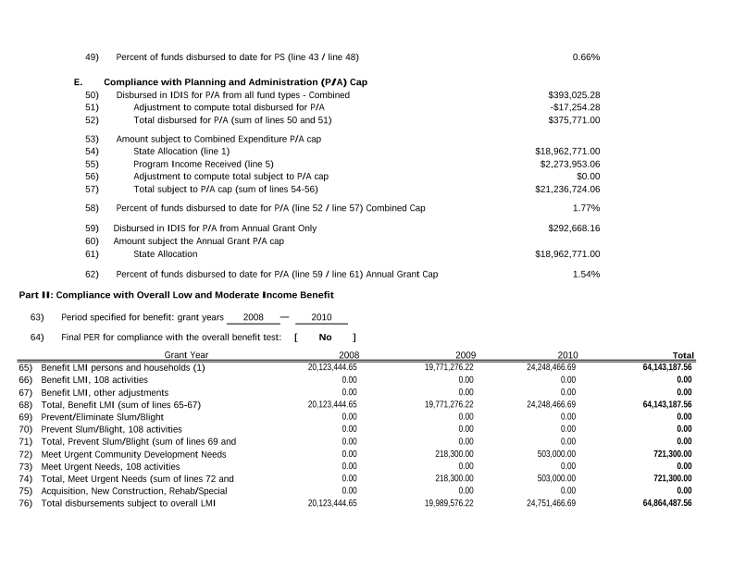
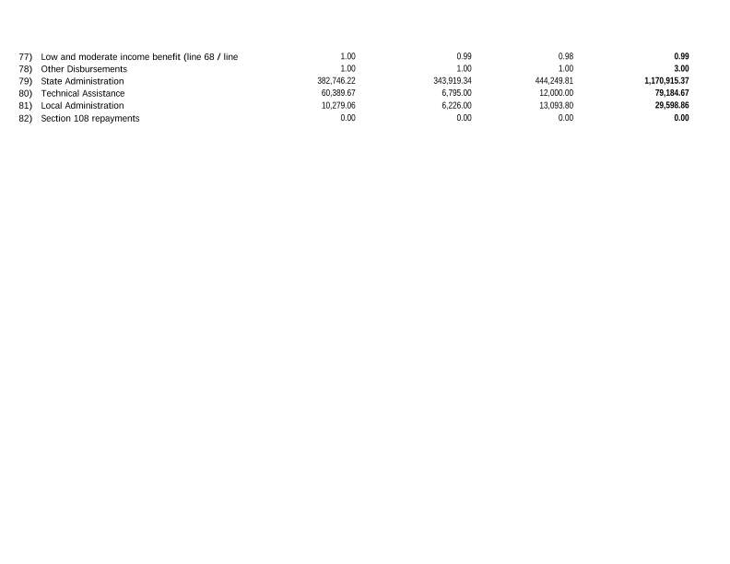
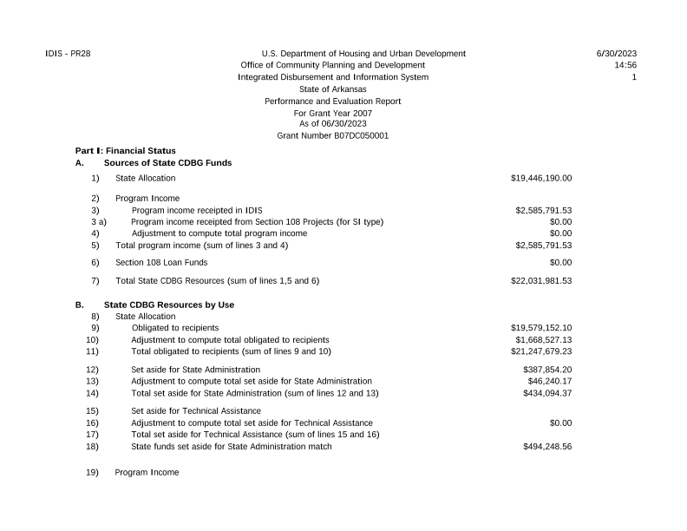
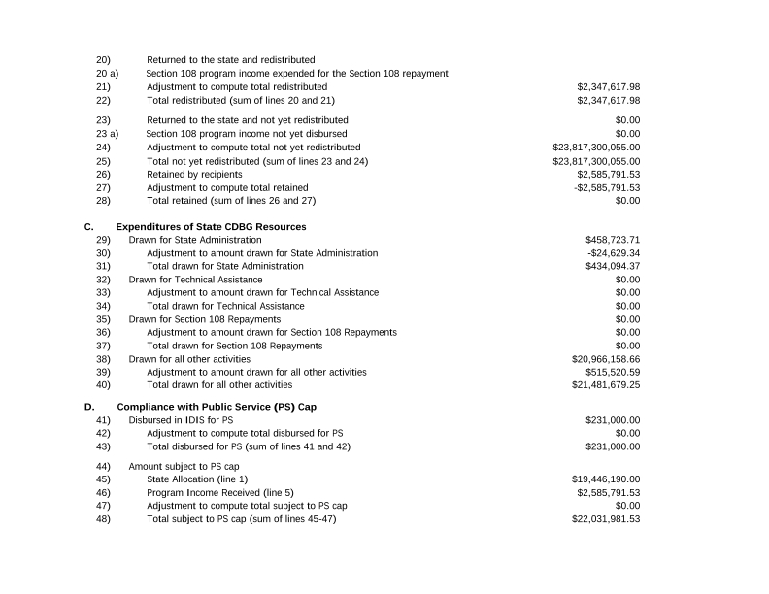
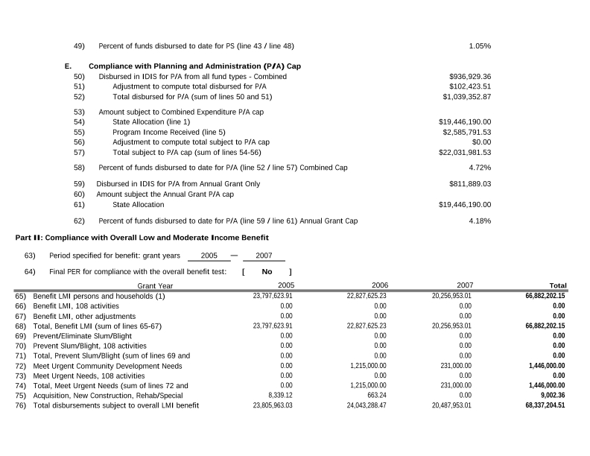
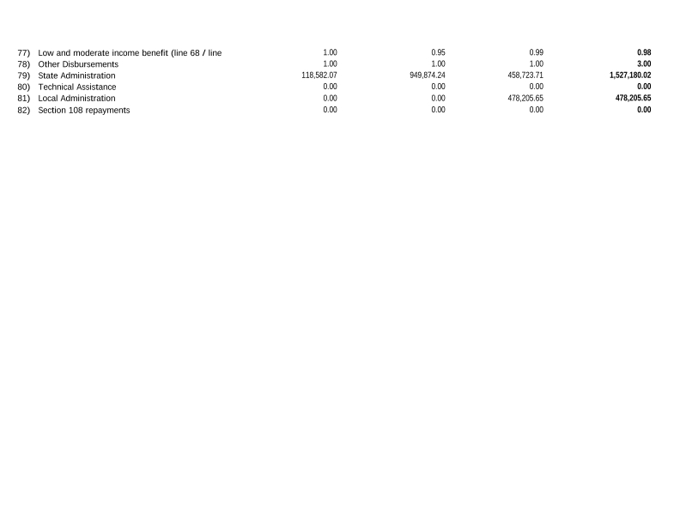
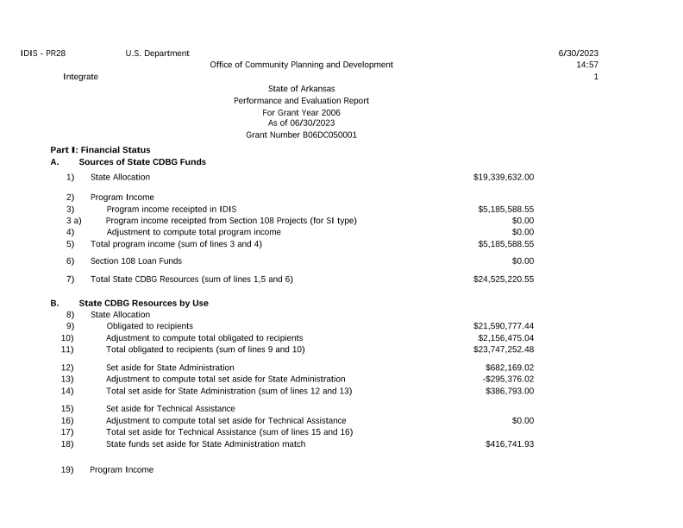
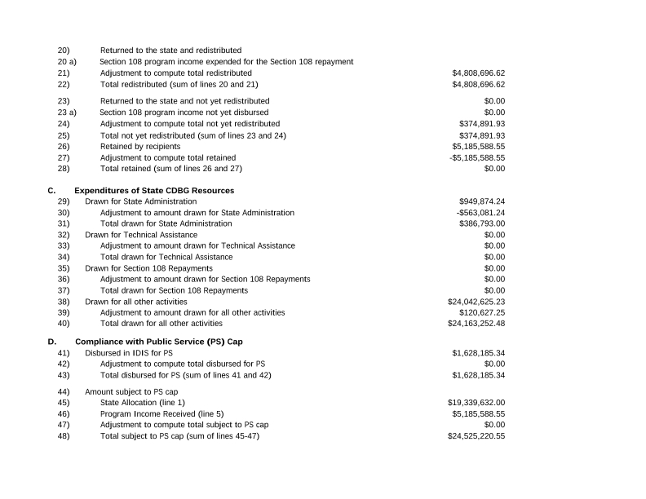
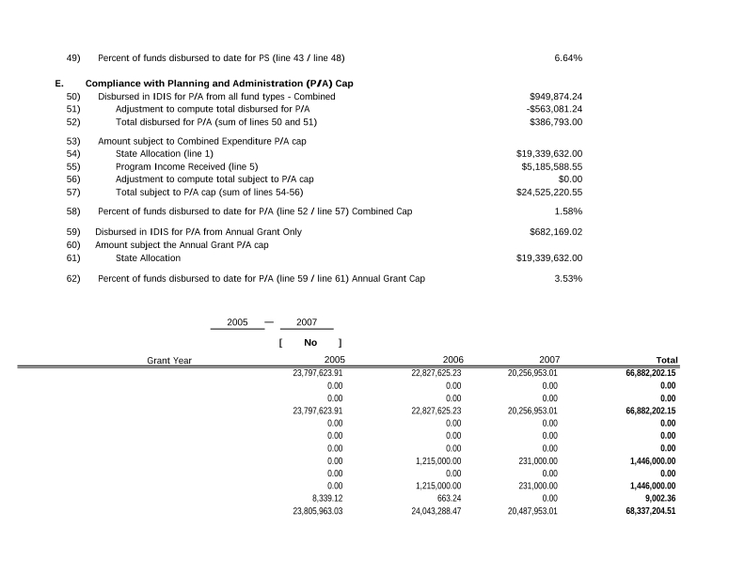
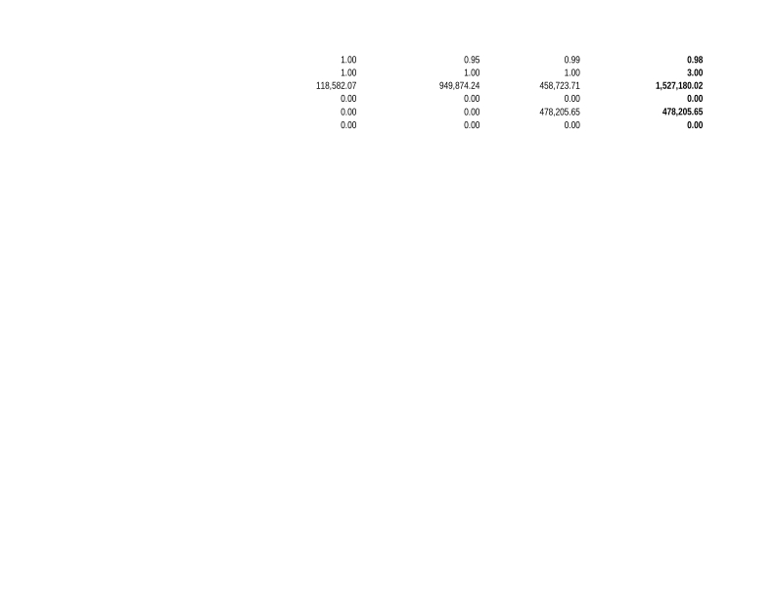
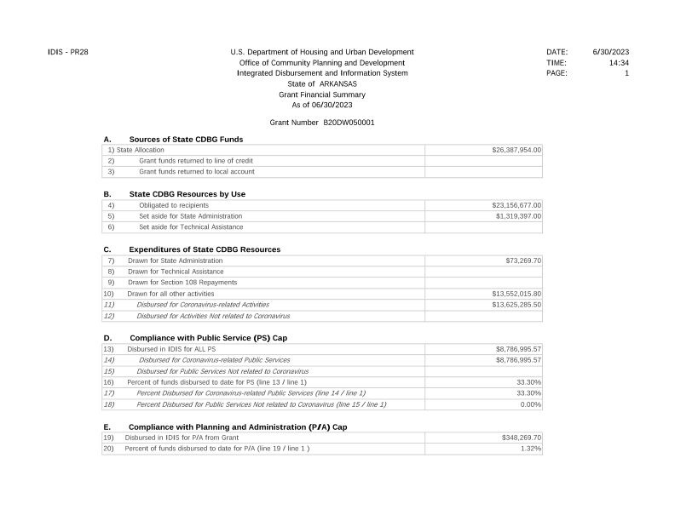
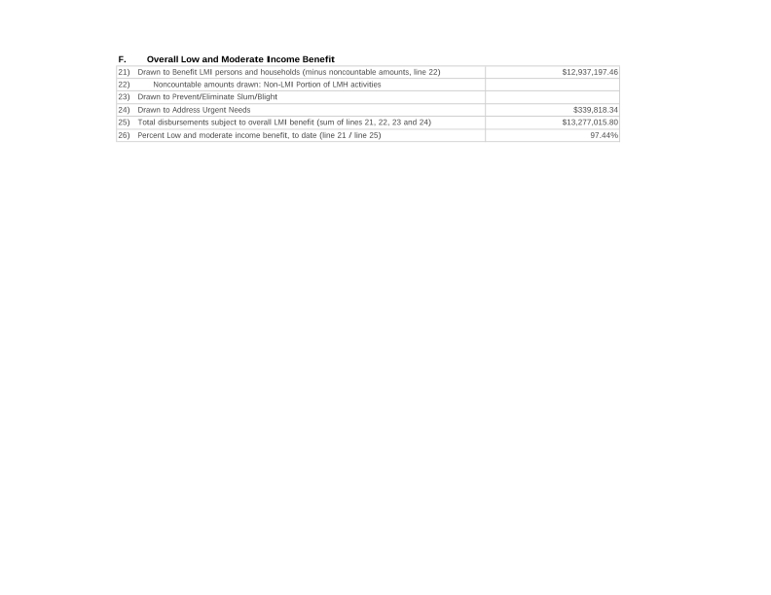
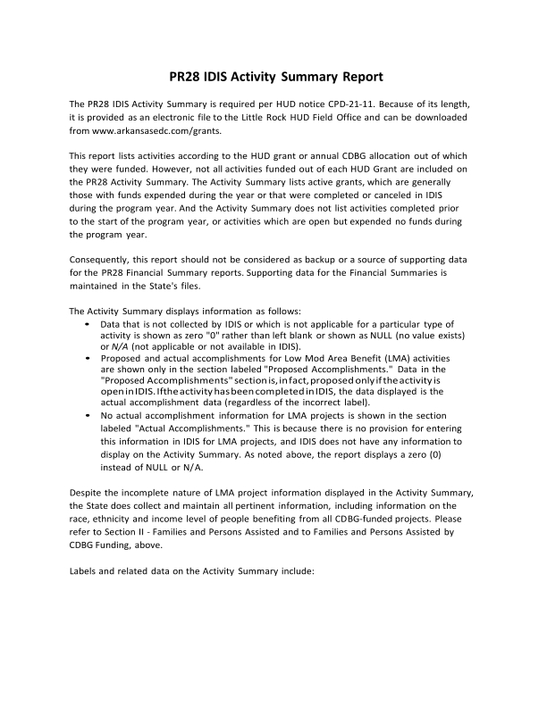
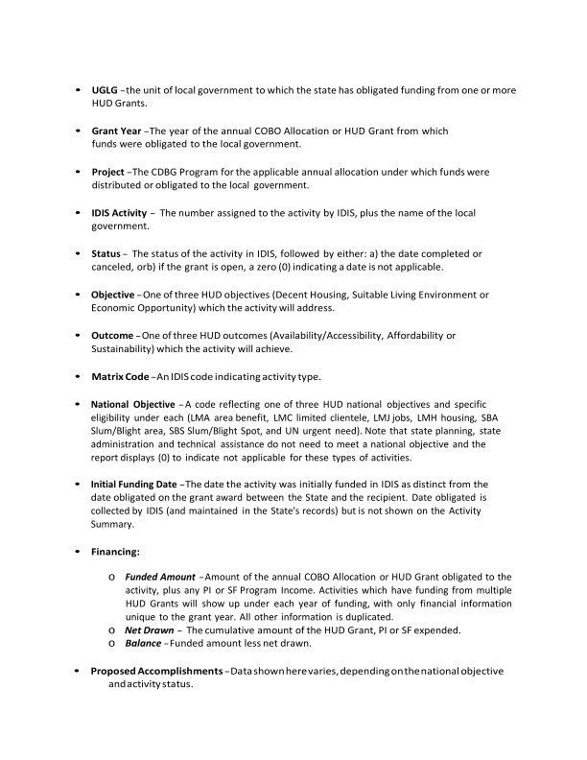
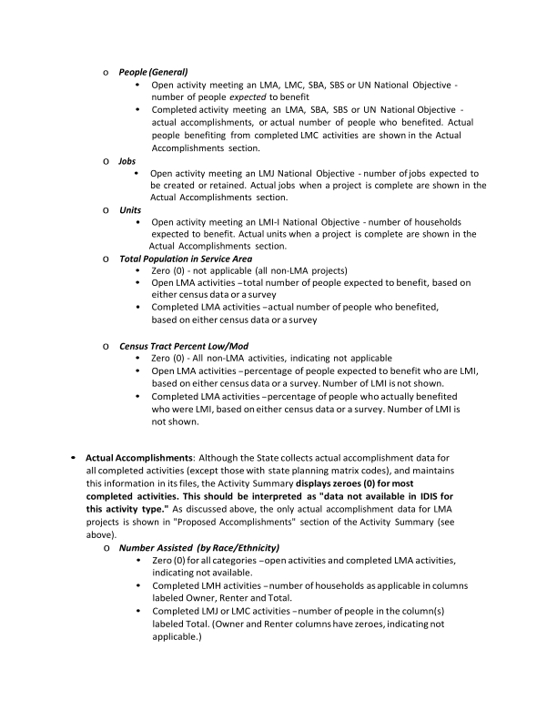
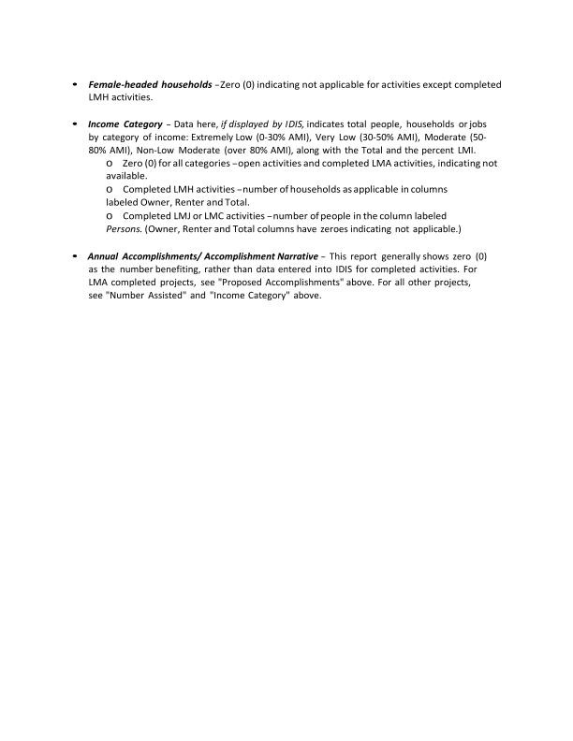

Proof of Publication, Public Comment Period
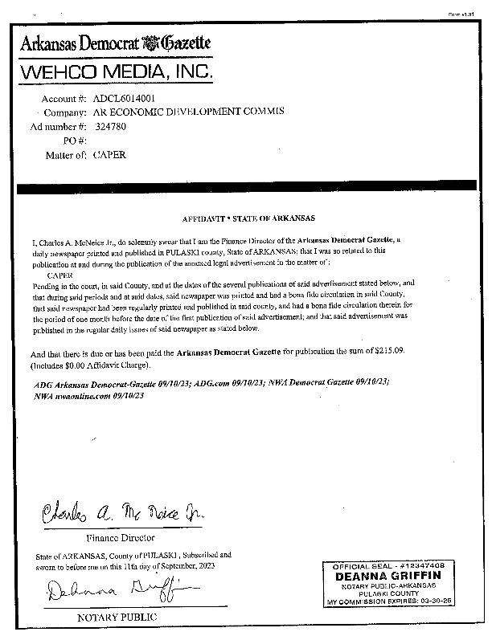
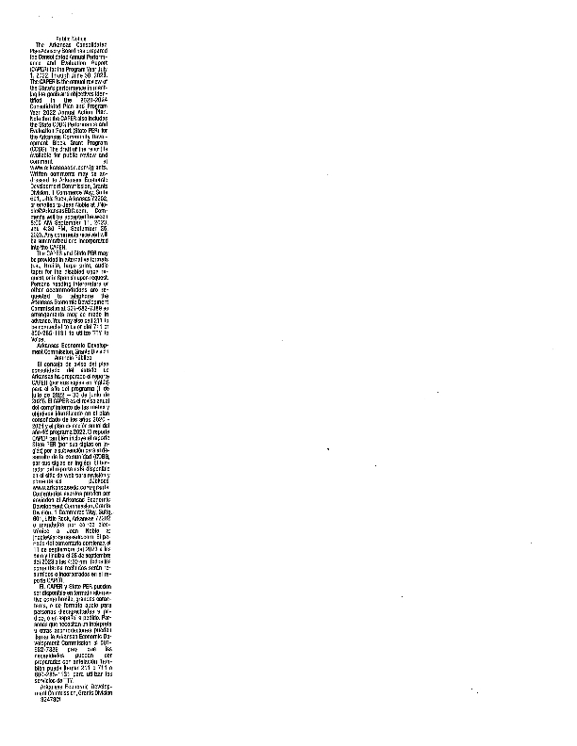

HOME - REPORTS PR07-PR20-PR23-PR33
