ARKANSAS COMMUNITY AND ECONOMIC
DEVELOPMENT PROGRAM (ACEDP)
Community Development Block Grant Program (CDBG)
State Program for Small Cities

Exhibits
Effective for 2020 Program Year (July 1, 2020 through June 30, 2021)

This is an electronically controlled document. The electronic version on the AEDC-Grants website is the most recent version, and is the only official version, of the document. Revisions are made periodically. The version date is shown in the footer of each page of the document. If the user is consulting a version with a version date differing from the version date of the official version on the website, then changes have been made. Refer to the table of revision changes online.
AEDC does not discriminate on the basis of Race, Color, National Origin, Sex, Age, Religion or Disability; and provides upon request, reasonable accommodation including auxiliary aids and services necessary to afford an individual with a disability an equal opportunity to participate in all programs and activities.

Table of Contents
Exhibits
Exhibit A Notice of Public Hearing 3
Exhibit B Authorizing Resolution 4
Exhibit C Statement of Assurances and Certifications 5
Exhibit D Citizen Participation Plan 8
Exhibit E Residential Anti-Displacement & Relocation Assistance Plan 10
Exhibit F Sample Excessive Force Resolution 11
Exhibit G-1 LMI Documentation/Low and Moderate Income Worksheet 12
Exhibit G-2 LMI Random Sample Worksheet 15
Exhibit H Limited Clientele (LMC) Worksheet 18
Exhibit I-1 Slum and Blight Area Basis Documentation 20
Exhibit I-2 Slum and Blight Spot Basis Documentation 22
Exhibit J Urgent Need Certification 23
Exhibit K FFATA (Federal Funding Accountability & Transparency Act) Reporting Form 24
Exhibit L Map of Proposed Project Area 25
Exhibit M Systems for Award Management (SAM) Documentation 28
Exhibit N-1 Four Factor Analysis Assessing Limited English Proficiency 31
Exhibit N-2 Language Assistance Plan 34

EXHIBIT A
NOTICE OF PUBLIC HEARING ON APPLICATION FOR
COMMUNITY DEVELOPMENT BLOCK GRANT PROGRAM

The following sample public notice is suggested for use in publicizing the first of two required public hearings. Each public hearing must be advertised separately in a manner the applicant determines to be responsible and customary in the community, and include all of this information.

A public hearing will be held on _________ ____, 20___ (date) at ______ a.m./p.m. at ____________________________________________ (location) for the purpose of identifying and prioritizing the community needs of (Name of the Local Government Unit), determining whether an application for Arkansas Community and Economic Development Program (ACEDP) funds should be developed and if so, for what community need. Also, comments on proposed project activities will be discussed, especially those with possible impacts on the community, should the project receive funding.

ACEDP funds are federal assistance received by the State of Arkansas and administered by the Arkansas Economic Development Commission. These funds will be made available to cities and counties according to need and can be used for community facilities, public infrastructure, or economic development, but must address one of the following objectives:

- Provide benefit to low and moderate income families,
- Aid in the prevention of slum and blight, or
- Meet other community needs, which pose a serious, immediate threat to the health or welfare of the community where no other funding is available to meet such needs.

All residents of (Name of the Local Government Unit) are encouraged to attend the hearing and participate in the community development process. The (Name of the Local Government Unit) will provide technical assistance in developing proposals by groups representing low- and moderate-income persons.

Individuals requiring physical or sensory accommodations including interpreter service, Braille, large print, or recorded materials, please contact (contact person) at (address, phone number) no later than (date). Accommodations will be made for persons with disabilities and non-English speaking individuals provided that (number) day notice is received by the (Name of the Local Government Unit).

Either Proof of Publication or Certificate of Posting must be submitted together with a summary of citizens’ comments and attendance roster

Please Note: At this hearing, specific CDBG program requirements and related project issues should be reviewed. For example, if taxes or user charges will need to be increased as part of financing the project, it is especially important that residents understand the necessity of raising funds. This discussion should specifically be reflected in meeting minutes.

EXHIBIT A

EXHIBIT B
RESOLUTION AUTHORIZING CHIEF ELECTED OFFICIAL TO SIGN AN APPLICATION FOR CDBG FUNDS
--Sample Format--

Resolution No. _____________

Be it resolved by the Quorum Court/City Council of (Name of the Local Government Unit), State of Arkansas, a resolution to be entitled:

A RESOLUTION AUTHORIZING THE SUBMITTAL OF AN APPLICATION FOR ACEDP GRANT FUNDS TO THE STATE OF ARKANSAS

WHEREAS: (Name of the Local Government Unit) is applying for funds through the Arkansas Community and Economic Development Program, and

WHEREAS: It is necessary that certain conditions be met as part of the application requirements; and

WHEREAS: (Name of the Local Government Unit) has, or will, conducted a public hearing and has an active Citizen Participation Plan/Community Development Plan, and as part of the application process has received and considered comments on community development and housing needs, and proposed activities; and

WHEREAS: As a result of the Community Development Planning activities; (Name of the Local Government Unit) has identified and prioritized the community development and housing needs.

NOW THEREFORE BE IT RESOLVED THAT THE CITY COUNCIL/QUORUM COURT OF (Name of the Local Government Unit) ARKANSAS THAT:

The Mayor/Judge of (Name of the Local Government Unit) is hereby authorized, on behalf of (Name of the Local Government Unit) to submit an application to the State of Arkansas for grant funds, under the Community Development provisions of the Arkansas Community and Economic Development Program, and to expend funds to accomplish such community development activities, if the grant is awarded.

This Resolution passed and adopted in regular session: (date)

__________________________________
Name and Title

ATTEST:

____________________________
Title
Use the language in this sample and provide an original signature or a
certified copy of the authorizing resolution.

EXHIBIT C
APPLICANT’S STATEMENT OF ASSURANCES AND CERTIFICATIONS

The (Name of the Local Government Unit) (Applicant) hereby assures and certifies to the Arkansas Economic Development Commission regarding an application for Community Development Block Grant (CDBG) funds, the following:

THRESHOLD CERTIFICATIONS
1. There are no significant unresolved audit findings relating to any prior grant award from the federal and/or state government that would adversely affect the administration of this grant.

2. No legal actions are underway or being contemplated that would significantly impact the Applicant’s capacity to effectively administer the program, and to fulfill the CDBG program; and

3. No project costs have been incurred that have not been approved in writing by the Commission.

FEDERAL COMPLIANCE CERTIFICATIONS
4. It will adopt and follow a residential anti-displacement and relocation assistance plan that will minimize displacement as a result of activities assisted with CDBG funds.

5. It will conduct and administer its programs in conformance with:
a. Title VI of the Civil Rights Act of 1964 (Pub. L. 88-352), and the regulations issued pursuant thereto (24 CFR Part 1).

b. Title VIII of the Civil Rights Act of 1968 (Pub. L. 90-284), as amended, administering all programs and activities relating to housing and community development in a manner to affirmatively further fair housing, and will take action to affirmatively further fair housing in the sale or rental of housing, the financing of housing and the provision of brokerage services.

c. The Fair Housing Act of 1988 (42 USC 3601-20) and will affirmatively further fair housing.

6. It will not attempt to recover any capital costs of public improvements assisted in whole or part by assessing any amount against properties owned and occupied by persons of low- and moderate-income, including any fee charged or assessment made as a condition of obtaining access to such public improvements, unless (1) grant funds are used to pay the proportion of such fee or assessment that relates to the capital costs of such public improvements that are financed from revenue sources other than grant funds, or (2) for purposes of assessing any amount against properties owned and occupied by persons of LMI who are not persons of very-low income, the recipient certifies to the state that it lacks sufficient grant funds to comply with the requirements of clause (1).

7. It will comply with all provisions of Title I of the Housing and Community Development Act of 1974, as amended, which have not been cited previously as well as with other applicable laws.

CITIZEN PARTICIPATION PLAN CERTIFICATION
8. It certifies that a detailed citizen participation plan is on file which includes:
a. Providing and encouraging citizen participation with particular emphasis on participation by lower income persons who are residents of slum and blight areas in which funds are proposed to be used to include target areas as identified in the application.

b. Providing citizens with reasonable and timely access to local meetings, information, and records relating to the Applicant's proposed and actual use of CDBG funds.

c. Furnishing citizens with information, including but not limited to, the amount of CDBG funds expected to be made available for the current fiscal year, including CDBG funds and anticipated program income; the range of activities that may be undertaken with CDBG funds; the estimated amount of CDBG funds to be used for activities that will meet national objective of benefit to low- and moderate-income people, and the proposed CDBG activities likely to result in displacement and the grantee's anti-displacement and relocation plans.

d. Providing technical assistance to groups representative of persons of low and moderate income that request such assistance in developing proposals. The level and type of assistance is to be identified within the plan.

e. Providing for public hearings at different stages of the program, for the purpose of obtaining citizen's views and responding to proposals and questions. The hearings must cover community development and housing needs, development of proposed activities and review of program performance. The hearing to cover community development needs must be held before submission of an application to the state. The hearing on program performance must be held during the implementation of the CDBG awarded grant. There must be reasonable notice of the hearings and they must be held at times and locations convenient to potential or actual beneficiaries, with accommodations for the handicapped. Public hearings are to be conducted in a manner to meet the needs of non-English speaking residents where a significant number of non-English speaking residents can
EXHIBIT C
be expected to participate.
f. Providing citizens with reasonable advance notice of, and opportunity to comment on, proposed activities in the application to the state and for grants already made, activities that are added to, deleted or substantially changed from the application to the state. Substantially changed is defined in terms of purpose, scope, location or beneficiaries defined by the state established criteria.

g. Providing citizens the address, phone number and acceptable hours for submitting complaints and grievances and providing timely written responses to written complaints and grievances within 15 working days where practicable.

SPECIAL REQUIREMENTS AND ASSURANCES.
9. The Applicant will comply with the administrative requirements of the program, those applicable items in the current Consolidated Plan, Title I of the Housing and Community Development Act of 1974, Public Law 93-383, as amended, and 24 CFR Part 570 (including parts not specifically cited below), and the following laws, regulations and requirements, both federal and state, as the pertain to the design, implementation and administration of the local project, if approved:

CIVIL RIGHTS AND EQUAL OPPORTUNITY PROVISIONS
- Public Law 88-352, Title VI of the Civil Rights Act of 1964 (42 U.S.C. 2000(d), et. seq.) (24 CFR Part 1)
- Section 109 of the Housing and Community Development Act of 1974, As Amended
- Age-Discrimination Act of 1975, As Amended (42 U.S.C. 6101, et. seq.)
- Section 504 of the Rehabilitation Act of 1973, As Amended (29 U.S.C. 794) and the Americans with Disability Act
- Executive Order 11246, As Amended
- Executive Order 11063, As Amended by Executive Order 12259 (24 CFR Part 107)

ENVIRONMENTAL STANDARDS AND PROVISIONS
- Section 104(f) of the Housing and Community Development Act of 1974, As Amended
- Title IV of the Lead-Based Paint Poisoning Prevention Act (42 U.S.C. 4831) and the Implementing Regulations found at 24 CFR Part 35
- The National Environmental Policy Act of 1969 (42 U.S.C. Section 4321, et. seq., and 24 CFR Part 58)
- The Clean Air Act, As Amended (42 U.S.C. 7401, et. seq.)
- Farmland Protection Policy Act of 1981, (U.S.C. 4201, et. seq.)
- The Endangered Species Act of 1973, As Amended (16 U.S.C. 1531, et. seq.)
- The Reservoir Salvage Act of 1960 (16 U.S.C. 469, et. seq.), Section 3 (16 U.S.C. 469 a-1), As Amended by the Archaeological and Historic Preservation Act of 1974
- The Safe Drinking Water Act of 1974 [42 U.S.C. Section 201, 300(f), et. seq., and U.S.C. Section 349 as Amended, particularly Section 1424(e) (42 U.S.C. Section 300H-303(e)]
- The Federal Water Pollution Control Act of 1972, As Amended, including the Clean Water Act of 1977, Public Law 92-212 (33 U.S.C. Section 1251, et. seq.)
- The Solid Waste Disposal Act, As Amended by the Resource Conservation and Recovery Act of 1976 (42 U.S.C. Section 6901, et. seq.)
- The Fish and Wildlife Coordination Act of 1958, As Amended, (16 U.S.C. Section 661, et. seq.)
- EPA List of Violating Facilities
- HUD Environmental Standards (24 CFR, Part 51, Environmental Criteria and Standards and 44 F.R. 40860-40866, July 12, 1979)
- The Wild and Scenic Rivers Act of 1968, As Amended (16 U.S.C. 1271, et. seq.)
- Flood Insurance
- Executive Order 11988, May 24, 1978: Floodplain Management (42 F.R. 26951, et. seq.)
- Executive Order 11990, May 24, 1977: Protection of Wetlands (42 F.R. 26961, et. seq.)
- Environmental Protection Act, NEB. REV. STAT. 81-1501 to 81-1532 (R.R.S. 1943)
- Historic Preservation

LABOR STANDARDS AND PROVISIONS
- Section 110 of the Housing and Community Development Act of 1974, As Amended
- Fair Labor Standards Act of 1938, As Amended, (29 U.S.C. 102, et. seq.)
- Davis-Bacon Act, As Amended (40 U.S.C. 276-a - 276a-5); and Section 2; of the June 13, 1934 Act., As Amended (48 Stat. 948.40 U.S.C. 276(c), popularly known as The Copeland Act
- Contract Work Hours and Safety Standards Act (40 U.S.C. 327, et. seq.)
- Section 3 of the Housing and Urban Development Act of 1968 [12 U.S.C. 1701(u)]

EXHIBIT C

FAIR HOUSING STANDARDS AND PROVISIONS

- Section 104(a)(2) of the Housing and Community Development Act of 1974, As Amended Public Law 90-284, Title VIII of the Civil Rights Act of 1968 (42 U.S.C. 3601, et. seq.). As Amended by the Fair Housing Amendments Act of 1988
- Uniform Relocation Assistance and Real Property Acquisition Policies Act of 1970, As Amended (42 U.S.C. 4630) and the Implementing Regulations Found at 49 CFR Part 24

ADMINISTRATIVE AND FINANCIAL PROVISIONS
- 2 CFR 200 Uniform Administrative Requirements, Cost Principles, and Audit Requirements for Federal Awards “Cost Principles”, where applicable
- 2 CFR 200 Uniform Administrative Requirements, Cost Principles, and Audit Requirements for Federal Awards “Administrative Requirements”, where applicable
- Arkansas Financial Management Procedures and Arkansas Procurement Laws
- 24 CFR 570.503 - Grant Administration Requirements for Use of Escrow Accounts for Property Rehabilitation Loans and Grants
- 24 CFR 570.488 to 570.499a - States Program: State Administration of CDBG Nonentitlement Funds
- 24 CFR Subtitle A (4-1-98 Edition) – 85 Administrative requirements for grants and cooperative agreements to State, local and federally recognized Indian tribal governments

MISCELLANEOUS.
- Hatch Act of 1938, As Amended (5 U.S.C. 1501, et. seq.)

The Applicant hereby certifies that it will comply with the above stated assurances.

Signed _____________________________________

 |  | Subscribed in my presence and sworn to before me.
Title
Date |  | Notary Public (Not required if on letterhead)

December 2015 Revised

EXHIBIT C
EXHIBIT D
(Sample)
Citizen Participation Plan
(Name of Local Government), Arkansas
A. Participation by Citizens
All citizens, including low- and moderate-income citizens, shall be requested and encouraged to participate in the assessment of community issues, problems and needs; the identification of potential solutions; and priority to such issues, problems and needs, as follows:
- All citizens shall be periodically requested to complete a community needs survey to identify community and neighborhood issues, problems and needs.
- All citizens shall be notified by publication and posting of all meetings to discuss the identified needs, potential solutions and solution priorities.
- All citizens, particularly low and moderate-income citizens, shall be afforded the opportunity to serve on various community improvement task forces established by (Name of Local Government)

B. Access to Meetings, Information and Records
Notice of public meetings conducted by (Name of Local Government) shall be published or posted within a reasonable number of days prior to such meetings.

Agendas of all such meetings shall be available at (location) for public inspection.

All meetings where CDBG projects or applications are to be discussed shall be published or posted
(within a reasonable number of) days prior to such meetings and all information and records concerning such CDBG projects or applications shall be available for public inspection at (location)

All meetings will be held at a time and location convenient to potential or actual beneficiaries which will be accessible to all citizens. The building and site will also be accessible to persons with disabilities.

C. Specific CDBG Project Information
All citizens shall be provided with information regarding specific CDBG projects through public meetings and publication of notices which provide all pertinent information regarding any CDBG project including, but not limited to:
- The amount of CDBG funds expected to be made available to (Name of Local Government) for the current fiscal year, including CDBG funds and anticipated program income;
- The specific range of activities that may be undertaken with CDBG funds;
- The estimated amount of CDBG funds to be used for activities that will meet the national objective of benefit to low-and moderate-income persons, and;
- A description of any proposed CDBG funded activities that are likely to result in displacement of persons along with (Name of Local Government) anti-displacement and relocation plans.

D. Provisions for Technical Assistance to Citizens
The (local representative) shall maintain current information of available resources for community improvement efforts and CDBG programs available and provide such information upon request by any citizen or group representing any citizen or group of citizens and the (local representative) shall provide assistance in developing proposals to address issues, problems and needs identified by such citizen or citizens.

E. Public Hearing on CDBG Activities
The (Name of Local Government) shall enact a minimum of two (2) public meetings or hearings to be conducted with regard to any CDBG application. At least one meeting or hearing shall be conducted prior to the submission of any such application and a second public hearing shall be held near the completion of any CDBG funded activity to obtain citizen input, comments or opinions with regard to such application(s) and to program or project performance.

The (local representative) shall act as the contact person for all questions, comments or concerns expressed by any citizen with regard to any CDBG program or project and shall forward any such questions, comments or concerns to (Name of Local Government) at the next regular meeting of (Name of Local Government) immediately following expression of such questions, comments or concerns. The (local representative) shall also be responsible for transmitting the (Name of Local Government) response to any such question, comment or concerns to the citizen or citizens expressing the same.

EXHIBIT D

F. Needs of Non-English Speaking Citizens

The (Name of Local Government) shall conduct the public hearings in a manner to meet the needs of non-English speaking residents where significant number of non-English speaking residents can reasonably be expected to participate, the (local representative) shall arrange for oral or written translation of information regarding any CDBG program, application or project
upon request by such non-English speaking persons or representatives of such persons.

G. Compliance/Grievance Procedures
The (local representative) shall post a notice at the (location) that provides name, telephone number, address and office hours of the (local government name) for citizens who wish to file a complaint or grievance regarding any CDBG program, project or application.

Individuals wishing to submit a complaint or file a grievance concerning activities, of or application for, CDBG funds may submit a written complaint or grievance to the (local representative).

The (local representative) shall present such complaint or grievance to the (location) at the next regular meeting of the (Name of Local Government) where it be reviewed by the Board members. The individual submitting such complaint or grievance shall be notified of such meeting and shall be given the opportunity to make further comments at such meeting. The (Name of Local Government) issue a written response to any complaint or grievance within fifteen (15) days following the meeting at which a response is formulated. Such response shall be mailed to the individual citizen(s) submitting the complaint or grievance by the (local representative) to the last known address of said citizen(s).

In the event that the nature of the complaint or grievance is determined to be a matter requiring immediate action, a special meeting of the (Name of Local Government) shall be called to review the matter within ten (10) days of receipt of such complaint or grievance.

H. Adoption
This Citizen Participation Plan is hereby adopted by action of the (elected body of the Local Government), Arkansas.

(Name of Chief Elected Official), (Title)
Attest: (Name of local representative), (Title)
Date

EXHIBIT D
EXHIBIT E
RESIDENTIAL ANTI-DISPLACEMENT AND
RELOCATION ASSISTANCE PLAN

The (Name of Local Government) will replace all occupied and vacant occupiable low- to moderate-income dwelling units demolished or converted to a use other than as low- to moderate-income housing as a direct result of activities assisted with Community Development Block Grant (CDBG) funds provided under the Housing and Community Development Act of 1974, as amended.

All replacement housing will be provided within three (3) years of the commencement of the demolition or rehabilitation relating to conversion. Before obligating or expending funds that will directly result in such demolition or conversion, the (Name of Local Government) will make public and submit to the Grants Division of AEDC the following information in writing:

1. A description of the proposed assisted activity;

2. The general location on a map and approximate number of dwelling units by size (number of bedrooms) that will be demolished or converted to a use other than as low-moderate-income dwelling units as a direct result of the assisted activity;

3. A time schedule for the commencement and completion of the demolition or conversion;

4. The general location on a map and approximate number of dwelling units by size (number of bedrooms) that will be provided as replacement dwelling units;

5. The source of funding and a time schedule for the provision of replacement dwelling units; and

6. The basis for concluding that each replacement dwelling unit will remain a low-moderate-income dwelling unit for at least ten (10) years from the date of initial occupancy.

The (Name of Local Government) will provide relocation assistance, according to either the Uniform Relocation Assistance and Real Property Acquisition Policies Act of 1970 (49 CFR Part 24) or 24 CFR 570.496a(c) to each low- to moderate-income family displaced by the demolition of housing, or the conversion of a low- to moderate-income dwelling to another use as a direct result of assisted activities.

Consistent with the goals and objectives of activities assisted under the CDBG program, the (Name of Local Government) will take the following steps to minimize the displacement of persons from their homes:

1. Maintain current data on the occupancy of houses in areas targeted for CDBG assistance.

2. Review all activities prior to implementation to determine the effect, if any, on occupied residential properties.

3. Include consideration of alternate solutions when it appears an assisted project will cause displacement, if implemented.

4. Require private individuals and businesses to consider other alternatives to displacement causing activities, if they are requesting CDBG assistance.

Signed

Title Subscribed in my presence and sworn to before me.

Date
Notary Public (Not required if on letterhead)

EXHIBIT E
Exhibit F
Resolution Establishing a Policy Prohibiting the Use of Excessive Force
by Law Enforcement Agencies within the Applicant's Jurisdiction
Against Individuals Engaged in Non-Violent Civil Rights Demonstrations

Resolution No. _____________

Note: The following resolution must be enacted by each City or County as a condition of Arkansas Community and Economic Development Program funding.

Whereas, the ____________________________(City/County) is applying for Arkansas Community and Economic Development Program funding.

Whereas, as required by the Housing and Community Development Act of 1974, as amended, it shall be the policy of ________________________________ (City/County) to ensure that the following are true:

- The City/County has adopted and is enforcing this policy prohibiting the use of excessive force by law enforcement agencies within its jurisdiction against any individuals engaged in non-violent civil rights demonstrations.

- The City/County will ensure that all law enforcement agencies within its jurisdiction will enforce all applicable State and local laws against physically barring entrance to or exit from a facility or location, which is the subject of such non-violent civil rights demonstrations within its jurisdiction.

- In response to non-violent civil rights demonstrations, the City/County will be mindful and protective of the rights of all participants in such demonstrations, as well as any onlookers, bystanders, or any other persons located in the vicinity or owning property in the vicinity.

- In connection with such demonstrations, the use of force shall be permitted only when necessary to protect the rights of individuals or to uphold the law. In no event shall the use of force in excess of that necessary to achieve the lawful goals of the City or County be permitted.

Now, therefore be it resolved that consistent with the goals and objectives of activities assisted under the Act, as amended, the ________________ (City/County) will adopt and enforce the policy contained herein.

Dated: _________________________

Approved: ______________________________________________

______________________________________________
(Name/Title)
Attest: _________________________________________________

EXHIBIT F

EXHIBIT G-1
Arkansas Community Development Block Grant Program
LOW-AND-MODERATE-INCOME WORKSHEET REPORTING
Census survey information
For LMI Area Benefit Activities not using HUD Census data
PART A. |  | INFORMATION CONTAINED IN YOUR SURVEY RESPONSES
1 | Enter the total number of families in the activity service area |  |  |  |  |  | 1. | ______
2 | Enter the total number of families contacted. (include not reachable, |  |  |  |  |  | 2. | ______
 | refused to answer, incomplete interview/questionnaire)
3 | Enter the total number of families responding to this survey |  |  |  |  |  | 3. | ______
4 | Enter the percent response rate (Item 3 divided by Item 1). |  |  |  |  |  | 4. | ______
5 | Enter the total number of low- and moderate-income families. |  |  |  |  |  | 5. | ______
6 | Enter the total number of persons living in the low- and moderate- |  |  |  |  |  | 6. | ______
 | income families
7 | Enter total number of families in which the income was above the |  |  |  |  |  | 7. | ______
 | low-and moderate-income level.
8 | Enter the total number of persons living in the families in which |  |  |  |  |  | 8. | ______
 | the income was above the low-and moderate-income level.
PART B. |  | CALCULATIONS BASED ON DATA CONTAINED IN YOUR
 |  | SURVEY RESPONSES
9 | Divide Line 6 by Line 5. (This is the average size of the low-mod |  |  |  |  |  | 9. | ______
 | families.)
10 | Divide Line 8 by Line 7. (This is the average size of the non-low- |  |  |  |  |  | 10 | ______
 | mod families.)
11 | Divide Line 5 by Line 3. (This is the proportion of families that |  |  |  |  |  | 11. | ______
 | have low- and moderate-incomes.)
12 | Divide Line 7 by Line 3. (This is the proportion of families that |  |  |  |  |  | 12. | ______
 | do not have low-moderate incomes.)
13 | Multiply Line 1 by Line 11. (This is the estimate of the total |  |  |  |  |  | 13. | ______
 | number of low-mod families in your activity service area.)
14 | Multiply Line 1 by Line 12. This is the estimate of the total |  |  |  |  |  | 14. | ______
 | number of non-low-mod families in your activity service area.)
15 | Multiply Line 9 by Line 13. (This is the estimate of the total |  |  |  |  |  | 15. | ______
 | number of low-mod persons in your activity service area.)
16 | Multiply Line 10 by Line 14. (This is the estimate of the total |  |  |  |  |  | 16. | ______
 | number of non-low-mod persons in your activity service area.)
17 | Add Line 15 and Line 16. (This is the estimate of the total |  |  |  |  |  | 17. | ______
 | number of persons in your activity area.)
18 | Divide Line 15 by Line 17, and multiply the resulting decimal by |  |  |  |  |  | 18. | ______
 | 100. (This is the estimated percentage of persons in your activity
 | service area who have low- and moderate-incomes.)

EXHIBIT G-1
PART C. SURVEY ANALYSIS AND DOCUMENTATION (attach separate sheets of paper if necessary)
Date(s) survey conducted: From |  |  |  |  |  |  |  | to |  |  |  | Effective date of income limits used:
Was the area surveyed: |  | Target Area |  |  |  |  | Entire Community |  |  |  |  |  |  | Community and Surrounding Area
Does the area surveyed include the entire service area of the CDBG activity proposed? |  |  |  |  |  |  |  |  |  |  |  |  |  |  |  |  |  | Yes |  | No
Source(s) of information used to develop complete list of families in the service area.
Describe the survey delivery method and follow-up plan.
List all organizations and individuals conducting and analyzing the survey
Provide a reason for current survey. Have there been significant demographic or economic changes to the area since the
last survey or decennial census?
Most current U.S. Census data LMI
If the difference between the U.S. Census data LMI and the income survey results LMI are 10% or greater, provide an
explanation for the difference.

*Census data must be taken from the AEDC website at: http://www.arkansasedc.com/grants. Contact the Grants Division for further information.

REQUIRED ATTACHMENTS:

Attachment #1: Copies of 5 COMPLETED survey forms

Attachment #2: Copy of the list used to compile families/household in the service area

Attachment #3: Copy of the list used to disseminate the survey, indicating which families completed the survey.

Attachment #4: Map indicating service area boundaries and location of families who completed survey.

Attachment #5: Copy of all publications/advertisements/letters directed towards citizens to publicize the income survey.

Attachment #6: If the LMI is between 51% and 54%, attach additional analysis of the distribution curve of family sizes above and family sizes below and family size percentages. See Income Survey Methodology for further information.

EXHIBIT G-1
CERTIFICATION OF COMPLETION OF AN INCOME SURVEY TO DETERMINE ELIGIBILITY FOR COMMUNITY DEVELOPMENT BLOCK GRANT FUNDS UNDER THE LOW-TO-MODERATE INCOME NATIONAL OBJECTIVE

The (Name of the Local Government Unit) (Applicant) hereby assures and certifies to the Arkansas Economic Development Commission (the Commission) regarding an application for Community Development Block Grant (CDBG) funds, the following:

- (Applicant) understands that eligibility to apply for a CDBG grant is based upon the results of the income survey that was conducted on (date) by (organization) .

- The income survey was conducted in accordance with HUD and Arkansas Economic Development Commission survey methodology requirements.

- This income survey was conducted after July 1, 2014.

- The completed/returned income surveys, lists used to determine families in the service area, lists of families who received an income survey and those who responded, and copies of all items used to publicize the survey are on file and are available for review by Department staff at any time.

- The list of families in the service area was based upon the most current and accurate source available. The source used to compile the list of families in the service area was ___________________________.

- In the event of an award, (Applicant) understands that if the income survey documentation required (all completed income surveys, lists that the families in service area were compiled from, lists indicating which families completed the income survey, what follow-up procedures were in place for non-respondent families and how they were implemented, copies of any documents used to publicize the income survey) is not available at the time the Department staff conducts a monitoring visit in relation to the CDBG award, the (Applicant) may be declared ineligible to receive the grant funds due to a lack of documentation of meeting the National Objective and may be required to pay back all grant funds received from the Department.

- The income survey results serve as documentation that (Applicant) meets the CDBG National Objective of benefiting low-to-moderate income persons. The results indicate that the identified service area is 51% or above low-to-moderate income persons.

- (Applicant) certifies that all income survey documentation will be kept on file until 10 years after the closeout of the last project for which the income survey was used to document eligibility under the National Objective of benefit to low-to-moderate income persons.

The Applicant hereby certifies that it will comply with the above stated assurances.

Signed _____________________________________

Title _____________________________________ Subscribed in my presence and sworn to before me.

Date __________________________________ _______________________________________
Notary Public (Not required if on letterhead)

EXHIBIT G-1
EXHIBIT G-2
LOW-AND-MODERATE-INCOME WORKSHEET REPORTING
random sample survey information
For LMI Area Benefit Activities not using HUD Census data
PART I. INFORMATION CONTAINED IN YOUR SURVEY
1. | Total number of families (including single person families) in the activity service area. | 1.
2. | Sample size (as determined by http://surveysystem.com/sscalc.htm). | 2.
3. | Total number of families in the service area that were contacted (include not reachable, refused to answer, incomplete interview/questionnaire). | 3.
4. | Total number of completed interviews. | 4.
5. | Total number of persons in the families interviewed. | 5.
6. | Total number of persons in the families interviewed who are LMI persons. | 6.
7. | Divide Line 6 by Line 5 and multiply by 100 to determine the LMI percentage. | 7.
8. | Total number of persons in the service area (MUST USE CENSUS DATA*). | 8.
9. | Total number of LMI persons benefiting (7 x 8). | 9.

PART II. SURVEY Analysis and Documentation (attach separate sheets of paper if necessary)
Date(s) survey conducted: From |  |  |  |  |  |  |  | to |  |  |  |  | Effective date of income limits used:
Confidence Level: |  |  |  |  |  | Confidence Interval:
Was the area surveyed: |  |  | Target Area; |  |  |  |  | Entire Community; |  |  |  |  |  |  | Community and Surrounding Area
Does the area surveyed include the entire service area of the CDBG activity proposed? |  |  |  |  |  |  |  |  |  |  |  |  |  |  |  |  |  | Yes |  | No
Source(s) of information used to develop complete list of families in survey area
Explain how a systematic representative sample was selected
In addition to sampling an adequate portion of the population, the surveyor must ensure that the responses correspond to a geographic cross section of the service area benefiting. Essentially, the northern, eastern, southern, western and central areas of the service area should be represented with completed surveys.

Census data must be taken from the AEDC Grants Division website at: http://www.arkansasedc.com/grants. Contact the Grants Division for further information.

EXHIBIT G-2

REQUIRED ATTACHMENTS:

Attachment #1: Copies of 5 COMPLETED survey forms.

Attachment #2: Copy of completed sample size calculator screen print.

Attachment #3: Copy of random number table used

Attachment #4: Copy of the list used to compile families in the service area

Attachment #5: Copy of the list used to determine which families were parts of the random sample, the oversample, and indicate which of those families responded, which families had to be replaced, which families from the oversample were used as a replacement and which families they replaced.

Attachment #6: Copy of all publications/advertisements/letters directed towards citizens to publicize the income survey.

Attachment #7: Map of the service area indicating which households responded to the survey

Attachment #8: If the LMI is between 51% and 54%, attach additional analysis of the distribution curve of family sizes above and family sizes below and family size percentages. See Income Survey Methodology for additional information.

Detail how the sample accurately reflects the total population and geographic cross-section of the survey area and, if there was a bias or gap in responses, how was it dealt with. Attach a map of the service area that indicates which households responded to the survey (Attachment #5). Explain any gaps by street or block in areas not covered.
List all organizations and individuals conducting and analyzing the survey
Summarize the survey process detailing the method of delivery (mail, door to door, telephone or other) and collection including time(s) of day/week, number of and follow-up efforts, and provisions for replacement of un-reachable and non-respondents.
Most current U.S. Census data LMI
If the difference between the U.S. Census data LMI and the income survey results LMI are 10% or greater, provide
an explanation for the difference.

EXHIBIT G-2
CERTIFICATION OF COMPLETION OF AN INCOME SURVEY TO DETERMINE ELIGIBILITY FOR COMMUNITY DEVELOPMENT BLOCK GRANT FUNDS UNDER THE LOW-TO-MODERATE INCOME NATIONAL OBJECTIVE

The (Name of the Local Government Unit) (Applicant) hereby assures and certifies to the Arkansas Economic Development Commission (the Commission) regarding an application for Community Development Block Grant (CDBG) funds, the following:

- (Applicant) understands that eligibility to apply for a CDBG grant is based upon the results of the income survey that was conducted from (date) to (date) by (organization) .

- The income survey was conducted in accordance with HUD and Commission survey methodology requirements.

- This income survey was conducted after January 1, 2014.

- The income surveys, lists used to determine families in the service area, lists of families who received an income survey and those who responded, and copies of all items used to publicize the survey are on file and are available for review by Department staff at any time.

- The list of families contacted was based upon the most current and accurate source available. The source used to compile the list of families in the service area was ___________________________.

- In the event of an award, (Applicant) understands that if the income survey documentation required (all completed income surveys, lists that the families in service area were compiled from, lists indicating which families were selected to complete the income survey, lists indicating which families responded to the income survey, what the follow-up procedures were for non-respondent families and how they were implemented, copies of any documents used to publicize the income survey) is not available at the time the Department staff conducts a monitoring visit in relation to the CDBG award, the (Applicant) may be declared ineligible to receive the grant funds due to a lack of documentation of meeting the National Objective and may be required to pay back all grant funds received through the Department.

- The income survey results serve as documentation that (Applicant) meets the CDBG National Objective of benefiting low-to-moderate income persons. The results indicate that the identified service area is 51% or above low-to-moderate income persons.

- (Applicant) certifies that all income survey documentation will be kept on file until 10 years after the closeout of the last project that the income survey was used to document eligibility under the benefiting low-to-moderate income persons National Objective.

The Applicant hereby certifies that it will comply with the above stated assurances.

Signed _____________________________________

Title _____________________________________ Subscribed in my presence and sworn to before me.

Date _____________________________________ _____________________________________________
Notary Public (Not required if on letterhead)

EXHIBIT G-2
EXHIBIT H
Arkansas community development block grant program
LIMITED CLIENTELE WORKSHEET REPORTING
LIMITED CLIENTELE information
For LMC Benefit Activities ONLY

PART I. identify the clientele to benefit
To qualify under Limited Clientele criteria, the activity must benefit clientele who are generally presumed by HUD to be principally low-moderate income (L/M) persons (24 CFR 570.483(b)(2)(ii)(A). Please select one of the following groups that are generally presumed by HUD to be principally L/M persons for this project.

Abused children Other_____________________________
Elderly persons (age 62 and older)
Battered spouses
Homeless persons
Severely disabled adults (as defined by Bureau of Census*)
Illiterate adults
Persons living with AIDS
Migrant farm workers

PART II. Documentation (attach separate sheets of paper if necessary)
Total Number Limited Clientele Beneficiaries _______ Number of beneficiaries who are LMI_________

Provide the following information as applicable to the proposed project. An example of the type of project where this information is required is provided. This is not all inclusive and it may be necessary to provide additional information relating to the type of project.

For Child Care Projects:
Please provide information on family size and income so that it is evident that at least 51 percent of the clientele are persons whose family income does not exceed the appropriate LMI limit.
________________________________________________________________________________________________________________________________________________________________________________________________________________________________________________

Income eligibility requirements that limit the activity exclusively to LMC persons.
________________________________________________________________________________________________________________________________________________________________________________________________________________________________________________

For an Architectural Barrier Removal project:
If project consists of removal of architectural barriers to the mobility or accessibility of elderly persons or of adults meeting the Bureau of Census Current Population Reports definition of “severely, disabled” (24 CFR 570.483(b)(2)(iii), please describe project in detail. ________________________________________________________________________________________________________________________________________________________________________________________________________________________________________________
For a Senior Center:
Documentation showing the activity is used by a segment of the population presumed by HUD to be LMC persons, i.e. elderly, illiterate adults. ________________________________________________________________________________________________________________________________________________________________________________________________________________________________________________
For projects under the “presumed” group (as listed above):
Documentation that the facility or service will be used exclusively by LMC persons. ________________________________________________________________________________________________________________________________________________________________________________________________________________________________________________
Documentation describing how the nature and/or the location of the activity establish that it will be used primarily by LMC persons. ________________________________________________________________________________________________________________________________________________________________________________________________________________________________________________

EXHIBIT H

ATTACHMENTS:
- Census documentation of LMC population specific to the category
- All requested documentation to support Exhibit H
*Severely disabled adults as defined by the Bureau of Census: Under this definition, persons are classified as having a severe disability if they: (a) used a wheelchair or had used another special aid for 6 months or longer; (b) were unable to perform one or more functional activities or needed assistance with an Activity of Daily Living or Instrumental Activity of Daily Living; (c) were prevented from working at a job or doing housework; or (d) had a condition including autism, cerebral palsy, Alzheimer's disease, senility, or mental retardation. Finally persons who are under 65 years of age and who are covered by Medicare or receive SSI are considered to have a disability (and a severe disability). Functional activities include seeing, hearing, having one's speech understood, lifting and carrying, walking up a flight of stairs, and walking. Activities of daily living include getting around inside the house, getting in and out of bed or a chair, bathing, dressing, eating, and toileting. Instrumental Activities of Daily Living include going outside the home, keeping track of money or bills, preparing meals, doing light housework, and using the telephone.

EXHIBIT H

EXHIBIT I-1
CDBG Slums and Blight National Objective Area……Checklist
As an applicant or grantee under the Community Development Block Grant (CDBG) Program, please submit a report on the following statements to the Department to address the slums/blight national objective.

CDBG National Objective Checklist Statement
Aid in the prevention or elimination of slums or blight on an area basis:

Area is designated by official action of the local government as substandard or blighted in accordance with Ark. Code § 14-168-301.

(1) Has area been officially designated as Slum or Blighted by local government within the last 10 years of the current program year? Yes or No
If Yes. Submit copy official action taken by local government, such as adoption resolution.
If No. Describe further how area not designated meets the definitions as listed in the NE Community Development law.

Documentation is provided and maintained by the recipient on the boundaries of the area and the conditions, which qualified the area at the time of its designation.

(2) Submit a local government map, such as a municipal plat or block map with street names, which outline the boundaries of the designated blight/substandard area. Provide a boundary description of the designated area. State the designation year for the area.
List the conditions used to qualify the area at date of designation in accordance with the Community Development Law.

- There are at least 25% of the properties throughout the area, which experience one or more of the following:

- Physical deterioration of buildings or improvements; abandonment of properties; chronic high occupancy turnover rates or chronic high vacancy rates in commercial or industrial buildings; significant declines in property values or abnormally low property values relative to other areas in the community; or known or suspected environmental contamination. OR
- Public improvements throughout the area are in a general state of deterioration.

(3) Submit a list of number of properties and percentage of properties located in the designated blighted/substandard area, which meet one or more of the following conditions and identify the conditions met for each property. State the definitions used to determine what is deteriorated or deteriorating.

Physical deterioration of buildings or improvements; abandoned properties; commercial or industrial buildings with either chronic high occupancy turnover rates or high vacancy rates; property with significant declines in property values or abnormally low property values in comparison to other areas of the community; properties with known or suspected environmental contamination located in the blighted/substandard designated area.

(4) Submit a listing of all public improvements located in the designated blighted/substandard area. Provide the state of deterioration for each listed public improvement and the standard/determination for identifying the public improvement as deteriorating.

The assisted activity is designed to address one or more of the conditions, which contributed to the deterioration of the area.

(5) Describe how the activity for CDBG assistance meets the prevention/elimination of the identified deteriorating conditions of the blighted/substandard area

Activities to be assisted with CDBG funds must be limited to those that address one or more of the conditions that contributed to the deterioration of the area.
EXHIBIT I-1

(6) State how the CDBG assisted activity addresses condition(s) that contribute to the deterioration of the blight/substandard area. Describe how the CDBG assisted activity improves identified deteriorated conditions. (The CDBG assisted improvements undertaken must match the conditions that contribute to the stated deterioration or decline of the substandard/blighted area.)

The designation of an area as slum or blighted under this section is required to be redetermined every 10 years for continued qualification.

(7) Submit a copy of the original official action designating the area as blighted. If it has been greater than 10 years since the original official action designating the area, submit an official record documenting the redesignation of the area and the date. Document improvements undertaken in the designated area prior to the most recent redesignation.

Submit the report to the attention of your Grants Manager of member of the AEDC Grants Division

Arkansas Economic Development Commission
Grants Division
900 W. Capitol, Ste. 400
Little Rock, AR 72201

Slums/Blight Checklist updated December 2015

EXHIBIT I-1
EXHIBIT I-2
CDBG Slums and Blight National Objective Spot……Checklist
As an applicant or grantee under the Community Development Block Grant (CDBG) Program, please submit a report on the following statements to the Commission to address the slums/blight national objective.

CDBG National Objective Checklist Statement
Aid in the prevention or elimination of slums or blight on a spot basis:
Area is designated by official action of the local government as substandard or blighted in accordance with Ark. Code § 14-168-301 (Public improvements cannot qualify under this standard except for rehabilitation of public buildings and historic preservation of public property that is blighted).

An activity must be designed to eliminate specific conditions of blight or physical decay not located in a designated slum or blighted area.

(1) Submit a local government map, such as a municipal plat or block map with street names, which delineates the location of the building or other improvement activity.

The project is limited to one of the following activities: acquisition, clearance, relocation, historic preservation, or rehabilitation of buildings.

(2) List the activity the project is undertaking, describe the substandard conditions, and provide a description of the improvements.

The project activity can only eliminate specific conditions detrimental to public health and safety.

(3) Submit a description for each activity improvement, including all budgeted items, and identify and document how it eliminates public health and safety conditions.

Submit the report to the attention of your Grants Manager of a member of the AEDC Grants Division
Arkansas Economic Development Commission
Grants Division
900 W. Capitol, Ste. 400
Little Rock, AR 72201

EXHIBIT I-2
EXHIBIT J
□
□

Urgent Need Certification:
Name of Applicant: ___________________________________________

In applying for an Urgent Need grant from the Community Development Block Grant program, the city/county is certifying that the project primarily serves persons of low- to moderate-income, and that:
- The proposed project must alleviate existing conditions which pose a serious and immediate threat to the health and welfare of the community;
- The conditions developed or became urgent within 18 months of the date the proposal is submitted;
- The applicant locality is unable to finance the project on its own, no other funding is available to address the problem, and the CDBG funding will be directly targeted towards alleviation of the threatening conditions; and,
- The threat must be supported by either:
  - A current declaration of an emergency by the Governor of Arkansas relative to a flood, a hurricane, a tornado, an earthquake, or other disaster event, not including droughts, snow, or ice conditions; or,
- A current declaration of an immediate and severe health threat by the Arkansas Department of Health or Arkansas Department of Environmental Quality relative to the complete failure of a public water or sewer system or incident of similar significance.
CDBG assistance will generally only be made available to projects which consist only of activities in support of long-term recovery. CDBG assistance will generally not be made available to projects with public facility failures resulting from neglected maintenance by a locality.
Potential applicants are encouraged to contact the AEDC Grants Division prior to submission of an application.
The application further assures and certifies that the applicant agrees to abide by all applicable state and federal rules and regulations.

________________________________
Signature, Chief Elected Official

________________________________
Name (typed or printed)

________________________________
Title

________________________________
Date

EXHIBIT J
□
□
EXHIBIT K
□
□
FFATA REPORTING FORM/CERTIFICATION – CDBG
The Federal Funding Accountability and Transparency Act (FFATA) seeks to provide the public with greater access to Federal spending information. Due to FFATA requirements, units of general local government are required to provide the following information, which may be used by the Arkansas Economic Development Commission (“Commission”) to comply with federal reporting requirements. Please fill out the following form accurately and completely, have it signed by an authorized official, and submit to the AEDC along with your application for funding.
Name of Applicant:

Applicant Address:

City: |  | State: | Zip:  - |  |  |  | Congressional District:
Applicant DUNS number:

Principal Place of Performance of Proposed Project:

City: |  | State: | Zip:  - |  |  |  | Congressional District:
Brief Project Description:

If certain conditions are met, Applicant must provide names and total compensation of Applicant’s top five highly compensated Executives to the Department. Please answer question number 1, and follow the instructions. If directed to answer question 2, please answer question 2 and follow instructions.
- In Applicant’s previous fiscal year, did Applicant receive (a) 80 percent or more of Applicant’s annual gross revenues in U.S. federal contracts and subcontracts and other federal financial assistance subject to the Transparency Act, as defined in 2 C.F.R. 170.320; AND (b) $25,000,000 or more in annual gross revenues from contracts and subcontracts and other federal financial assistance subject to the Transparency Act, as defined in 2 C.F.R. 170.320?
Yes If yes, answer question 2 below.
No If no, stop, you are not required to report names and compensation. Please sign and submit form to AEDC.

- Does the public have access to information about the compensation of Applicant’s senior executives through periodic reports filed under section 13(a) or 15(d) of the Security Exchange Act of 1934 (15 U.S.C. 78(m)(a), 78o(d)), or section 6104 of the Internal Revenue Code of 1986?
Yes If yes, stop, you are not required to report names and compensation. Please sign and submit form to the Department.
No If no, you are required to report names and compensation. Please fill out the remainder of this form.
Please provide the names and Total Compensation of the top five most highly compensated Executives in the space below.
(NOTE: Executive means officers, managing partners, or any other employees in management positions. Total Compensation means the cash and noncash dollar value earned by the Executive during the Applicant’s preceding fiscal year and includes salary and bonus, awards of stock, stock options, and stock appreciation rights; earnings for services under non-equity incentive plans, change in pension value, above market earnings on deferred compensation which is not tax-qualified; and other compensation exceeding $10,000 as defined in Appendix A to 2 C.F.R. Part 170.)
Name: |  |  |  |  | Total Compensation:
Name: |  |  |  |  | Total Compensation:
Name: |  |  |  |  | Total Compensation:
Name: |  |  |  |  | Total Compensation:
Name: |  |  |  |  | Total Compensation:
The Applicant certifies that the information contained on this form is true and accurate. |  |  |  |  |  | AEDC USE
Signed:
Title:
Date:
EXHIBIT K

EXHIBIT L
Instructions for Exhibit L: Map of Proposed Project Area

In order to obtain additional site specific information for your project, please include relevant maps associated with the project and any related activities. Include relevant aerial maps of the site and surroundings and, if applicable, include additional maps and information that relate to the specific application proposal (i.e. waste water facility, a drainage plan, etc.). For example, if an application includes the development of a drainage plan include an aerial map of the community requesting the plan and then include relevant floodplain maps and topographic maps in order to provide a graphic representation of the data.

Below is a list of examples of potential data sources that may be used. This list should not be considered exhaustive; as applicants are encouraged to utilize data that best reflects the purpose of their proposed project. Most services noted below may be used free of charge.*

American FactFinder
http://factfinder2.census.gov (format: .csv and .xls)
Provides demographic and economic data, including data from the following surveys: American Community Survey, American Housing Survey, Annual Economic Surveys (Annual Survey of Manufactures, Business Patterns, and Nonemployer Statistics), Census of Governments, Decennial Census, Economic Census, Equal Employment Opportunity (EEO) Tabulation, Population Estimates Program, etc.

Arkansas Economic Development Commission Map Room
http://www.arkansasedc.com/news-events/media-center/map-room

Arkansas Economic Development Institute
http://aedi.ualr.edu/arkansas-census-data.html?id=329:arkansas-maps&catid=1
AEDI is a university-based economic development units that offers neutral, credible research, and technical assistance whose sole focus is to support and enhance its state’s economic development activities. AEDI offers assistance in data and analysis; economic forecast and impact, and, community economic development assistance.
Arkansastats!
http://arkanstats.com/
Comprehensive data and policy issue, web-based dashboard available free. Provides comprehensive data on Arkansas in way that will explain why it is important to the current and future economic development of our state. Addresses economic development related policy issues that public and private policy leaders will need to consider when working to make Arkansas a more competitive state.

Arkansas Census State Data Center
https://ualr.edu/aedi/census-state-data-center/
The CSDC assists the Census Bureau in promoting the decennial census but its main responsibility is one of dissemination. The State Data Center disseminates the Arkansas census information to data users throughout the state through a variety of media. In addition to data dissemination, the CSDC provides technical assistance in the understanding and application of the census information.

Arkansas GIS Office Data Maps
https://gis.arkansas.gov/data/

Bureau of Labor Statistics (BLS)
http://www.bls.gov/data/ (.txt, PDF, and html)
An independent statistical agency measuring labor market activity, working conditions, and price changes in the economy.

Census Bureau Interactive Maps
https://www.census.gov/geography/interactive-maps.html (.html, PDF)
Interactive maps with 2010 Census Demographic Profiles detailing race and Hispanic groups, age, sex, and housing status. Search and compare at the following summary levels: County, County Subdivision, Place, Census Tract, Block Group, and Block.

Census Bureau TIGER Products
http://www.census.gov/geo/maps-data/data/tiger.html (.shp, .dbf, .kml, and html)
Topologically Integrated Geographic Encoding and Referencing (TIGER) products are spatial extracts from a census bureau database and contain features such as roads, railroads, rivers, as well as legal and statistical geographic areas.

Data.gov
http://www.data.gov (.xls, .csv, and html)
Clearinghouse for the federal government’s open data.

ESRI
http://www.esri.com/data/find-data (.shp and .dbf)
http://www.esri.com/software/arcgis/arcgisonline/maps/maps-and-map-layers (.shp, .dbf, and html)
Some data and/or maps are available for free; others may require a paid subscription or pay-per-download.

Federal Geographic Data Committee (FGDC)
http://www.fgdc.gov/dataandservices (.shp, .dbf, and html)
The FGDC coordinates the sharing of geographic data, maps, and online services through an online portal, GeoPlatform.gov, that searches metadata held within the National Spatial Data Infrastructure (NSDI) Clearinghouse Network.

FEMA Map Service Center (Floodplain)
https://msc.fema.gov/portal (PDF)
https://hazards.fema.gov/femaportal/NFHL/ (.shp)
Searching by address or place, Map Service Center allows users to generate PDF FIRMettes from FIRM panels or download GIS data from the National Flood Hazard Layer (NFHL) Database.

Google Earth
http://www.google.com/earth/ (.kml and .html)
A limited version of Google Earth Pro, Google Earth is a virtual 3D globe, map, and geographical information system (GIS) program utilizing satellite imagery, aerial photography, and GIS data.

Google Maps
https://maps.google.com/ (html)
A free web mapping service application providing street maps and a route planner for traveling by foot, car, bicycle, or via public transportation where available, including locator services for businesses.

HUD Community Planning and Development, CPD Systems
https://www.hudexchange.info/manage-a-program/acs-low-mod-summary-data-local-government/ (.xls)
https://www.hudexchange.info/manage-a-program/acs-low-mod-summary-data-block-groups-places (.xls)
https://egis.hud.gov/cpdmaps/
Census data as extracted by HUD, including most current LMI Income Estimates Summary Data, Disability by Gender and Age, Disability by Race and Ethnicity, and selected Summary File 1 data, as well as HUD GIS Formula Boundary Files to graphically represent the demographic data.

Map Your Community
https://www.kansascityfed.org/research/community/regional-profiles (html)
Map Your Community is a web-based mapping tool that allows users to create custom maps of communities, counties and states using key economic and demographic indicators. These indicators include educational attainment, demographic trends, various types of lending activity and homeownership rates.

US FWS Information, Planning, and Conservation System (iPaC)
http://ecos.fws.gov/ipac/ (html)
iPaC is an interactive mapping and conservation planning tool for streamlining the environmental review process by helping to locate, thus minimize conflicts with natural resources during the project siting phase.

*Some file format types may require special software: Microsoft Excel files (.xls) may be read by downloading a free viewer (available at: http://www.microsoft.com/en-us/download/details.aspx?id=10); however, shapefiles (.shp), database files (.dbf), and Keyhole Markup Language files (.kml) require geospatial processing software such as Esri ArcMap or Google Earth Pro. Portable Document format (PDF) files can be read by downloading a free viewer (available at: http://get.adobe.com/reader/), those resources listed as Hypertext Markup Language (html) can be displayed in a most web browsers and are interactive mapping services.

(Example)
Map of Proposed Project Area
Example Title: 2013 HUD LMI Estimates (represented by HUD Log Record) and 100-year floodplain
(Name of Community), Arkansas
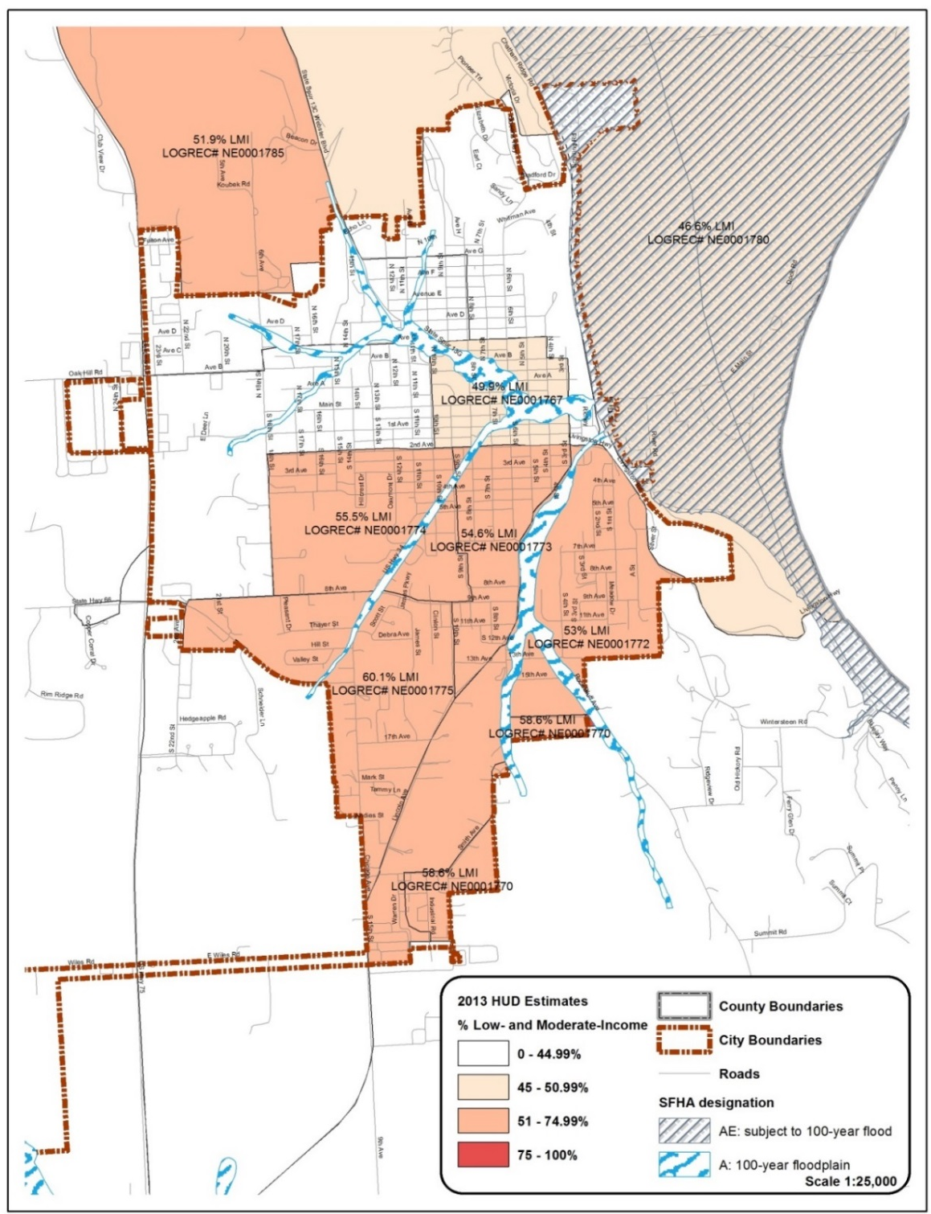
Source: HUD Community Planning & Development, CPD Systems and FEMA Map Service Center.

**Note: please identify any areas of interest as they relate to the proposed project (e.g. context, floodplain, census tracts, HUD log record, parcels, building footprints, etc.) on the map, provide explanatory narrative, and indicate source.

EXHIBIT M

Instructions for Exhibit L: SAM database record and clearance

Each applicant must obtain a Duns and Bradstreet (DUNS) number and also register within the SAM system.

The Federal Funding Accountability and Transparency Act (FFATA) of 2006 mandated specific reporting requirements for recipients of federal funds. In order to report in this system, each State award recipient must have a DUNS and a CAGE code, assigned as a result of registration in the federal SAM.

For more information on obtaining a DUNS number go to: http://www.dnb.com/get-a-duns-number.html
For registering in the System for Award Management (SAM), please review the following information at: https://www.sam.gov/SAM/pages/public/help/samQUserGuides.jsf

Once registered, each applicant must access SAM, determine that the applicant is eligible within SAM, and provide a print out of the information from SAM. Each applicant must also provide documentation that they are registered in the SAM using the DUNS number entry (refer to the check your registration status in SAM) the last illustration.

Applicant must run a query at the System for Award Management website (www.sam.gov) at the time of application and include a copy of the search record showing the DUNS Number and/or search terms and date. This information must be provided within the application and labeled as “Exhibit L”.

- Using your internet browser, navigate to www.sam.gov
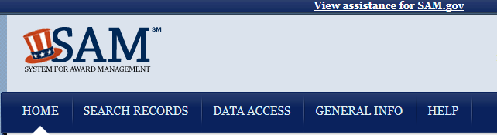
- Select “Search Records”, enter the DUNS number, and click “Search”.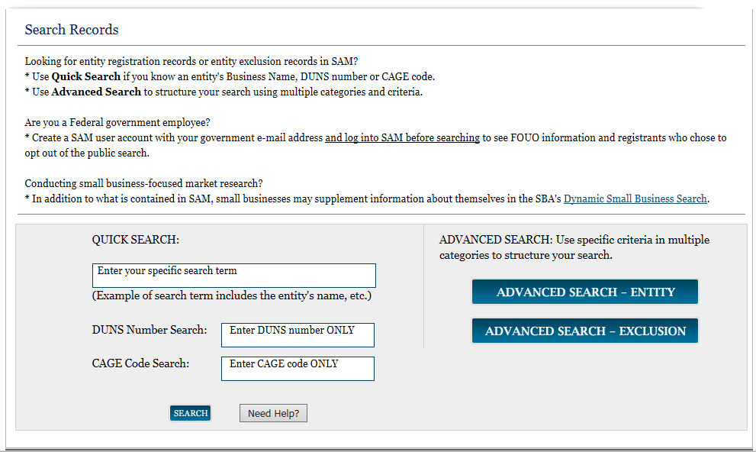
- Review the search results and click “Print” to print the results. Your printed copy should include a date stamp at the bottom of the page.
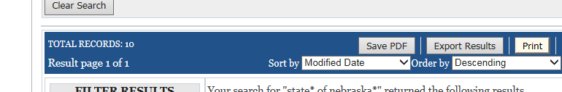

- If you need to register in the SAM, click Create User Account. The applicant must Check Status and submit a printout of Status, which must be an active status.

ALERT - June 11, 2018: Entities registering in SAM must submit a notarized letter appointing their authorized Entity Administrator. Read our updated FAQs to learn more about changes to the notarized letter review process and other system improvements.

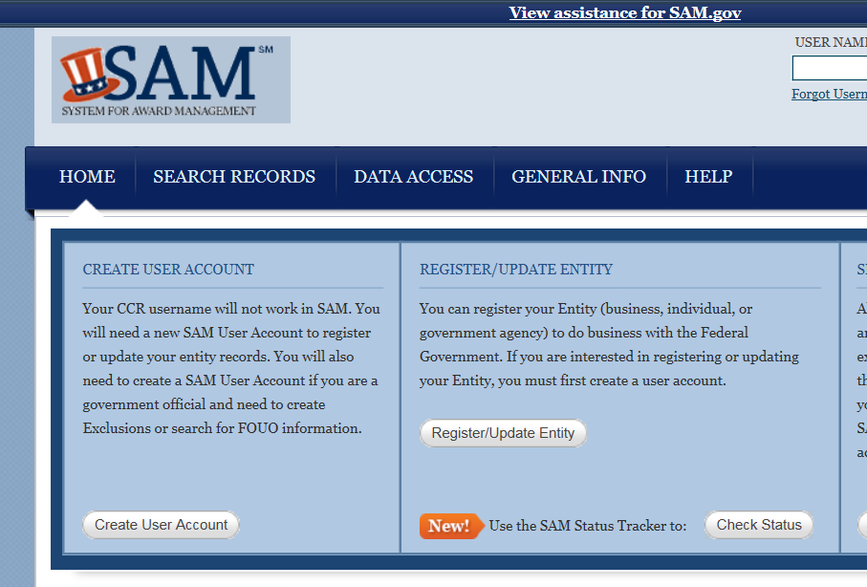

- Check your registration status in the SAM by entering applicant nine digit DUNS number.
If result is not active, create a user account. If result is inactive, reactive user account.

EXHIBIT M

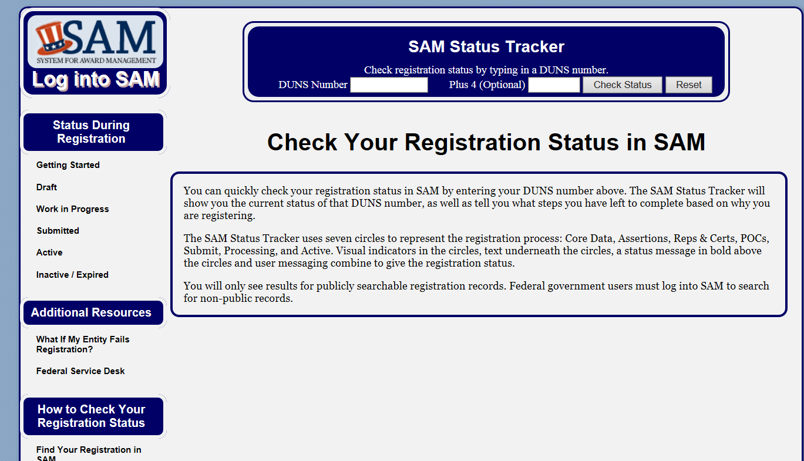

- You can tract your status at the SAM status tracker which indicates exactly where your applicant is in the process. The applicant must be in an active status as determined by DUNS number entry. https://www.sam.gov/SAM/pages/public/samStatusTracker.jsf

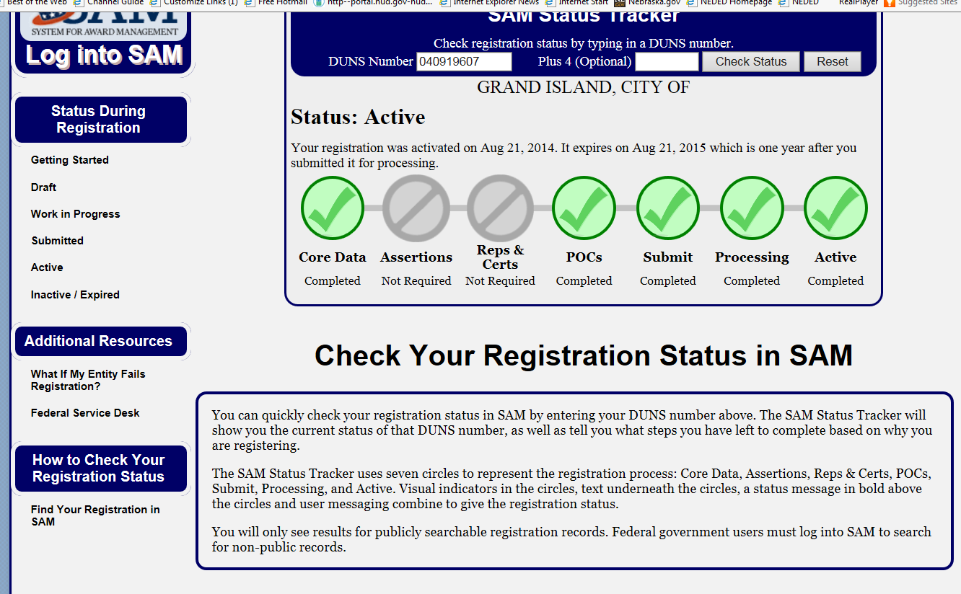

The final Exhibit M that the applicant must submit with their application must contain proof that the applicant is currently registered in SAM.gov.

EXHIBIT M
EXHIBIT N-1

FOUR FACTOR ANALYSIS

ASSESSING

LIMITED ENGLISH PROFICIENCY

AND
LANGUAGE ASSISTANCE PLAN

PREPARED BY

[LOCAL GOVERNMENT]

FOR

THE COMMUNITY DEVELOPMENT BLOCK GRANT PROGRAM

EXHIBIT N-1

- POLICY STATEMENT

It is the policy of the [LOCAL GOVERNMENT] to take reasonable steps to provide meaningful access to its programs and activities for persons with Limited English Proficiency (LEP). The [LOCAL GOVERNMENT]’s policy is to ensure that staff will communicate effectively with LEP individuals, and LEP individuals will have access to important programs and information. [LOCAL GOVERNMENT] is committed to complying with federal requirements in providing free meaningful access to its programs and activities for LEP persons.

- HISTORY

Act of 1964 is the federal law which protects individuals from discrimination on the basis of their race, color, or national origin in programs that receive federal financial assistance. In certain situations, failure to ensure that persons who have Limited English Proficiency can effectively participate in, or benefit from, federally assisted programs may violate Title VI’s prohibition against national origin discrimination.

Persons who, as a result of national origin, do not speak English as their primary language and who have limited ability to speak, read, write, or understand English may be entitled to language assistance under Title VI in order to receive a particular service, benefit, or encounter.

On August 11, 2000, Executive Order 13166, titled, “Improving Access to Services by Persons with Limited English Proficiency,” was issued. Executive Order 13166 requires federal agencies to assess and address the needs of otherwise eligible persons seeking access to federally conducted programs and activities who, due to LEP cannot fully and equally participate in or benefit from those programs and activities. Section 2 of the Executive Order 13166 directs each federal department or agency "to prepare a plan to improve access to…federally conducted programs and activities by eligible LEP persons…."

- DEFINITIONS

Beneficiary: The ultimate consumer of HUD programs and receives benefits from a HUD Recipient or Sub-recipient.

Limited English Proficient Person (LEP): Individuals who do not speak English as their primary language and who have a limited ability to read, write, speak, or understand English because of national origin.

Language Assistance Plan (LAP): A written implementation plan that addresses identified needs of the LEP persons served.

Recipient: Any political subdivision of the State of Arkansas, or an eligible nonprofit organization, to whom Federal financial assistance is extended for any program or activity, or who otherwise participates in carrying out such program or activity, including any successor, assign or transferee thereof, but such term does not include any Beneficiary under any such program.

Sub-recipient: Any public or private agency, institution, organization, or other entity to whom Federal financial assistance is extended, through another Recipient, for any program or activity, or who otherwise participates in carrying out such program or activity but such term does not include any Beneficiary under any such program.

Vital Document: Any document that is critical for ensuring meaningful access to the Recipient’s major
activities and programs by Beneficiaries generally and LEP persons specifically.

EXHIBIT N-1

FRAMEWORK & METHODOLOGY

This Four Factor Analysis is the first step in providing meaningful access to federally funded programs for LEP persons. The Four Factor Analysis completed by [LOCAL GOVERNMENT] addresses the following:

- The number or proportion of LEP persons eligible to be serviced or likely to be encountered by [LOCAL GOVERNMENT];
- The frequency with which LEP persons using a particular language come in contact with [LOCAL GOVERNMENT];
- The nature and importance of the [LOCAL GOVERNMENT] program or activity provided to the individual’s life; and
- The resources available to [LOCAL GOVERNMENT], and costs associated with providing LEP services.

- FOUR FACTOR ANALYSIS

- The number or proportion of LEP persons eligible to be served or likely to be encountered by [LOCAL GOVERNMENT].

[Response to Item #1]

- The frequency with which LEP persons using a particular language come in contact with [LOCAL GOVERNMENT].

[Response to Item #2]

- The nature and importance of the [LOCAL GOVERNMENT] program or activity provided to the individual’s life.

[Response to Item #3]

- The resources available to [LOCAL GOVERNMENT], and costs associated providing LEP services.

[Response to Item #4]

As a result of the Four Factor Analysis, [LOCAL GOVERNMENT] has determined a Language Assistance Plan is needed: YES NO

EXHIBIT N-1

EXHIBIT N-2
LANGUAGE ASSISTANCE PLAN [OPTIONAL]

As a result of the preceding Four Factor Analysis, [LOCAL GOVERNMENT] has developed a Language Assistance Plan. The Language Assistance Plan addresses the identified needs of the LEP persons [LOCAL GOVERNMENT] serves, the process by which [LOCAL GOVERNMENT] will monitor and update the LAP.

[LOCAL GOVERNMENT] understands that the actions [LOCAL GOVERNMENT] is expected to take to meet its LEP obligations depend upon the results of the Four Factor Analysis including the services [LOCAL GOVERNMENT] offers, [LOCAL GOVERNMENT]’s service area, the resources [LOCAL GOVERNMENT] possesses, and the costs of various language service options. However, [LOCAL GOVERNMENT] is to take reasonable steps to ensure meaningful access to LEP persons. The meaningful access is based upon a reasonableness standard that is both flexible and fact-dependent.

- The procedures [LOCAL GOVERNMENT] will use to identify LEP persons with whom [LOCAL GOVERNMENT] has contact, the size of LEP populations, and the languages of LEP populations.

[Response to Item #1]

- Points and types of contact [LOCAL GOVERNMENT] may have with LEP persons.

[Response to Item #2]

- Ways in which language assistance will be provided by [LOCAL GOVERNMENT], and the plan for outreach to LEP populations.

[Response to Item #3]

- [LOCAL GOVERNMENT]’s plan for training staff members on LEP guidance and the LAP, including specific provisions for training staff that are responsible for monitoring Recipients of HUD funding.

[Response to Item #4]

- A list of Vital Documents to be translated, the languages into which they will be translated and the timetable for translations.

[Response to Item #5]

- [LOCAL GOVERNMENT]’s plan for translating informational materials that detail services and activities provided to Beneficiaries and [LOCAL GOVERNMENT]’s plan for providing appropriately translated notices to LEP persons.

[Response to Item #6]
- [LOCAL GOVERNMENT]’s plan for providing interpreters for large, medium, small and one-on-one meetings.

[Response to Item #7]

EXHIBIT N-2

- [LOCAL GOVERNMENT]’s plan for developing community resources, partnerships, and other relationships to help with the provision of language services.

[Response to Item #8]

- [LOCAL GOVERNMENT]’s plan for monitoring and updating the LAP.

[Response to Item #9]

AVAILABLE LEP RESOURCES

HUD Frequently Asked Questions on the Final LEP Guidance: http://portal.hud.gov/hudportal/HUD?src=/program_offices/fair_housing_equal_opp/promotingfh/lep-faq

HUD’s LEP Website:
http://www.hud.gov/offices/fheo/lep.xml

Federal LEP Website:
http://www.lep.gov/

LEP and Title VI Videos:
http://www.lep.gov/video/video.html

“I Speak” Card:
http://www.lep.gov/ISpeakCards2004.pdf

COMPLAINTS

If you believe that you have been denied the benefits of this Language Assistance Plan, you may file a written complaint by mail to:

[LOCAL GOVERNMENT]

Any person that feels that the Title VI of the Civil Rights Act of 1964, 42 U.S.C. 2000(d) and Executive Order 13166 regulations were not complied with may file a complaint directly to the Assistant Secretary for Fair Housing and Equal Opportunity at the following links (or as otherwise directed):

FORT WORTH REGIONAL OFFICE  U.S. Department of Housing and Urban Development  Southwest Office  801 Cherry St., Unit 45, Suite 2500  Fort Worth, TX 76102 | Garry Sweeney, Regional Director | (817) 978-5868  Fax: (817) 978-5876

Or Contact (888)560-8913 and for the hearing impaired, please call TTY (800)927-9275

EXHIBIT N-2

